Introduction to Hummingbird
P3: Switched on lights!
On this page, you will use Inputs as well as Outputs

The majority of computer control real-world things that you see around you every day. Can you and your partner think of 5 things that are computer controlled?
Make a list and share your answers with your teacher …
1
2
3
4
5
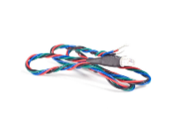
For You to Do
Now connect your Hummingbird board to the computer and open Snap! Don’t forget … you must click on the Bluebird Connector desktop link to load the extra blocks needed to control the Hummingbird board.
Once the Hummingbird is connected, open your Hummingbird box and find a Three-Color LED – hint: it has four wires!
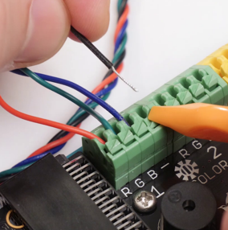
Using the Terminal too, connect the 3-color LED to Tri-Color port 1. The RED wire connects to the R port; the GREEN wire to the G port; the BLUE wire to the B port, and the BLACK wire to the – port.

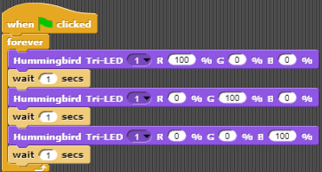
Using the Looks pallet, create this block in Snap …
Make sure you select the correct Port (1), and set R, G and B to 100% in each step.
You will now see how a single LED can contain three different LED chips, each of a different color.
To STOP the program, click the RED button at the top of the screen.
You have used 2 different Hummingbird Outputs, let’s see if we can use a Hummingbird real-world Input!
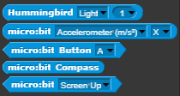
Open the Sensing pallet … there are a number of INPUTs that can be used to make things happen instead of using the keyboard.

For You to Do:
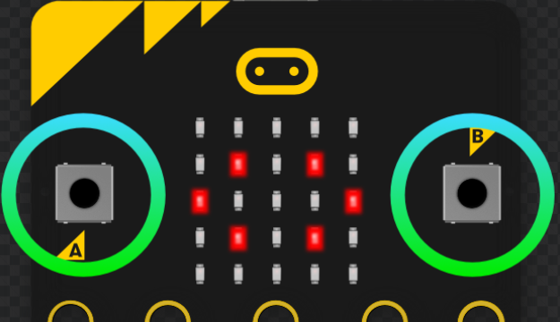
Using Button A on the Micro:bit board (it sticks out of one end of the Hummningbird board), modify the Snap Block above to make the light the LED sequence … Save your program in the Cloud.

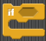
Can you create a block that will light the RED LED when BUTTON A is pressed, and the GREEN LED when BUTTON B is pressed? Just imagine that you are creating a yes simple traffic light!
HINT – You might need to use the IF block (Control pallet) when you create your program
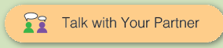
Decide on the Blocks that you need to use …

When you have completed the task, show the code to your teacher.

Teaching Tips:
If the student teams have completed the table with 5 items that are real world computer-controlled devices or systems, they can move on.
If they have selected items that are not computer controlled, use this as a teachable moment to ask the class why a particular item is not computer controlled …
1 | Car
2 | Fitness monitor
3 | Sun dial
4 | Waterwheel
5

The 2 Button Red Green Activity requires the students to use Conditionals … the following code will work, but it isn’t the only way to do this.
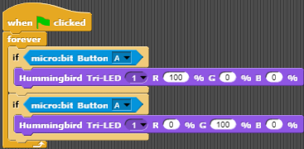
If your students get the system working using a different approach, use share their approach with the class and use the opportunity to show that there is often more than one way to solve a problem and that sometimes there is no single right answer. (If desired, you can continue to talk about how some answers are more efficient and use few code blocks)

