Introduction to Hummingbird
P2: Light things up!
On this page, you will use computer controlled outputs!
Computer are very versatile … they can follow your commands and control things for you … when you press a key, you can control what you see on the screen, or sometimes make a sound or even create music.
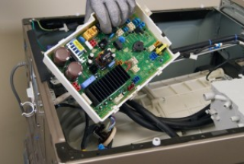
Most of the computers in the world are not traditional the usual keyboard, system and screen system, they are doing very specific things such as controlling the brakes on a car, or the heating system in a house. If the washing machine in your home was purchased in the last five years, it is almost certainly computer controlled!
Figure 1 Washing Machine Control Board

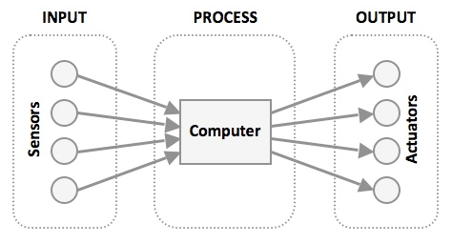
For a computer to control something, it must be setup as part of a system …
The system must have an Input of some kind (your computer has a keyboard to input information).
It must Process information in an organized way … the programs you use on your computer do just that … a web browser is a program or process that allows you to surf the web.
And the system must be able to Output the results of the Process … when you use a web browser to visit a website, the Output is the images on the computer screen.
Talk to your pair programming partner and talk about the washing machine. What are the inputs? What are the Processes? What are the Outputs?

Use a table like this to list your answers
INPUTS | PROCESSES | OUTPUTS

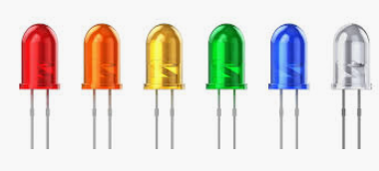
For you to do:
Light emitting diodes are small electronic devices that convert electrical energy into light energy. They are usually known as LEDs, and they must be connected correctly if they are to work! They also come in a wide range of colors too!

Now connect your Hummingbird board to the computer and open Snap!
Once the Hummingbird is connected, open your Hummingbird box and find a Single-Color LED – hint: it has two wires! The color of the LED doesn’t matter


Also find the orange Terminal tool – it will help you insert the wires into the terminals on the Hummingbird board.

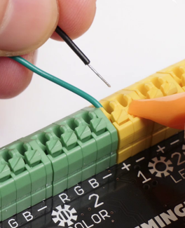
Now find the yellow LED 1 connector or port on the Hummingbird board … it has 2 connections, one marked with a + and one marked with a -

Using the Terminal tool, push down the small button and insert the Black wire in the – terminal. Release the button once the wire is fully inserted.
Repeat the process to Insert the other wire (it will be colored) in the + terminal (or port)

Talk to your partner and decide if an LED is an Input or an Output ….

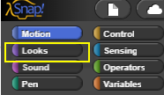
Once you have decided what it is, open the Looks pallet in Snap.

You will see that there are some extra commands …

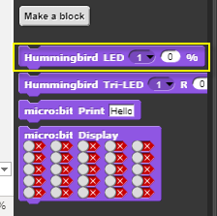

You are going to use the Hummingbird LED command to make the LED light up …
Drag the Hummingbird LED command into the Script workplace, and set the LED selection to 1 … and set the % to 100 and click on the Command to make it active …
Did the LED light up when you clicked? If not, have you mixed up the wires, and connected the Black wire to the + port? If yes, move the Black wire to the – port and click once on the command once more ...
Now, were going to make the LED flash on and off for one second. Create the following block …
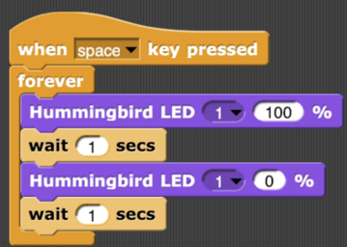
Talk to your partner about the System you have created …
What is the INPUT?
What is the PROCESS?
What is the OUTPUT?

Save your program by clicking on the Cloud icon, then remove the LED using the Terminal tool. Put the LED back in the Hummingbird kit.

Teaching Tips
The following table lists the common input, processes and outputs for a modern washing machine.
INPUTS | PROCESSES | OUTPUTS
Door closed sensor | Door lock program, when program is started | Door locked
Water Level sensors | Water fill program, controls the level of water in the machine | Water valve opened and closed
Temperature sensors | Water temperature control program | Water temperature is maintained at the correct temperature using the inbuilt heater to raise the temp., and blending cold water with the hot to lower the temp.
Vibration sensor | Out of balance program, detects if the washing is out of balance. | Slows down or stops the washing motor so the wash or spin cycle so the machine is not damaged by out of balance forces
Timer | The wash cycle control program uses the timer to control the actions of the machine | Wash cycle follows a timed sequence of steps
Wash control buttons or rotary switches or keypad | Selects the desired wash cycle program | Machine follows desired wash cycle

The INPUT-PROCESS-OUTPUT question:
INPUT is the space bar
PROCESS is the programming block control of the Hummingbird
OUTPUT is the control of an LED
Possible expansion to LED activity
There are 3 LED ports; ask the students to connect the LED 2 port, and to change the block to make the LED light up.
Ask the students to connect a second LED to LED port 2 and to change the program so that the LEDs flash alternately.
