introduction to the Hummingbird: P1 Connect to the Real World!
On this page, you will connect the computer to the real world!

For you to do
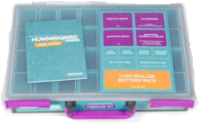
Collect your Hummingbird Kit ….
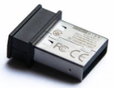
Open the box, and locate the Bluetooth connector (sometimes called a “dongle”)

Also, locate the Hummingbird board, and the battery power supply
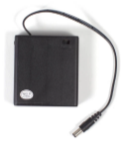
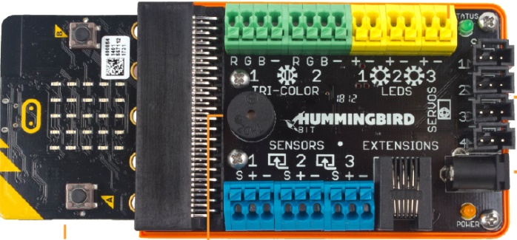

Connect the battery pack to the Hummingbird board by plugging the cord into the Power Connector socket.
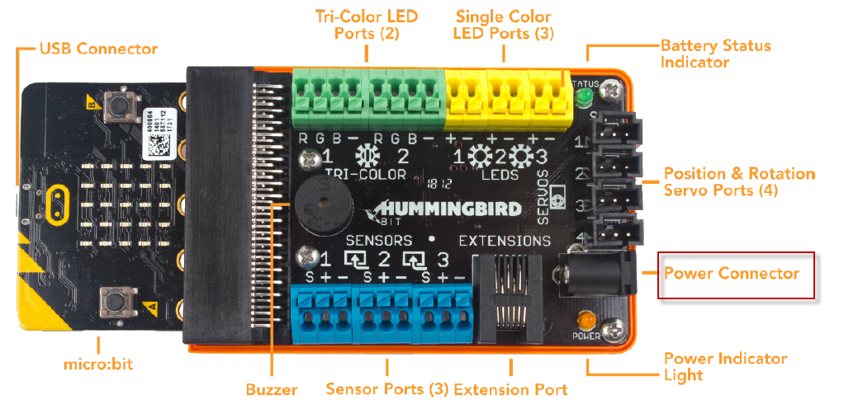

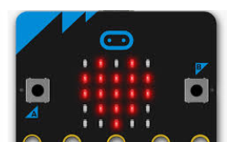
Turn on the power using the switch on the battery pack …

You now will see a three-letter code being displayed on the Micro-bit display

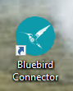
Now insert the Bluetooth connector into a USB port on your computer.
And then start the special version of Snap! that will allow you and your partner to program the Hummingbird … click on the Bluebird Connector icon on the computer desktop

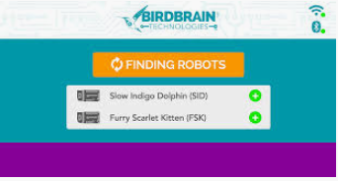
You will now see this screen …
Click on the link that matches the three letter code being displayed on your Micro:bit …

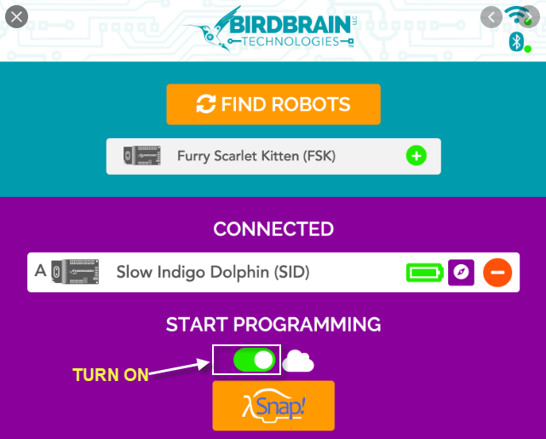

The screen will show CONNECTED when everything is working … make sure the Cloud slider is turned ON – then click on the Snap! Icon to launch the computer control version of Snap!

When Snap opens, click on the Cloud icon to login (IMPORTANT: if you are not logged in, you cannot save your computer control programs!)

Teaching Tips:
The activity is self-guided, however, it might be worthwhile showing the whole class the steps to connect the power, launch the software and entering the code to link the HB to the computer.
If you would like to see a video of the entire setup process, click on this link to the Hummingbird setup information on the Birdbrain Technologies site.

