 | Name_______________________ Date______  Modeling with Computer Aided Design (CAD)  Big Idea: Models are a powerful means for visualizing, analyzing, and predicting the behavior of systems.
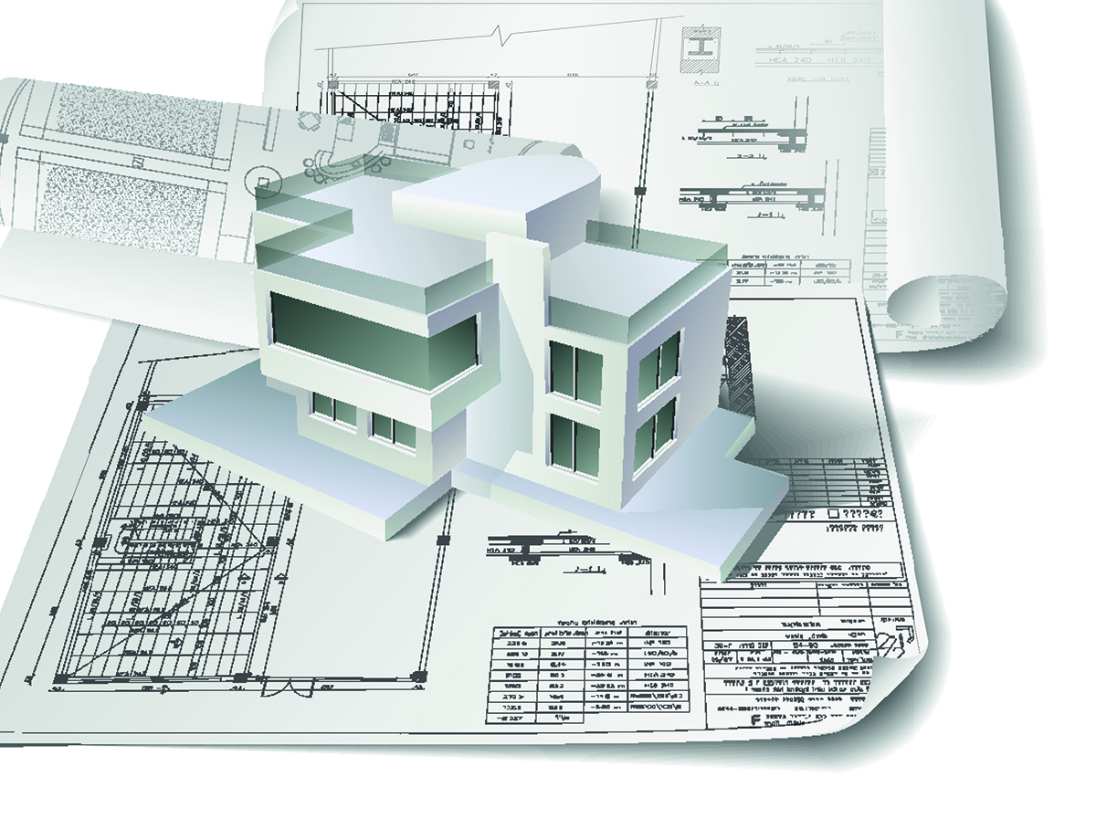
Courtesy of Freedesignfile.com. Creative Commons
To complete your training as a valued employee of Fresh Food Engineers we would like you to learn to use Computer Aided Design software to make 3D models. These are usually called CAD programs. CAD allows you to create a drawing that you can manipulate onscreen. Because you can change and manipulate the drawing, it is a powerful means for visualizing, analyzing, and predicting the behavior of a system.
There are several different software programs that you can choose from, which are free and can be downloaded from the Internet. The one we have chosen to use is SketchUp, but any CAD program will do.
- When you complete this KSB, you will show your ability to use CAD by designing an apartment building with at least one wall that has no windows.
- Later you will show your increased ability to use CAD by adding a vertical hydroponic system to your 3-D model.
- Finally, you will show your ability to import ready-made 3-D objects from a graphics library.

What Is a 3D Model?
Look at the three images of an onion below. They are very different, although they are all representations of an onion.
 |  | 
A | B | C
People make different types of representations for different purposes. Which representation of an onion (A, B, or C) would you use for the following purposes?

To hang on the wall in a restaurant. _____
To advertise onions at a grocery store. _____
To illustrate a botany lab notebook. _____

There are no right or wrong answers to the above questions. It’s a matter of personal preference. However, for some purposes, one type of drawing may be better than others. CAD software is used by engineers to produce 3D models. Here’s what you can do with a computer-based model of an object:
- You can make a set of 2D drawings, with dimensions, that can be used to manufacture the object.
- You can display the object as a 3D drawing, which you can move around the screen and look at from different points of view.
- You can make objects with certain exact sizes, shapes, colors and textures.
- If you make a mistake you can correct it easily without redrawing everything.
- You can easily send your drawings to someone else via email.

View one or two videos about CAD on the Internet. Your teacher may have one for you to see, or you can use a search engine to find videos about “Computer Aided Design.”

Let’s Get Started!
There are several CAD programs available. The one we have chosen for this course is SketchUp, since it is free and easy to learn; but any CAD software is fine. If SketchUp is not already on your computer you will need to download it at the following website:
VIDEO LINK INSERT [http://www.sketchup.com/products/sketchup-make]
One of the teachers who helped to develop this unit has produced video tutorials to help you learn to use SketchUp. Download these videos at the following website:
VIDEO LINK INSERT [NEED TO INCLUDE STEVE HANER’S VIDEOS]
If possible, open a window for a video and another for the software so you can stop the video after seeing each step and try it for yourself.
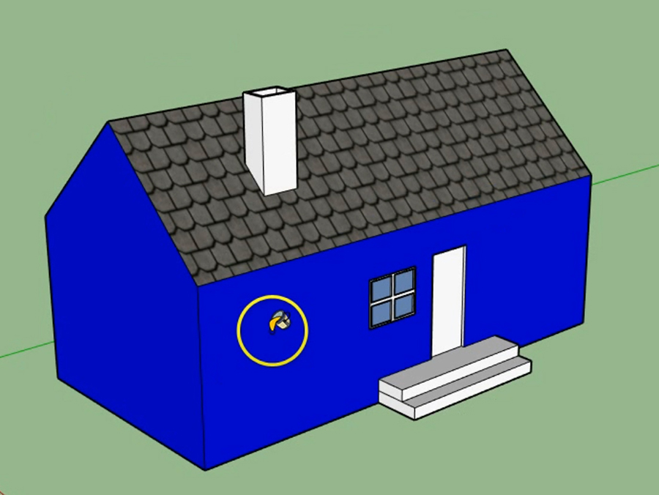 | 1st SketchUp Tutorial: Push and Pull Basic Shapes  In this introductory video you ‘ll learn how to use a few basic commands to create and change a shape, then “paint” it the color you choose.
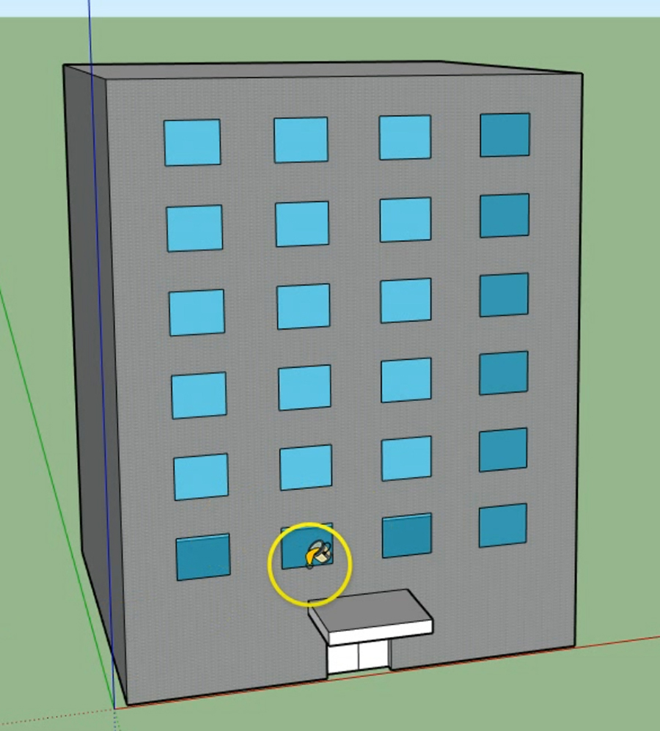 | 2nd SketchUp Tutorial: Design a Building  Learn how to create and copy elements to make them all alike, such as the windows on this apartment building.
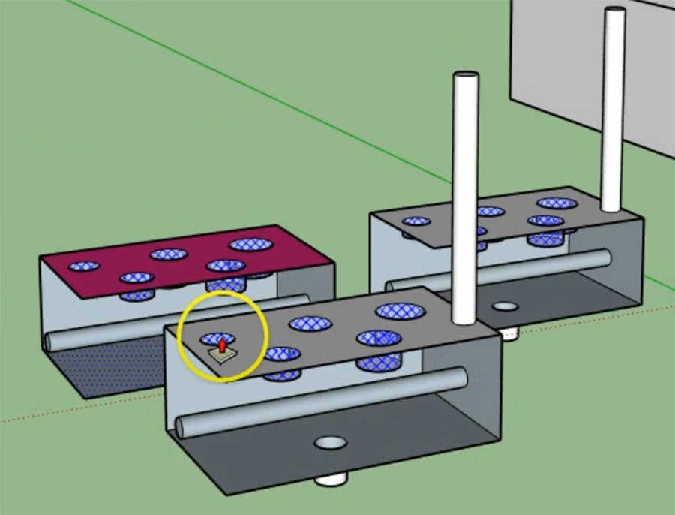 | 3rd SketchUp Tutorial: Groups and Components  This tutorial will illustrate how to use groups and components to make different objects and how to rotate individual pieces of the model.
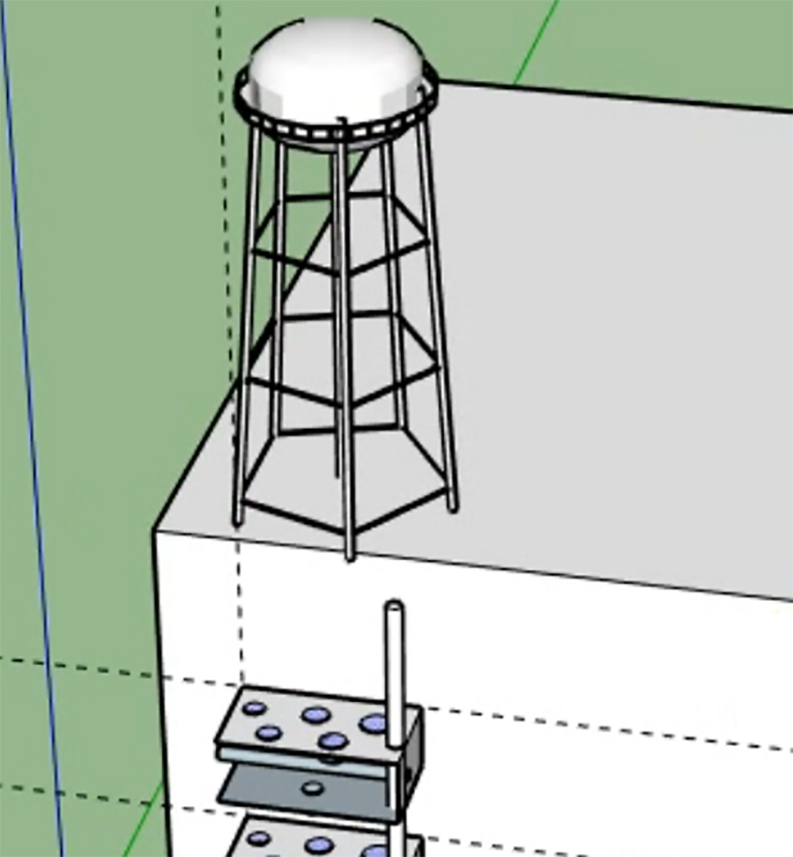 | 4th SketchUp Tutorial: Moving and Rotating Models  The last tutorial illustrates how to rotate individual parts and assemble them into a complete system. You’ll also learn about importing pre-made parts and even whole objects that are available from the online SketchUp Warehouse.

Practice Using SketchUp
Your next assignment is to design the outside of an apartment building. Later you will design a vertical hydroponic farm on one or two walls of the building..  - Observe buildings in your neighborhood, such as apartment buildings like those in the pictures on the right, to include in your design.  - Start with the ground floor. Imagine how many apartments might be on one floor, and how big they would be. Use that information to create the size and shape of the ground floor.  - Assume there will be about 10 feet per story. Decide how many stories you want to draw. It’s best not to draw too many or it will take too long to copy items like balconies and windows. Six to eight stories is fine.  - Include one or two walls with no windows, like those shown on the buildings at right.  - Add windows, balconies, and any other features you think would be interesting. Try to make the building a place in which you might like to live.  - Save your building design, as you will need it later.  Tradeoffs. As you design your building you’ll need to make some tradeoffs. For example, people like to hang pictures on their walls. They also like to have natural light. More windows means less space for pictures; more space for pictures means less natural light. Finding the right balance is a tradeoff. Name two other tradeoffs involved in designing an apartment building: | 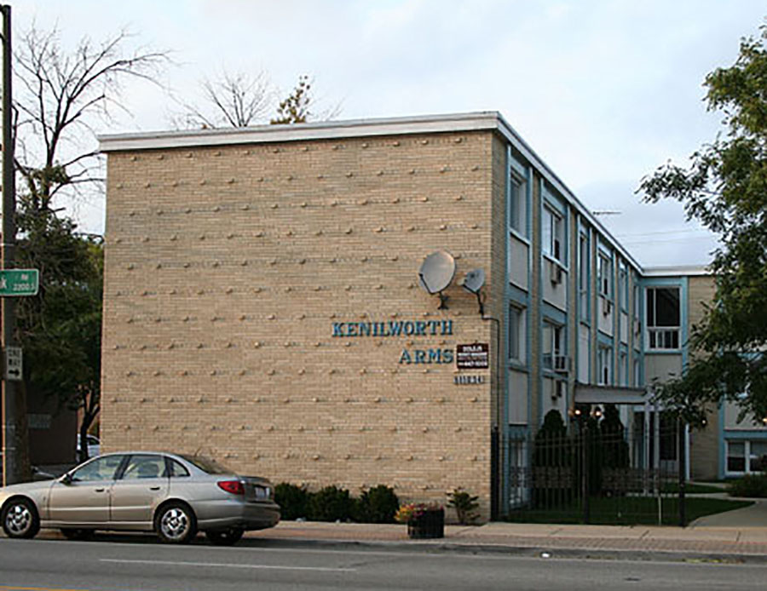  Image Courtesy of Cary Sneider
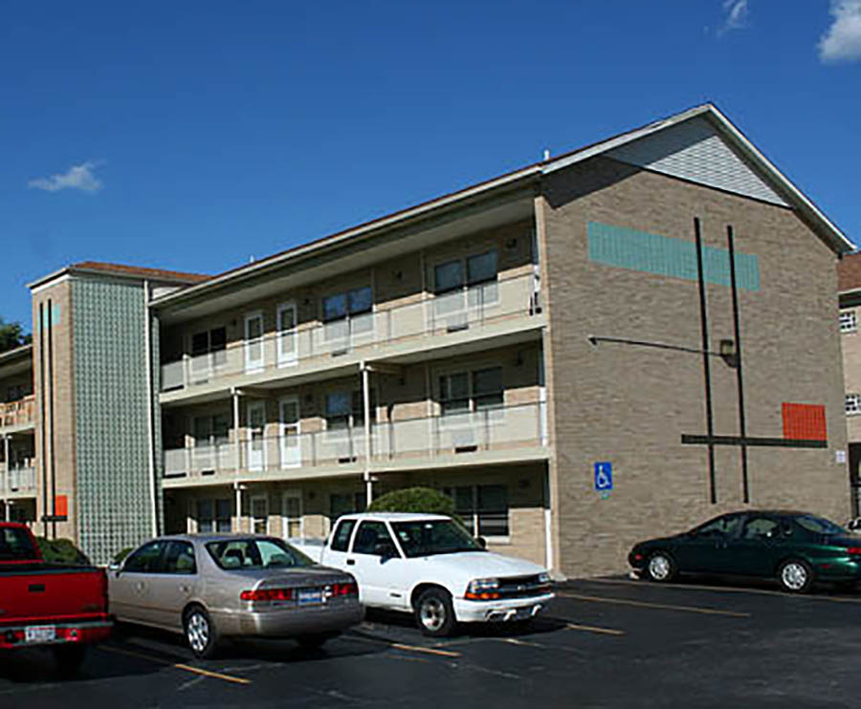
Image Courtesy of Cary Sneider
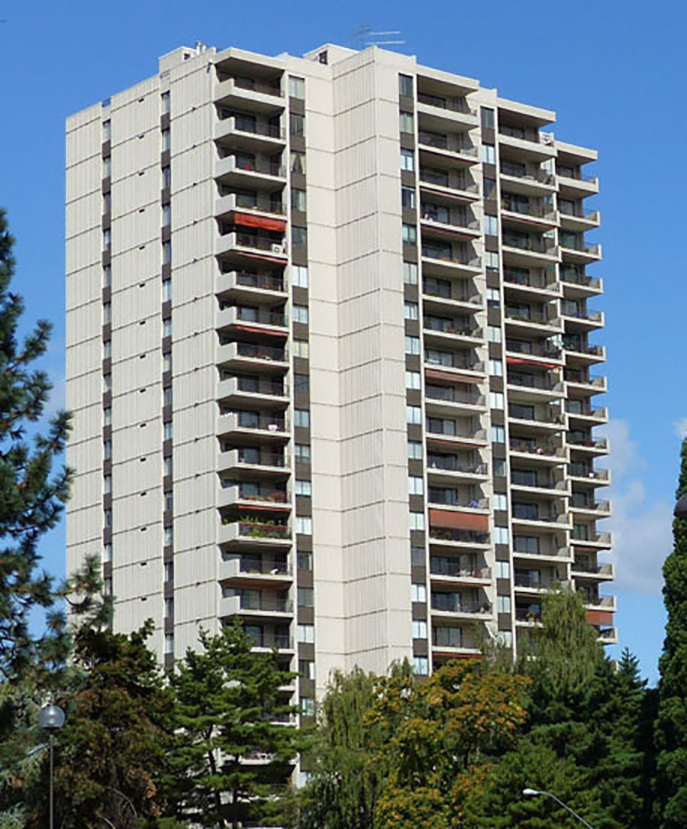
Image Courtesy of Cary Sneider

Check Your Understanding
Inspect Your Building
Designing an apartment building is not an easy task. Check your work against the criteria listed on the previous page. Then exchange with a teammate and score each other’s work.

 | Maximum Points | Your  Score | Teammate’s  Score
Width vs, Height of Bldg,. Is the size and shape of the building reasonable for number of apartments you envision in each story? | 25
Number and height of floors. Have you allowed 10 feet per story? Do all of the apartments have some windows? | 25
Blank Walls vs. Windows. Have you made a reasonable tradeoff between blank external walls and windows to allow for a vertical farm? | 25
Attractive. Is the building sufficiently attractive that you’d like to live there? | 25
Pre-made objects. Did you import a pre-made object into your building? If yes, give yourself a bonus of 25 points and list it here:__________ | 25
Total | 125

How easy or difficult was it to learn how to use SketchUp? (Circle one)
Very Easy Easy Medium Difficult Very Difficult

Is there anything about using SketchUp that you still need help with? Please describe.

Points to Ponder | CAD or Hand Drawing?  No single solution works for everything. Consider the following situations where sketching on paper or CAD drawing is maybe preferred. Circle the best answer for each case. Then explain why you made that choice.

1. Accurately draw parts to see if they will fit together.  Explain: | CAD?  Or  Hand Drawing?
2. Get ideas down on paper quickly before you forget.  Explain: | CAD?  Or  Hand Drawing?
3. Provide a drawing for a device to be manufactured.  Explain: | CAD?  Or  Hand Drawing?
4. CAD is one tool that you can use to create 3D Models. Search the Internet to find at least 3 careers that use 3D modeling. What are they?

What’s the  Big Idea? | In KSB5 you have been creating 3D models using CAD software. Unlike a drawing, a virtual 3D model can be inspected from different points of view by rotating around it. You can also change the model easily and then return it to its original state. That’s why CAD software is so useful in design.

There are other kinds of models besides CAD drawings. A model is any representation of the real world that emphasizes certain features and ignores others. A model can be a diagram, a physical replica, or a computer simulation. A model can represent a natural system or a designed system.

1. a. What is one feature of a building that a CAD model can represent well?

b. How is it helpful to include that feature in a model?

2. a. Which features of a building does a CAD model ignore?

b. How is it helpful to ignore those features?

3. Car designers build small physical replicas of new ideas for cars. How might they use such models to improve the cars’ performance and safety?

4. The BIG IDEA for this KSB is that “Models are a powerful means for representing, analyzing, and predicting the behavior of systems.” What does this statement mean to you?

