Name_______________________ Date______

Hydroponic Farming
Big Idea: Feedback involves monitoring and adjusting a system to maintain a desired output.

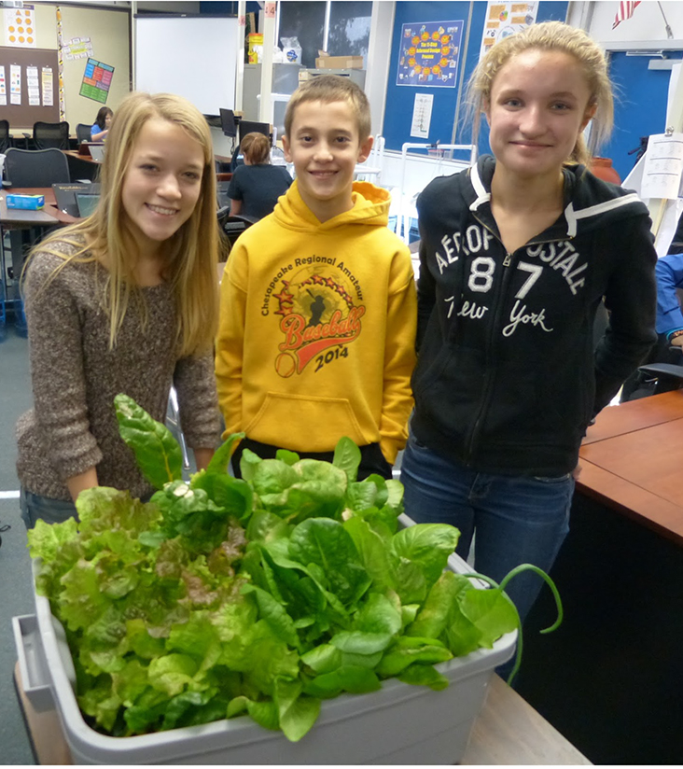
ICourtesy of Korbin Shoemaker
Now that you have set up your hydroponic system it’s time to start farming! As you’ll see, farming involves more than just planting seeds. You’ll need to check on your plants’ progress frequently. Based on what you observe and measure, you’ll need to adjust the chemical composition of the nutrient solution, lighting, and temperature. When you finish this KSB you will be able to answer the following questions:
- What does it mean to monitor and maintain a system?
- How can you measure the most important characteristics of a hydroponic system?
- What do you do when the system is not operating as expected?
A. Prepare the Nutrient Solution
In traditional farming, plants get their minerals from the soil. In hydroponic systems a nutrient solution is added to the water. Keep in mind that the nutrient solution is not “food.” It’s more like a multi-vitamin with minerals that plants need. Plants make their own food by capturing the energy in sunlight and using it to break up water molecules. They combine the hydrogen atoms from water with CO₂ from the air to form carbohydrates. Plants use the carbohydrates to build stems, leaves, roots, flowers and fruits.
Prepare the nutrient solution as follows:

1. Wipe down the reservoir and growing tray with a cloth that has been moistened with rubbing alcohol. That will kill harmful bacteria. Allow the reservoir and growing tray to dry overnight.  2. Fill the reservoir with eight gallons of clean water. Double-check fittings for leaks before proceeding.  3. Mix the nutrient solution into the water, following directions on the container.  4. Before you plant, measure the pH of the solution. pH is a measure of how acidic a solution is.  5. To test the pH of the nutrient solution, follow directions on the test kit bottle and your teacher’s demonstration. You will need to use a pipette, which is a chemical tool for transferring small amounts of liquid. If the pH is too low (too acid) you will add a small amount of the “Up” solution. If too high (too basic) you will add a small amount of the “Down” solution, and retest. | 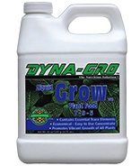  Nutrient Solution  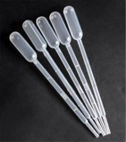  Pipettes | 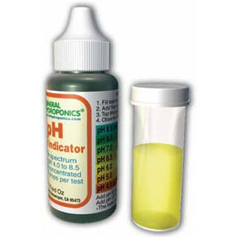  pH Test Kit    Up Solution    Down Solution
6. Different plants require different pH levels to grow best. Use the Internet to look up the pH that your plants need in order to thrive.
B. Planting in the Aeroponics System
1. Check to be sure you have done the following before planting:
___ Constructed your hydroponic system and tested it with water
___ Cleaned the growing tray and reservoir with alcohol
___ Mixed the nutrient solution
___ Tested for pH, and adjusted it as needed so pH is in the recommended range
___ Placed the system near an electrical outlet
2. If you have completed the above checklist, your team will be given:
- 8 Net Cups
- 8 Plant seeds or bulbs
- clay pellets
3. Pour a few clay pellets into each cup.
4. If planting bulbs for onions or garlic, place one bulb in the middle of each cup and gently add clay pellets so the top of the bulb is just below the surface. If you are planting seeds, put 3 or 4 seeds in different parts of the cup so their roots will not become tangled. Place the cups into the holes in the aeroponics system.
5. Place the light 6” above the growing tray.
6. Check the temperature at the top of the net cups. Temperature should not be greater than 25°C (about 80°F). If it is too hot change the position of the light.  7. Light timing: Set the programmable timer connected to the lights to be 12 hours on (during the day) and 12 hours off (at night.)  8. Pump timing: Start with 15 minutes on, 15 minutes off (repeat continuously). If the environment is very dry the pump should be on longer so the roots don’t dry out. If very humid it should be on less time so the roots don’t rot. | 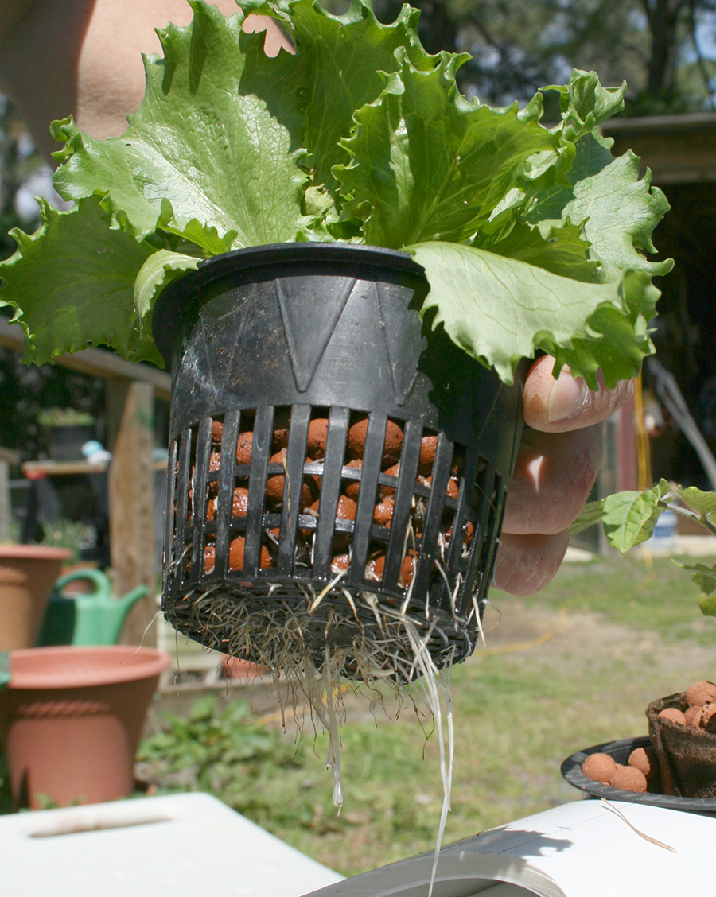  Image Courtesy of Ildar Sagdejev

C. Planting in the Ebb and Flow System
1. Check to be sure you have done the following before planting:
___ Constructed your hydroponic system and tested it with water
___ Ensured that the nutrient solution drains completely when the pump is off
___ Cleaned the growing tray and reservoir with alcohol
___ Mixed the nutrient solution
___ Tested for pH, and adjusted as needed so pH is in the recommended range
___ Located the system near an electrical outlet
2. If you have successfully completed the above checklist, your team will be given:8 Rockwool cubes with seedlings that have already been started. Place the cubes on the bottom of the growing chamber.
3. Place the light 6” above the growing tray.
4. Check the temperature at the top of the Rockwool cubes. Temperature should not be much above room temperature (not be greater than 80° F). If it is too hot change the position of the light.
5. Light timing: Set the programmable timer connected to the lights to be 12 hours on (during the day) and 12 hours off (at night.)  6. Pump timing: Start with 15 minutes on, 15 minutes off (repeat continuously). If the environment is very dry the pump should be on longer so the roots don’t dry out. If very humid it should be on less time so the roots don’t rot. Here’s a good place to start:  7. Observe a full cycle to be sure that the growing chamber floods to soak the Rockwool cube (and later the roots,) and that it drains thoroughly. If it does not, re-engineer until it cycles properly. | 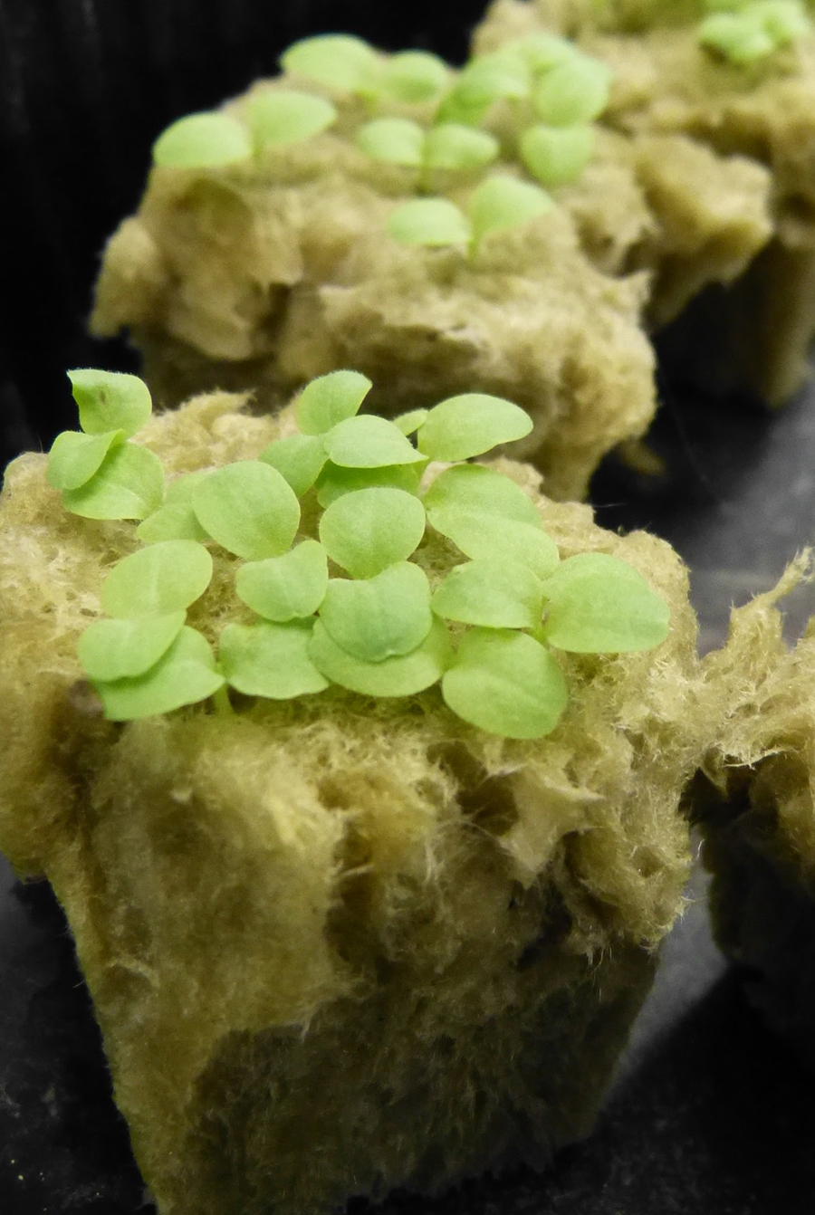  Image Courtesy of Korbin Shoemaker

D. Collect Data

Depending on the kind of plant that you are growing, choose a means for measuring growth. It might be the height of the plant or length of the longest leaf. At least twice a week measure each plant in your system. Record these measurements below, so that you can graph the results when it is time for harvesting. You will then be able to see how the rate of growth has changed.
Your teacher will ask you to measure the pH of the plant water frequently to ensure it is within the normal range of 5.8 and 6.5. Your teacher may also ask you to measure the Total Dissolved Solids in parts per million (ppm) to determine if the solution has the right concentration of minerals. Write these numbers in the third column and record the depth of water in the reservoir in the fourth column.

Date | pH | ppm | Depth | Plant 1 | Plant 2 | Plant 3 | Plant 4 | Plant 5 | Plant 6 | Plant 7 | Plant 8

Points to Ponder

When you harvest your plants summarize the data in a graph. Which kind of chart or graph will best display the data you plan to collect? Circle the kind of graph you think will be best.
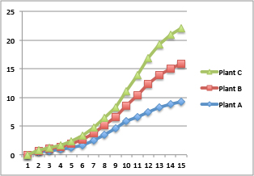  Line Chart | 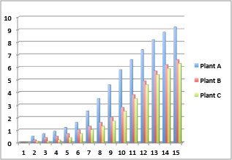  Bar Chart | 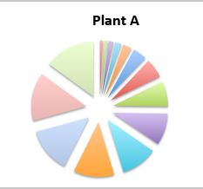  Pie Chart

Summarize Your Results
1. How did the growth rate change from the time you planted to the time you harvested? ____________________________________________________________________

____________________________________________________________________

2. Did all plants grow at the same rate? If not, what were the differences, and why do you think those differences occurred? ____________________________________________________________________

____________________________________________________________________

3. Based on your graph, how large do you think your plants would grow if you could keep them growing for another week? __________ another month?____________
4. Collecting data about a system’s output to make decisions about how to maintain the system is called feedback. In what ways did you use feedback to maintain the health of your hydroponic systems?
__________________________________________________________________
__________________________________________________________________

Agricultural Engineering
Just about all the foods we eat have been changed from the wild variety to make them more nutritious and easier to grow. For example, corn was developed by Native Americans at least 5,000 years ago. The wild plant, called teosinte, is shown in the image to your right. Native Americans selected seeds from the biggest and best teosinte cobs for planting. They then harvested and selected the best of those to replant, and so on. After many generations, they developed the corn we grow now. | 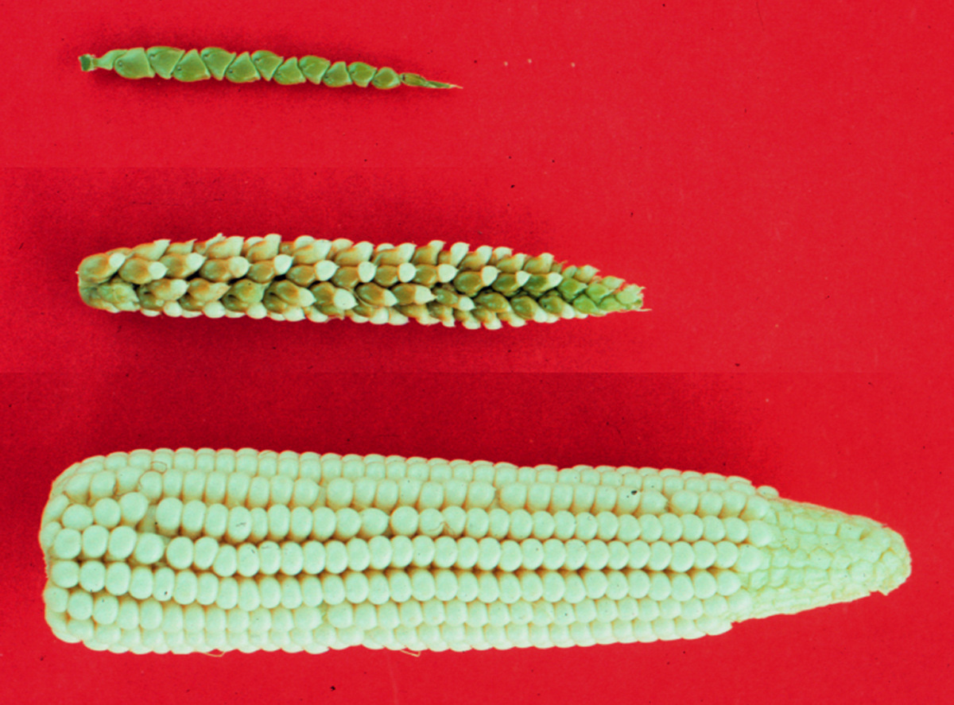  John Doebley
By developing corn and other crops, Native Americans changed the natural plants to better meet their needs. Although they would not have used that term, they acted as agricultural engineers. Selecting seeds from the best crops to plant is one method of improving crops. Another method is conducting experiments.
Experiments can be conducted by scientists or engineers. Scientists experiment to test their explanations of natural phenomena. Engineers experiment to see which designs performs better, or to find out how their product works. Here’s an example of an agricultural engineering experiment.
1. Decide on an outcome variable. Let’s say some agricultural engineers wanted to increase the amount of lettuce that they grew in their hydroponic garden. The first thing they did was to decide how to define “amount.” They decided that weight would be the best way to define amount.
2. Decide on an experimental variable. Next the agricultural engineers thought about what may make the biggest difference in the growth rate of their lettuce plants. They decided that pH might make the biggest difference.
3. Decide what to keep constant. A good experiment should test just one experimental variable. In this case the agricultural engineers wanted to find out if pH made a difference in growing lettuce, so they kept all of the other variables the same. Here’s a diagram of their experiment.

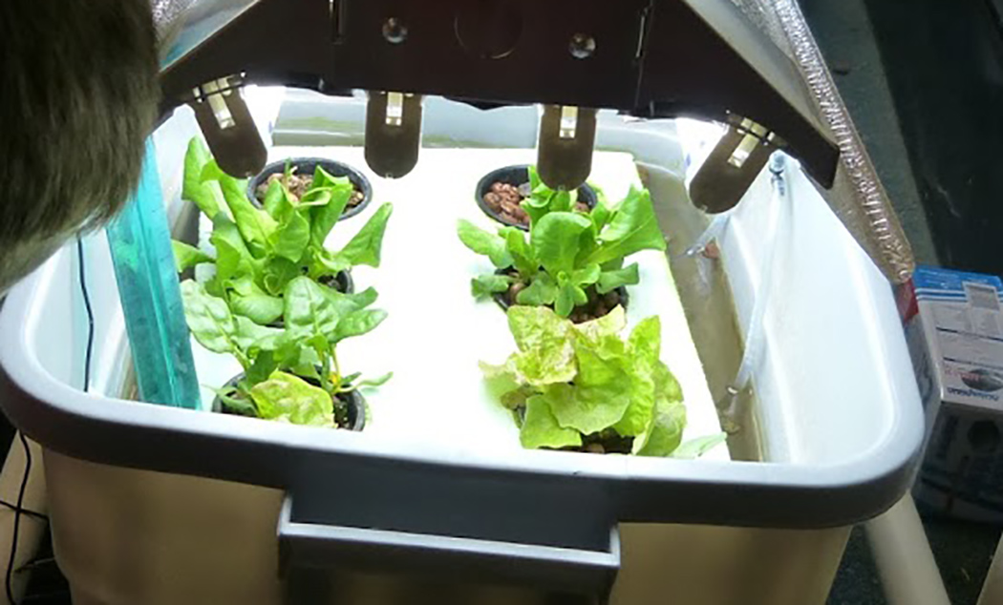
pH = 6.0  8 lettuce plants  Aeroponics  Average temp = 75°C  Lights 12” above plants | pH = 6.5  8 lettuce plants  Aeroponics  Average temp = 75°C  Lights 12” above plants | pH = 7.0  8 lettuce plants  Aeroponics  Average temp = 75°C  Lights 12” above plants
Images courtesy of Korbin Shoemaker
4. Conducting the Experiment. During the experiment the agricultural engineers made sure that each hydroponic system was given the same amount of nutrients, on the same schedule, so that the experiment would be a fair test of the effect of pH on the growth of the lettuce plants.
5. Drawing Conclusions. When the plants achieved their maximum growth, the engineers harvested and weighed the plants. They made a bar graph of their results and recommended the best level of pH for growing that type of lettuce.

1. Plan an experiment to determine whether the aeroponics system or ebb and flow system is better for growing vegetables.
A. What is the experimental variable?
_____________________________________________________________________
B. What would your outcome variable be? How would you measure it?
_____________________________________________________________________
C. What will you keep constant in this experiment?
_____________________________________________________________________
2. Is agricultural engineering something you may want to do as a career? __________
If yes, what do you like about it? If not, why not? ______________________________
_____________________________________________________________________

Think Like an Engineer
Engineering requires good teamwork. That means everyone contributes to the work, everyone’s ideas are considered, and each team member behaves respectfully to the other team members. Please circle the number that best reflects your groups’ teamwork.

Disagree Agree
I contributed fully to our project. | 1 2 3 4 5 6 7 8 9 10
I listened to my teammates’ ideas | 1 2 3 4 5 6 7 8 9 10
I expressed my ideas honestly. | 1 2 3 4 5 6 7 8 9 10
My teammates contributed fully to our project. | 1 2 3 4 5 6 7 8 9 10
My teammates listened to my ideas | 1 2 3 4 5 6 7 8 9 10
My teammates expressed their ideas honestly. | 1 2 3 4 5 6 7 8 9 10
I enjoyed working on this project. | 1 2 3 4 5 6 7 8 9 10

Check Your Understanding

1. A student is raising tomato plants using hydroponics. The ideal nutrient solution pH for tomato plants ranges from 6.0 to 6.8. The student measures the pH of the nutrient solution and finds that it is 5.0. What should she do?
a. Add a small amount of acid solution until the right pH level is reached
b. Add a small amount of base solution until the right pH level is reached
c. Add equal amounts of acid and base solutions until the right pH level is reached
d. Do nothing, since pH will correct itself as the water evaporates

2. Four students are having an argument about how to compare two different hydroponic systems, A and B, to see which is best for growing onions and garlic. Which method will produce the most useful information about the two systems?
a. Plant garlic in System A and onions in System B.
b. Plant garlic in both System A and System B.
c. Plant onions and garlic in both System A and System B.
d. Plant onions in both System A and System B

3. Joe and Tasha are growing basil in small, homemade hydroponic systems. Each system grows only one basil plant. To explore the effect of the nutrient solution, they grow one plant using the nutrient solution and one plant using just tap water. To improve this experiment they should:
- Use only one hydroponic cell
- Increase the pH of the tap water
- Increase the number of basil plants
- Use onion instead of basil

4. One group of students measured the length of the longest onion leaf that grew in their hydroponic system several times a month. They plotted the data on the following graph.

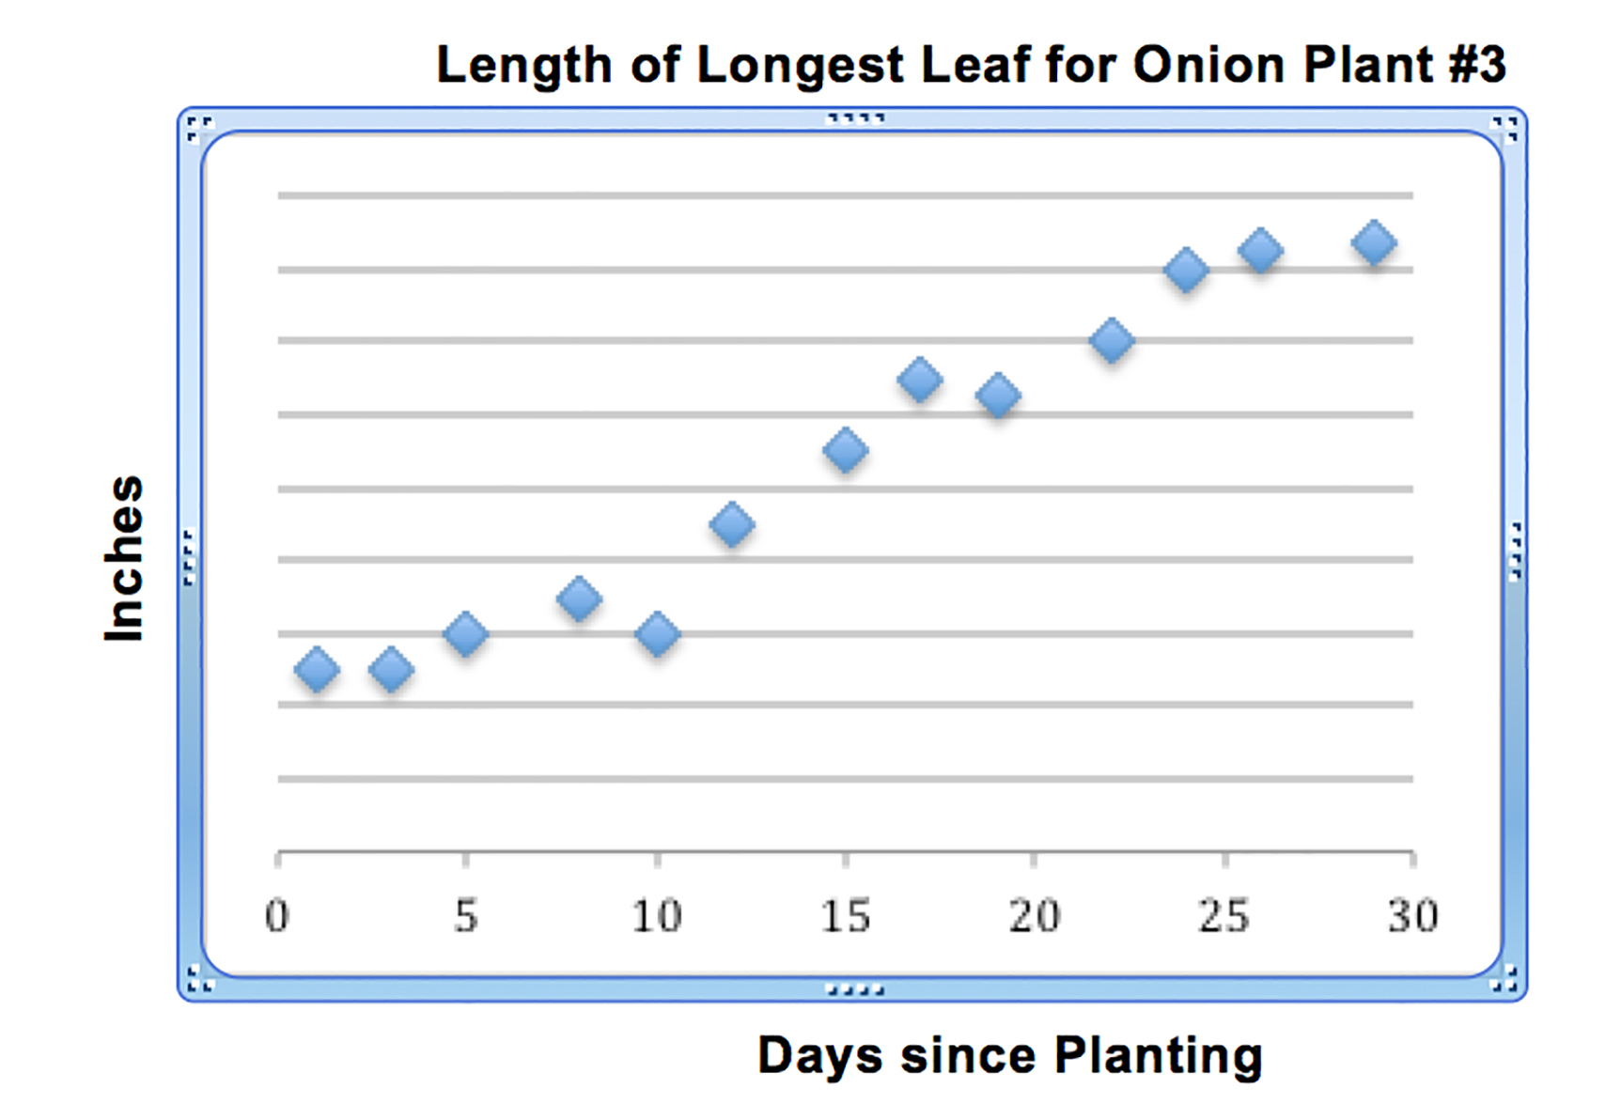
If the students want to draw a line on their graph to reveal patterns in plant growth, they should:
a. Draw a straight line between each of the data points
b. Draw a straight line from the data point on day 1 to the data point on day 30
c. Draw a smooth curved line to fit as many of the data points as possible
d. Draw a curved line that touches each of the data points

5. The data point for day 10 in the graph above is lower than expected. What is the most likely reason for that? (Refer to the graph.)
a. The students forgot to water the plants
b. The leaf shrunk a little naturally
c. The students made a measurement error
d. The lighting system was accidentally turned off

What’s the  Big Idea? | The most valuable commodity to a farmer is not good seeds or fertilizer. It is information about how the crops are doing, and the environment where they are growing. Without information the farmer is powerless to provide what the crops need to survive. The diagram at left shows how the farmer can change the process of growing plants by examining the output for signs of what the plants may need, and changing the input accordingly. Monitoring and changing the system in this way is called feedback.
Feedback involves monitoring the output of a process, and adjusting the input so that the entire system accomplishes a goal.

When you are monitoring your hydroponic system, what information are you collecting?

How will that information help to change the input to your hydroponic system?

See if you can think of one other situation in life where feedback is used.

