Name_______________________ Date______

Engineer an Ebb and Flow System
Big Idea: Systems have parts that work together to achieve desired results.

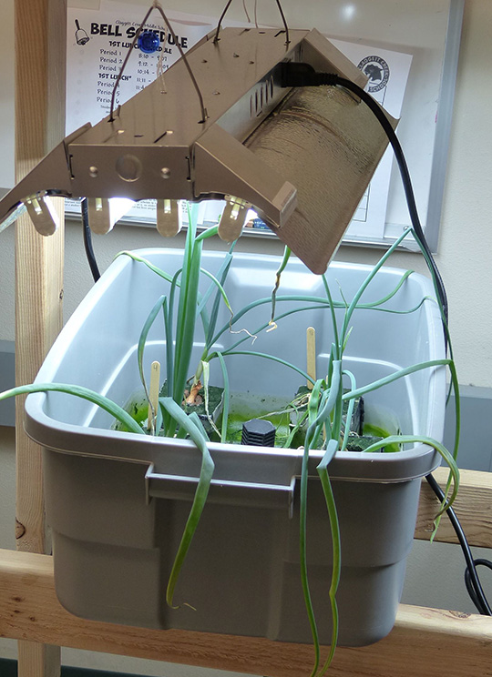  Image Courtesy of Cary Sneider | 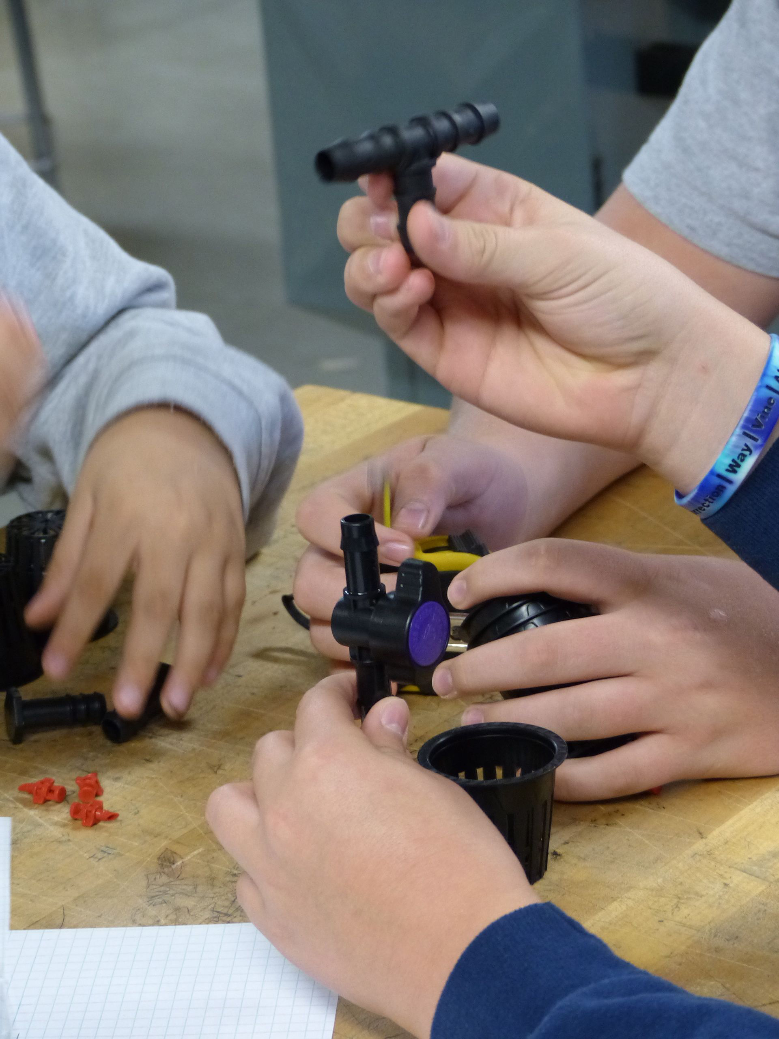  Image Courtesy of Cary Sneider

Like cars, airplanes and houses, hydroponic systems are made of many parts that do very little on their own, but accomplish something quite remarkable when assembled and properly maintained. They can be used to grow food! The system that you have been assigned to build works by spraying the roots of plants with a nutrient solution—water with dissolved minerals that plants need to survive.
When you finish this KSB you will be able to answer the following questions:
- What is a system?
- How does an Ebb and Flow system function?
- What are the inputs, outputs, and goals of an Ebb and Flow system?
A. Introducing the Ebb and Flow System
Hydroponics is a way to grow food that uses less land and much less fresh water than soil farming. As a member of our engineering department at Fresh Food Engineers you will learn to design, build, and maintain an Ebb and Flow system.
In the ebb and flow system bulbs or seeds are placed in Rockwool cubes. Rockwool retains water and supports the plants as they grow.
A pump is submerged in the nutrient solution. It is controlled by a timer so that it turns on and off every few minutes. When the pump is on it floods the growing chamber. An overflow fitting is placed so the plants are not covered by the nutrient solution—just their roots. When the pump is turned off the nutrient solution drains back into the reservoir.
Your challenge is to design and build an ebb and flow system that will:
a) Support the plants so they do not fall over.
b) Provide the nutrients that the plant needs for growth.
c) Have no leaks.
d) Use the materials that are provided, as shown on the next page.

Work together as a team to make decisions and accomplish these tasks. But everyone on the team must create their own drawings and answer all questions.

Points to Ponder: What Is a System?
The idea of a system is very important in engineering. You can’t design, build, or fix anything at all complex without understanding it as a system.

A system is a group of related parts that move or work together to accomplish a desired result.

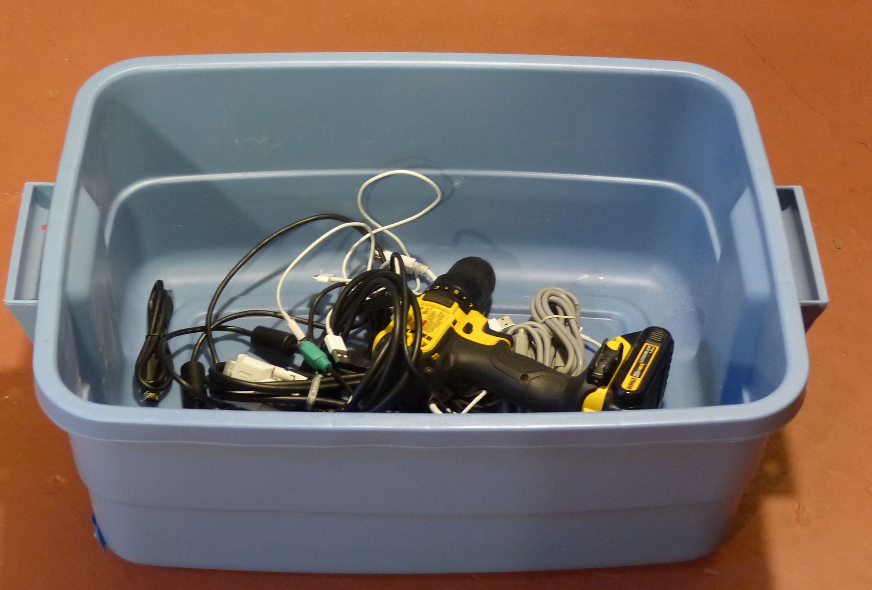  Cary Sneider  Is the image above a system? Yes___ No___  Is the image at right a system? Yes___ No___  How do you know? | 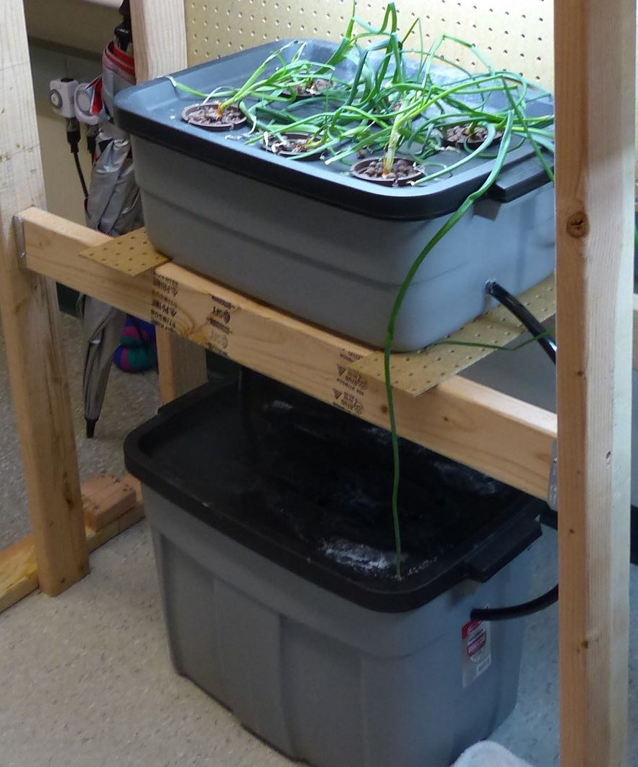  Steve Haner
_____________________________________________________________________

Systems have goals (the desired result), resources (such as the materials that go into the system and the energy sources used), processes (events that go on inside the system) and outputs (the actual result). For hydroponic systems, the goal is to grow plants, and the resources include light, air, and nutrients.
What is the goal of the ebb and flow system on the previous page?

Systems also have subsystems, which are smaller systems made from related parts. The goals of subsystems contribute to the goal of the larger system.
What are two of the main subsystems of the ebb and flow system?
The __________________________ and the ___________________________

B. Tools and Supplies
- Check to see if you have all of these supplies. (Tools are not shown in this list.)
- Put a checkmark next to the name of each item as you identify it.
- If you are missing anything ask your teacher about it.

Item | Quantity | Size | Item Description | Image
Flood Tray | 1 | 10 gallon | 10 Gallon Tote (or equivalent)  -Used as Growing Chamber for Ebb & Flow | 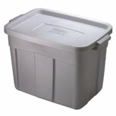
Reservoir | 1 | 18 gallon | 18 Gallon Tote (or equivalent)  -Used to contain nutrient solution, pump and (for E&F) air brick.
Power strip | 1 | 115V 6 outlet | 6 Outlet Power Strip (or equivalent) | 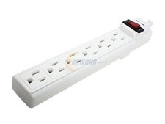
Water Pump | 1 | 115V  250 g/h | Active Aqua  250 Gallons Per Hour | 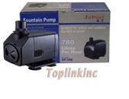
Aquarium Pump and air stone | 1 | 115V | Airpump 3.2 L | 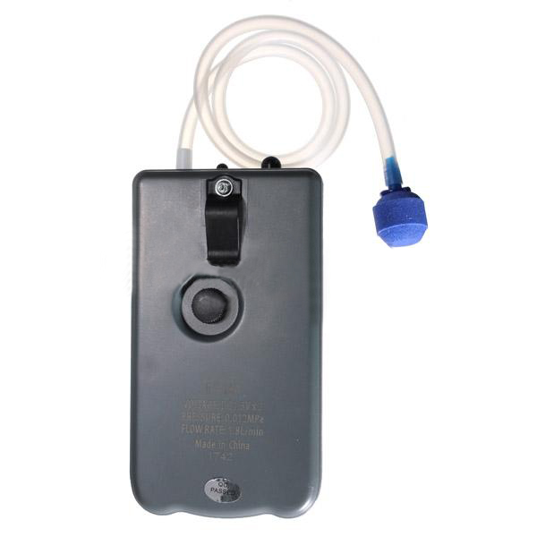
1/2" Black Tubing | 1 | 1/2"x 25 ft | 1/2" Inside Diameter Black Tubing | 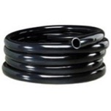
1/2" Bulkhead Barbed Fitting | 2 | 1/2" | 1/2" Bulkhead Barbed Fitting | 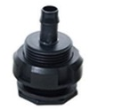
Bulkhead Screen Fitting | 1 | 1/2" | Bulkhead Screen Fitting | 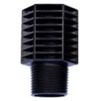
Bulkhead Screen Fitting Extender | 1 | 1/2" | Bulkhead Screen Fitting Extender | 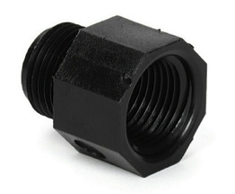
Rubber Gromet | 1 | 0.625” | Use to avoid leaks at the bottom of the growing chamber | 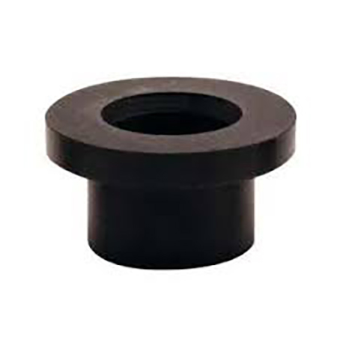
Rockwool Cubes | 1 | 3" | Rockwool cubes  3"x3"x2.5" 8-pack | 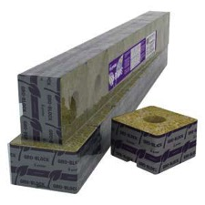
Grow-lights | 1 | 115V | T5 Grow Light 2ft bulbs 6500k | 
Analog Timer | 1 | 115V | 24hr grounded timer for light | 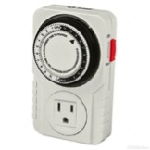
Analog Timer | 1 | 115V | 15 minute grounded timer for pump

C. Step 1 Ensure the Growing Chamber Drains
Place the growing chamber and reservoir on the platform you designed.
You will need to make sure that the nutrient solution drains completely into the reservoir when the pump turns off. That will ensure the roots do not rot and algae does not build up inside the growing chamber. So, your first task is to figure out how to arrange the tray so that happens. This could be done with wedges of wood or a simple framework that might be adjustable. Your teacher will advise you on what materials you can use.
Discuss this problem with your teammates. Below sketch at least two ideas for how to ensure the growing chamber drains completely—and be able to adjust it if necessary.

1st Draining Design | 2nd Draining Design

Work with your teammates to decide on the simplest way to ensure the growing chamber will drain. Show your group’s decision to the teacher. When you have the teacher’s permission, go ahead and set up the growing chamber as you planned.

D. Step 2 Design the System
Look at the diagram of the hydroponic system on page 2. Notice how the two parts of the system are connected.
On a separate sheet of paper, sketch the side view and front view showing the tubes that run between and inside of the two parts of your hydroponic system. When you are satisfied with your design, draw the tubes on each of the two diagrams below
On the diagram show the dimensions, in inches, for the length of each tube. Add a certain amount to the length to allow for the tee fittings.

Side View of Ebb & Flow System | End View of Ebb & Flow System

A hole in the bottom of the growing chamber for the drain will need a bulkhead barbed fitting in a rubber gromet, so the tub does not leak. Show these in your drawings.
You will also need a hole in the side of the reservoir for the power cord, and another for the air stone. Show where they will be located.
When you are finished, show the teacher your sketches. When your teacher approves your design, you can start building.

Add the fittings to your drawing. The Bulkhead Screen Fitting and Extender acts as an overflow to keep the solution from flowing over the walls of the tote.
E. Step 3 Build and Test the System
Safety Note: Before you start building be sure you are familiar with all of the safety rules your teacher has provide for the use of tools.

Measure and cut the lengths of the ½” tubing you will need.
If you have difficulty slipping a tube over the outlet of the pump, use the hot glue gun nozzle to gently warm the end of the tubing to make it soft. Safety Note: Do not touch the nozzle of the glue gun or the heated end of the tubing!
To determine the drill size that you will need to drill the two holes at the bottom of the growing chamber, measure the diameter of the threaded section of the Bulkhead Barbed Fitting (the part that passes through the bottom of the Growing Tray and connects to the tubes.) Record that diameter here: ______  Find the hole saw (or step drill) that is same size as the above dimension or very slightly larger. |  | 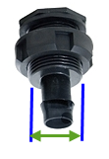
 | Assemble the entire system. Then pour about three to four gallons of water into the reservoir and test it as shown below. Check to see if there are any leaks. If there are, pour the water out, and re-seal the fittings using silicon calk or a hot glue gun.
Once all leaks are fixed plug in the pump and observe to see if it floods the growing tray. Flood until the water reaches the overflow and starts to flow out.
Turn off the pump and observe how long it takes for all of the water to drain out of the growing chamber.
If you encounter any problems, pour out the water, dry the components and re-engineer as needed.

Explain the Ebb and Flow System
A member of your class is sick and missed the lessons on setting up the Ebb and Flow system. Your teacher has asked you to draw a diagram and explanation for how the Ebb and Flow system works, so the student who has been sick can catch up with the rest of the class.
In the space below, draw a diagram of an Ebb and Flow system. The diagram should include labels for the: reservoir, growing chamber, Rockwool®, pump, and all of the tubing. Use arrows to show which way the nutrient solution flows through the system..
Diagram

In a few sentences explain how the Ebb and Flow system operates.
Explanation

How Long Will It Take To Reach Overflow?
Timing is very important in the ebb & flow system. The pump must be left on long enough to at least reach the top of the overflow. The following will help you calculate how long that will be.
1. Measure the height of the overflow (Bulkhead Screen Fitting with extender) that will stand above the bottom of the growing chamber after it is filled. Write the height here in inches.
Height of Overflow (H) = ___________ inches
2. Measure the length and width of the inside of the growing chamber.
Width (W) = ____________ inches Length (L) = ______________ inches

3. Calculate the approximate volume of nutrient solution when the growing chamber floods to the top of the overflow.

Volume (V) = L x W x H

V = _________inches x ________inches x ________ inches = ________ cubic inches

4. How many gallons is that? 1 gallon = 231 cubic inches

V (in gallons) = Volume in cubic inches = _________ Volume in gallons
231

5. If the nutrient solution is pumped into the growing chamber at the rate of 4 gallons per minute, about how many minutes will it take for the level of nutrient solution to reach the overflow? _______________ minutes.

The length of time that the pump is on must be at least that long.

What’s the  Big Idea?  The most important thing to keep in mind is that your hydroponic system is not just a collection of parts. It is a system in which all the parts work together to achieve desired results. Changing one part of the system will affect all the other parts of the system. | 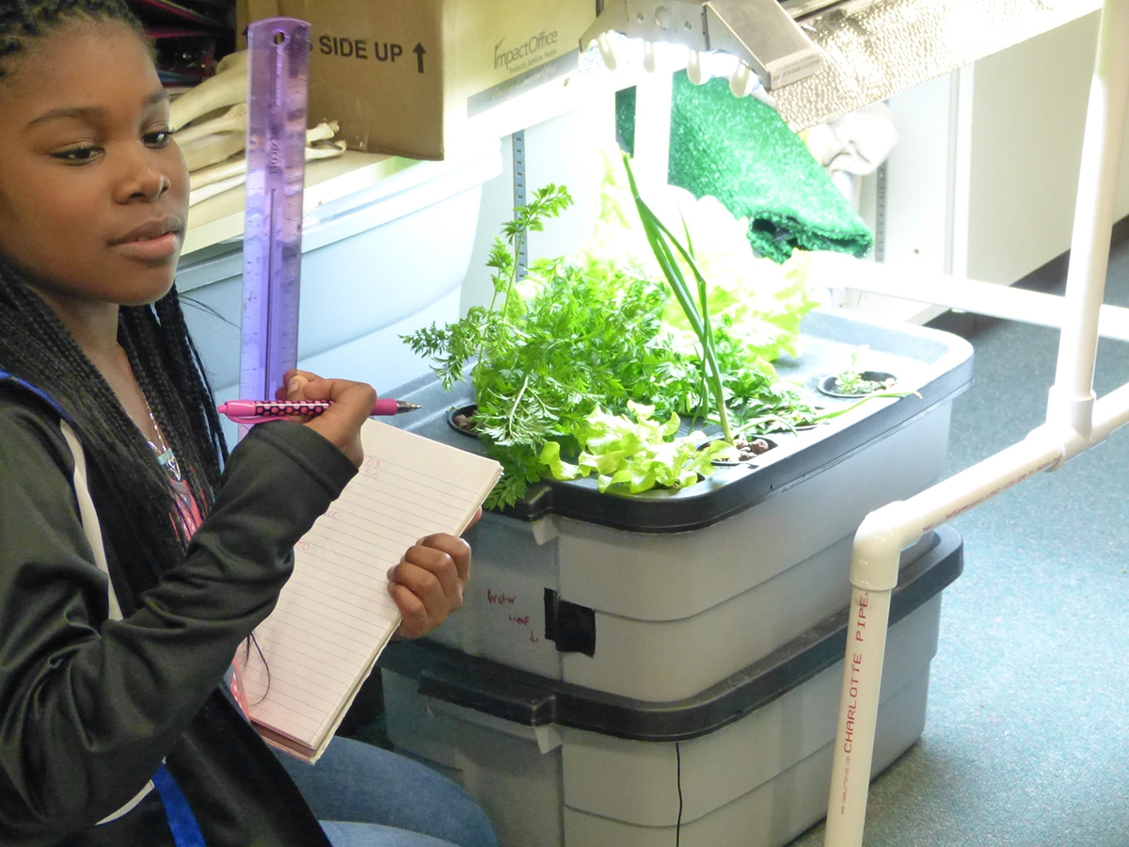  Courtesy of Korbin Shoemaker
The following sentence frames are intended to help you think about your system. Fill in the blanks with your ideas. (Connections do not have to be physically connected.)

Name 8 parts of the Ebb and Flow System:
1.________________ 2.________________3._______________4._____________
5.________________ 6.________________7._______________8._____________
What will happen if one of these parts breaks down?

Name a different hydroponic system and three or four of its parts.

What a complicated system in nature? What makes it complicated?

What is a complicated system created by an engineer? What makes it complicated?

