Name_______________________ Date______

Engineer an Aeroponics System
Big Idea: Systems have parts that work together to achieve desired results.

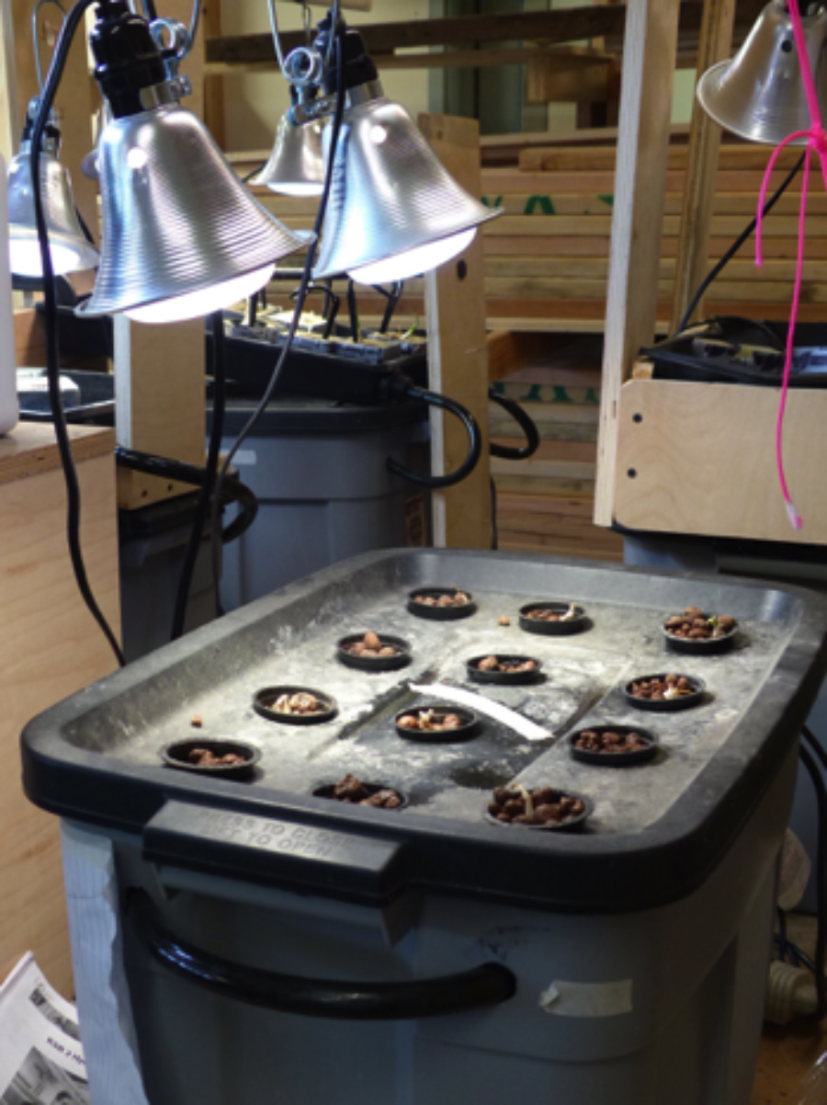  Image Courtesy of Cary Sneider | 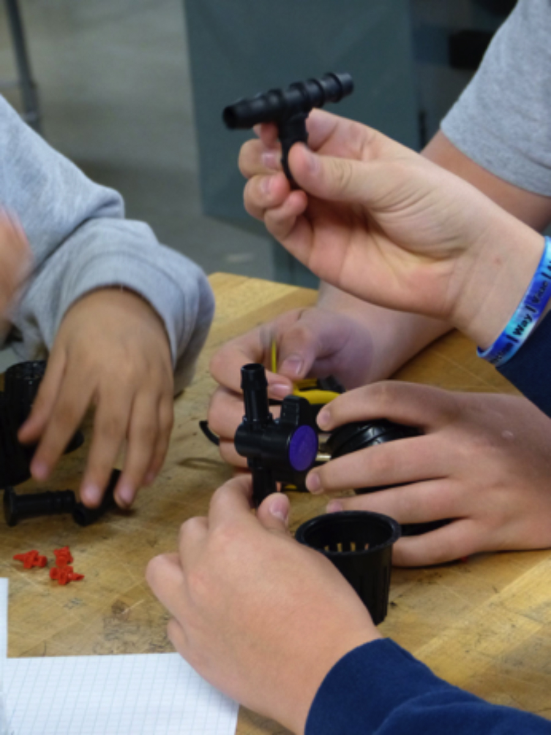  Image Courtesy of Cary Sneider

Like cars, airplanes and houses, hydroponic systems are made of many parts that do very little on their own, but accomplish something quite remarkable when assembled and properly maintained. They can be used to grow food! The system that you have been assigned to build works by spraying the roots of plants with a nutrient solution—water with dissolved minerals that plants need to survive.
When you finish this KSB you will be able to answer the following questions:
- What is a system?
- How does an aeroponics system function?
- What are the inputs, outputs, and goals of an aeroponics system?

A. Introducing the Aeroponic System
Hydroponics is a way to grow food that uses less land and much less fresh water than soil farming. As a member of our engineering department at Fresh Food Engineers you will learn to design, build, and maintain an aeroponic system.
In the aeroponic system the roots hang in the air and are misted with water that includes a solution of nutrients. The mist is created by a series of small nozzles. These are supplied with nutrient solution that is pumped from the reservoir.
The pump is submerged in the nutrient solution. It is controlled by a timer so that it turns on and off every few minutes. If the roots are sprayed constantly they will rot. If they are allowed to dry out the plant will die.

Your team will design and build an aeroponic system that will:
a) Support the plants so they do not fall over.
b) Provide the nutrients that the plant needs for growth.
c) Have no leaks.
d) Use the materials that are provided, as shown on the next page.

Work together as a team to make decisions and accomplish these tasks. But everyone on the team must create their own drawings and answer all questions.

Points to Ponder: What Is a System?
The idea of a system is very important in engineering. You can’t design, build, or fix anything at all complex without understanding it as a system.

A system is a group of related parts that move or work together to accomplish a desired result.

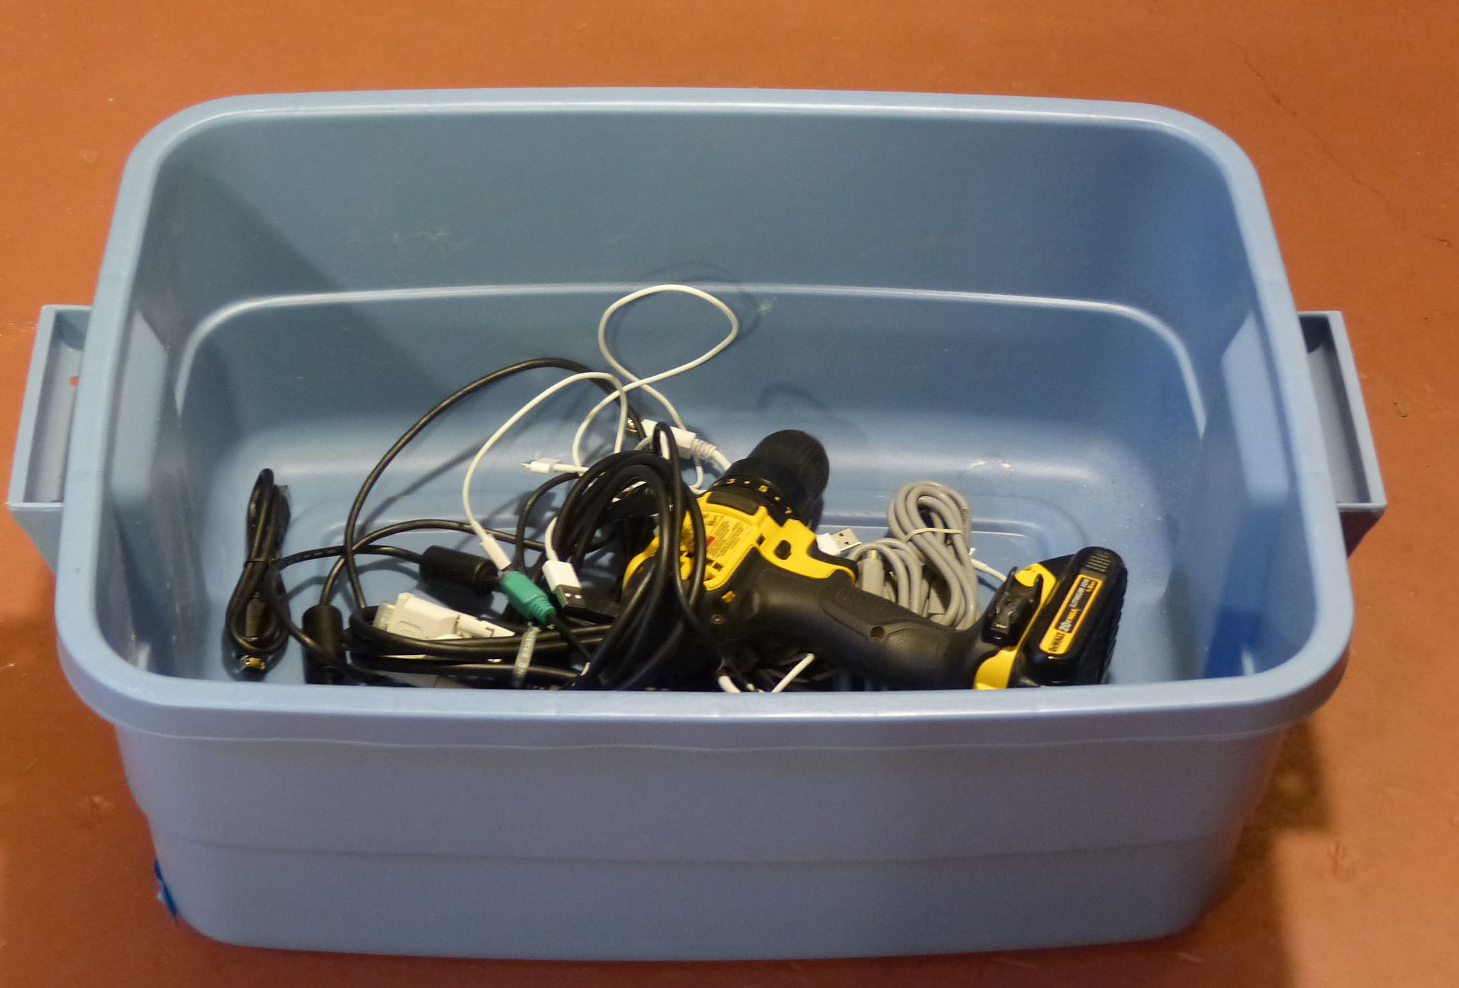  Cary Sneider  Is the image above a system? Yes___ No___  Is the image at right a system? Yes___ No___  How do you know? | 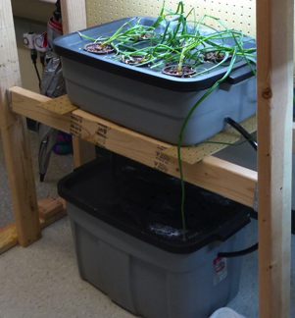  Stephen Haner
_____________________________________________________________________

Systems have goals (the desired result), resources (such as the materials that go into the system and the energy sources used), processes (events that go on inside the system) and outputs (the actual result). For hydroponic systems, the goal is to grow plants, and the resources include light, air, and nutrients.
What is the goal of the aeroponics system on the previous page?

Systems also have subsystems, which are smaller systems made from related parts. The goals of subsystems contribute to the goal of the larger system.
What are two of the main subsystems of the aeroponics system?
The __________________________ and the ___________________________
B. Tools and Supplies
- Check to see if you have all of these supplies. (Tools are not shown in this list.)
- Put a checkmark next to the name of each item as you identify it.
- If you are missing anything ask your teacher about it.

Item | Quantity | Size | Item Description | Image
Growing Tray | 1 | 10 gallon | 10 Gallon Tote (or equivalent) | 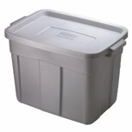
Reservoir | 1 | 18 gallon | 18 Gallon Tote (or equivalent)
Power strip | 1 | 115V 6 outlet | 6 Outlet Power Strip (or equivalent) | 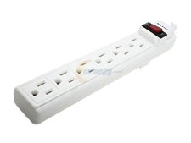
Aquarium Pump | 1 | 115V  250 g/h | Active Aqua  250 Gallons Per Hour | 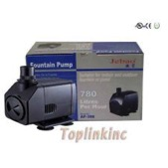
1/2" Black Tubing | 1 | 1/2"x 25 ft | 1/2" Inside Diameter Black Tubing | 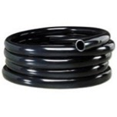
1/2" Stopper | 2 | 1/2" | 1/2" Stopper | 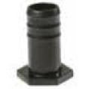
1/2" Bulkhead Barbed Fitting | 1 | 1/2" | 1/2" Bulkhead Barbed Fitting | 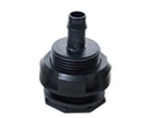
1/2" Barbed Elbow | 2 | 1/2" | 1/2" Barbed Elbow | 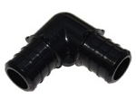
1/2" Barbed Tee | 2 | 1/2" | 1/2" Barbed Tee | 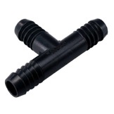
1/2" Barbed Shut-off valve | 1 | 1/2" | 1/2" Barbed Shut-off valve | 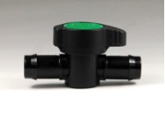
Rubber Gromet | 1 | 0.625” | Use to avoid leaks at the bottom of the growing chamber | 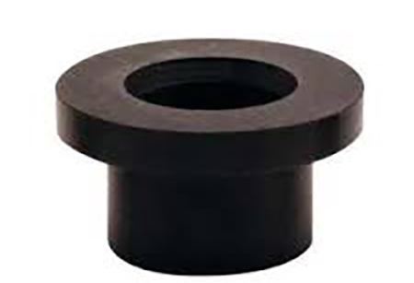
Misting Nozzles | 8 | SMALL | EZ Clone 360 Vertical Spray Misting Nozzles | 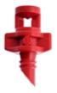
Net Cups | 8 | 2" | 2" Net Cups | 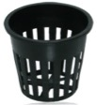
Sheet Plexiglas | 1 (share) | 16” x 24” | To test aeroponics spray pattern
LED or Fluorescent Growlight | 1 | 115V  45 W LED  or 75W CFL | LED Growlight or  T5 Grow Light 2 or 4 bulbs, 2 ft. long 6500k | 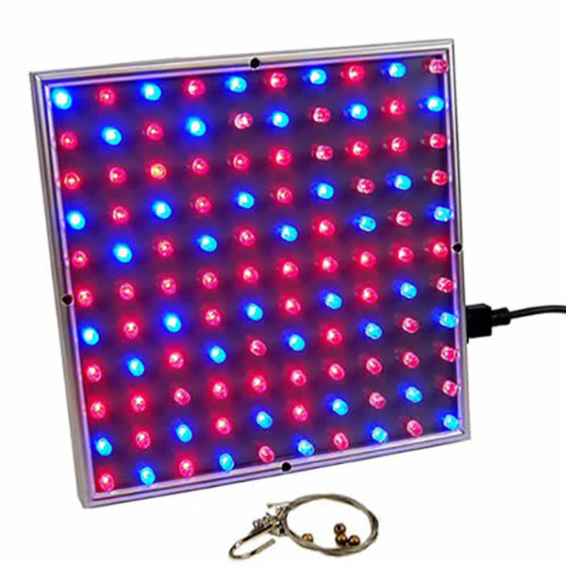
Analog Timer | 1 | 115V | 24hr grounded timer for light | 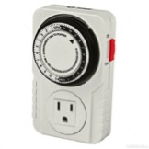
Analog Timer | 1 | 115V | 15 minute grounded timer for pump
Marking Pen | 1 |  | Permanent marker to mark location of holes to be drilled | 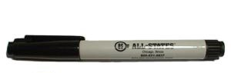
C. Step 1 Plan Location of Holes for Net Cups
The lid of the 10-gallon tote serves as the plant carrier in this hydroponic system, since it holds the eight net cups that support the growing plants. The plants need to be located as far away from each other and from the sides of the tote as possible, so the roots have the maximum space to be watered by the mister nozzles.
1. Measure the length and width of the part of the lid that will be inside the growing cell. Also measure the maximum diameter of the net cups.
2. Research the maximum width of the mature plant you are planning to grow. Then, draw a sketch of the lid below, and indicate on the sketch how far the eight cups should be from each other and from the sides of the lid so they will be spaced as widely as possible.

3. Use a measuring tape or ruler and marking pen to locate the center of each hole on the lid.
4. Show your work to your teacher, in order to receive approval to drill the holes with a 2” hole cutter.
D. Step 2 Design the System

The roots of the plants receive their food through a fine mist spray. Your team has eight misting nozzles in the kit of parts.

Although you do not have to use all eight, the nozzles that are used must be arranged inside the reservoir tub so that ALL plants receive a spray of nutrient from the nozzles.

The illustration at the right shows how to connect the pump to a shut-off valve and a mister nozzle.

Your job is to design an arrangement of tubes, ½” elbows, Ttee joints, and mister nozzles so that all of the plants will be sprayed equally. Two possible arrangements are shown at right.

In the boxes below, sketch your design for the design mister array, showing a top view and side view. Write the length of each tube on both sketches.

Top View of Mister Array | Side View of Mister Array
Look at the diagram of the hydroponic system on page 2. Notice how the two parts of the system are connected.
On a separate sheet of paper, sketch the side view and front view showing the tubes that run between and inside the two parts of your hydroponic system. When you are satisfied with your design, draw the tubes on each of the two diagrams below
On the diagrams, show the dimension, in inches, for the length of each tube. Add a certain amount to the length to allow for the tee fittings.
Show where you will insert a shutoff valve to adjust the flow. If the shutoff valve is between the reservoir and growing chamber it will be easy to adjust the flow.

Side View of Aeroponic System | End View of Aeroponic System

A hole in the bottom of the growing chamber for the drain will need a bulkhead barbed fitting in a rubber grommet, so the tub does not leak. Show these in your drawings.
You will also need a hole in the side of the reservoir for the power cord. Show where it will be located.
When you are finished, show the teacher your sketches. When your teacher approves your design, you can start building.
E. Step 3 Build and Test the Mister Array
Safety Note: Before you start building, be sure you are familiar with all of the safety rules your teacher has provide for the use of tools.

Measure and cut the lengths of the ½” inside diameter tubing you will need, and assemble the mister array. If you have difficulty slipping a tube over the outlet of the pump, use the hot glue gun nozzle to gently warm the end of the tubing to make it soft. Safety Note: Do not touch the nozzle of the glue gun or the heated end of the tubing!

When drilling holes in the ½” tubing for the nozzles, place the tube in a vise and use a portable drill with a 1/16” twist drill to make a hole for each nozzle. Insert a stopper into the end of the tube.
To determine the twist drill size that you will need to drill the two holes at the bottom of the growing chamber, measure the diameter of the threaded section of the bulkhead barbed fitting (the part that passes through the bottom of the growing tray and connects to the tubes.) Record that diameter here: ______  Find the hole saw (or step drill) that is same size as the above dimension or very slightly larger. | 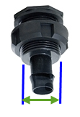
Assemble the entire system. Then pour about three to four gallons of water into the reservoir and test it as shown below. Check to see if there are any leaks. If there are, pour the water out, and re-seal the fittings using silicon caulk or hot glue gun.
Test the mister array by removing the lid from the growing chamber and replacing it with a sheet of clear plastic over the top. Trace the position of the net cups with a marker to see where the plants will be.
Plug in the pump and slowly open the shutoff valve until the misters spray all of the net cup locations marked on the clear plastic sheet. If the system leaks, or some plants do not receive the nutrient spray (water in this test), then re-engineer the system until all plants receive an equal spray.
Check Your Understanding: Aeroponics
A member of your class is sick and missed the lessons on setting up the aeroponic system. Your teacher has asked you to draw a diagram and explanation for how the aeroponics system works, so the student who has been sick can catch up with the rest of the class.
In the space below, draw a diagram of an aeroponics system. The diagram should include labels for the reservoir, growing chamber, mister nozzles, net cups, pump, and all of the tubing. Use arrows to show which way the nutrient solution, water and materials flow through the system.
Diagram

In a few sentences explain how the aeroponics system operates.
Explanation

Will the Growing Chamber be Dark?
Removing more than 60% of the lid will allow light to leak through and may damage the roots. Perform the following calculation to find out what percent of the lid is removed by drilling holes.

1. Calculate the area of the circles you will be cutting out. (The formula for the area of one circle is below. In the formula, “r” is the radius of the circle (equal to ½ of the diameter); and π = 3.14.)
Area of Circle = π r² ₌ 3.14 x r²

2. Calculate the area of the lid that will cover the inside of the growing chamber.
Area of Lid = Length x Width

3. Divide the area of all of the circles by the area of the lid to find the percentage that must be removed by drilling circles. Area of circle
Area of lid = _________ X 100
Show all of your calculations below.

The percentage of the lid that is removed by drilling is _____ %
Will the lid be strong enough? (less than 60% removed) YES? ___ NO?___

What’s the  Big Idea?  The most important thing to keep in mind is that your hydroponic system is not just a collection of parts. It is a system in which all the parts work together to achieve desired results. Changing one part of the system will affect all the other parts of the system. | 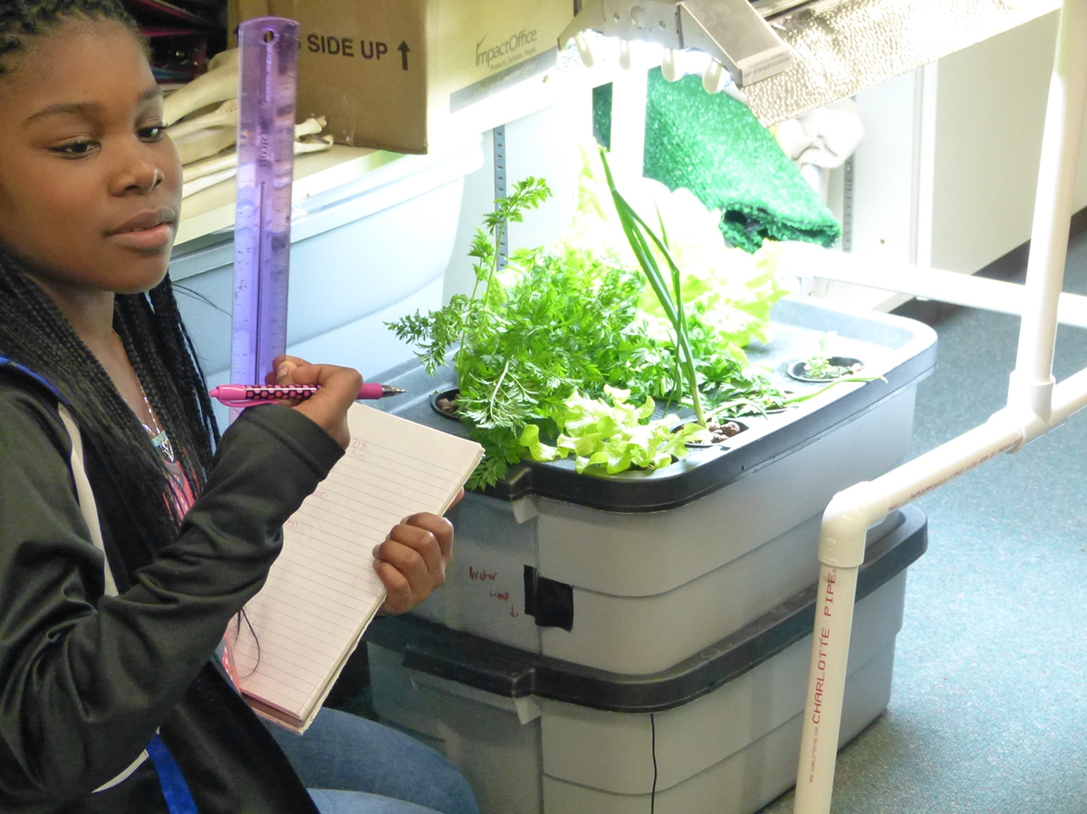  Courtesy of Korbin Shoemaker
The following sentence frames are intended to help you think about your system. Fill in the blanks with your ideas. (Connections do not have to be physically connected.)

Name 8 parts of the Aeroponics System:
1.________________ 2.________________3._______________4._____________
5.________________ 6.________________7._______________8._____________
What will happen if one of these parts breaks down?

Name a different hydroponic system and three or four of its parts.

What is a complicated system in nature? What makes it Complicated?

What is a complicated system created by an engineer? What makes it complicated?

