Name_______________________ Date______
Welcome to Fresh Food Engineers
Big Idea: Sustaining the supply of food is a great engineering challenge, especially as the world’s population grows.

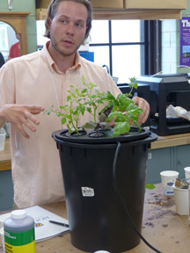  Hydroponics System  Cary Sneider | 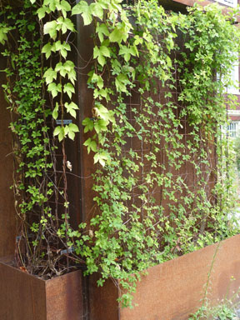  Vertical Farms with Crops Growing on Walls  Cary Sneider

Our new company, Fresh Food Engineers, helps people who live in cities grow their own fresh organic fruits and vegetables. Today we help people construct small hydroponic systems for their apartments. Tomorrow you will help us design and build vertical farms that will cover the walls of buildings with rich crops.
As our newest engineer, your first task is to build your knowledge and skills as an Agricultural Engineer—a person who develops new and improved technologies for growing and processing food. In this KSB you will learn how to grow food without soil, and find out why we think hydroponics is the wave of the future. When you finish this KSB you will be able to answer the following questions:
- What is a “food desert?”
- Why is the world’s supply of fresh, nutritious food at risk?
- What is hydroponics?
- How do hydroponic systems function?
- How could hydroponics help provide fresh food for people in cities?

Food Deserts in the United States
As a new employee of Fresh Food Engineers, it is important that you understand some of the problems that our company hopes to solve. Perhaps the most important of these is known as “food deserts.” |   U.S. department of Agriculture. Public domain
A food desert is a low-income community that is located more than one mile from a source of fresh fruits and vegetables and other healthful foods. Few people who live in these communities have cars, so they are forced to buy food from quickie markets that provide mostly packed foods with long shelf life but fewer nutrients.

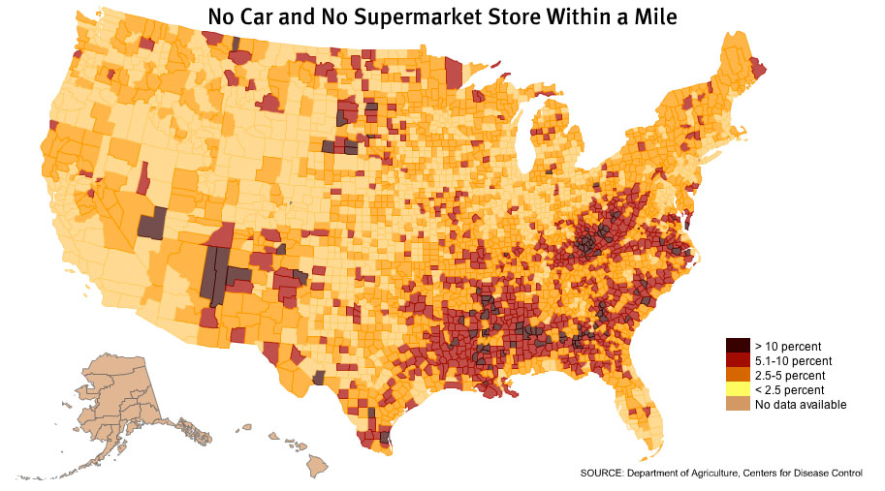 | On the Internet, use a search engine to find the Food Access Research Atlas. This interactive map has been created by the U.S. Department of Agriculture to identify areas where people do not have access to fresh foods available in supermarkets. Use the search tool on this website and search for the city or town where you live. Summarize what you find about food access in your town.

According to the U. S. Department of Agriculture, 23 million people in the United States live in food deserts. The map above shows where these food deserts are located.
Although the problem of food deserts could be solved by building more markets where people can buy fresh food, a more difficult problem looms in the future—being able to produce enough food to feed everyone. Two problems are already becoming evident: having enough land for farms and enough water to grow crops.

Why is the world’s supply of fresh, nutritious food at risk?

An even greater problem than food deserts in a local community is having enough food to feed a growing world population. According to the United Nations, today’s world population of more than 7 billion people is expected to increase to 8 billion in 2025 and more than 9 billion by 2050.  In addition to the problem of having more people to feed, the growing population creates two very difficult problems for agricultural engineers to solve: | 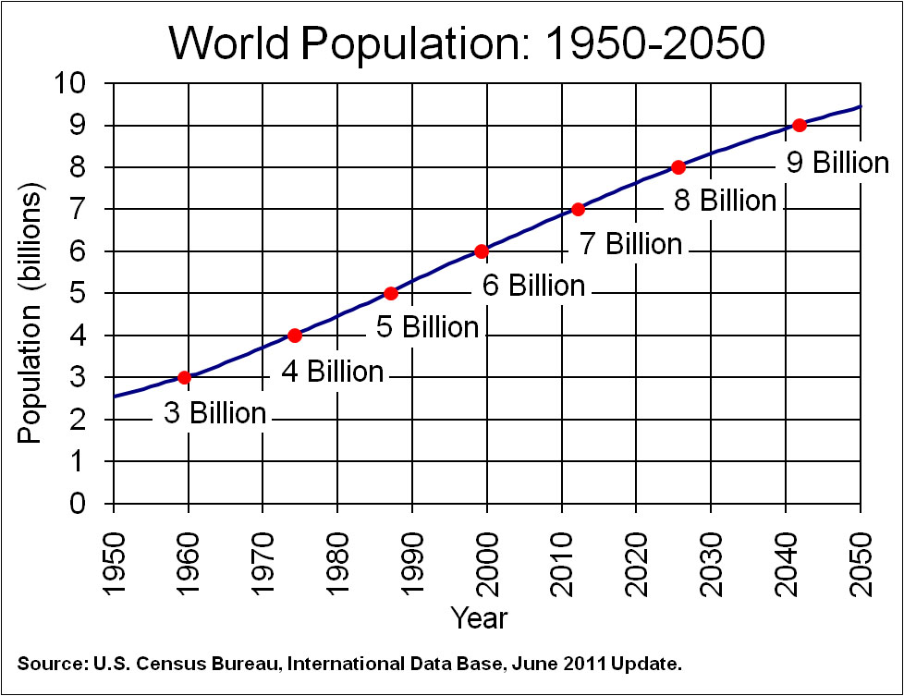

1) Less land for growing food. As the population grows, more people choose to live in cities. As cities grow developers turn farmland into houses, apartments, and businesses. So the amount of land that can be farmed—called arable land—has been shrinking.  2) Less fresh water for growing crops. The burning of coal, oil, and natural gas for electricity may contribute to changes in the climate, so that more areas now receive less rain than before. In order to grow their crops, farmers have diverted water from rivers to fields, creating competition between farms and cities for water. | 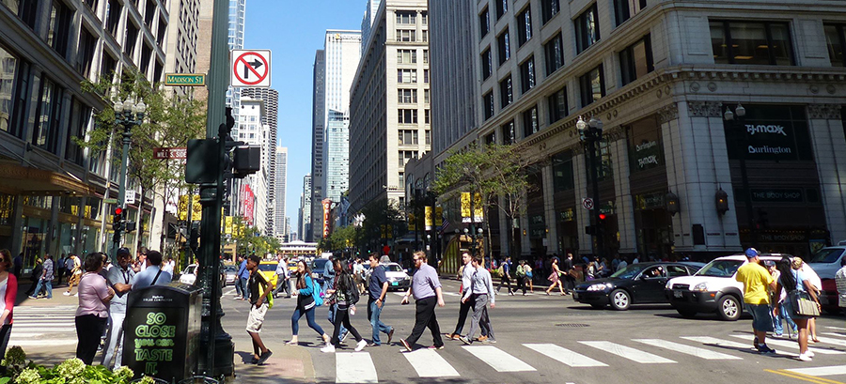  Cary Sneider  Bigger cities means less land for farms
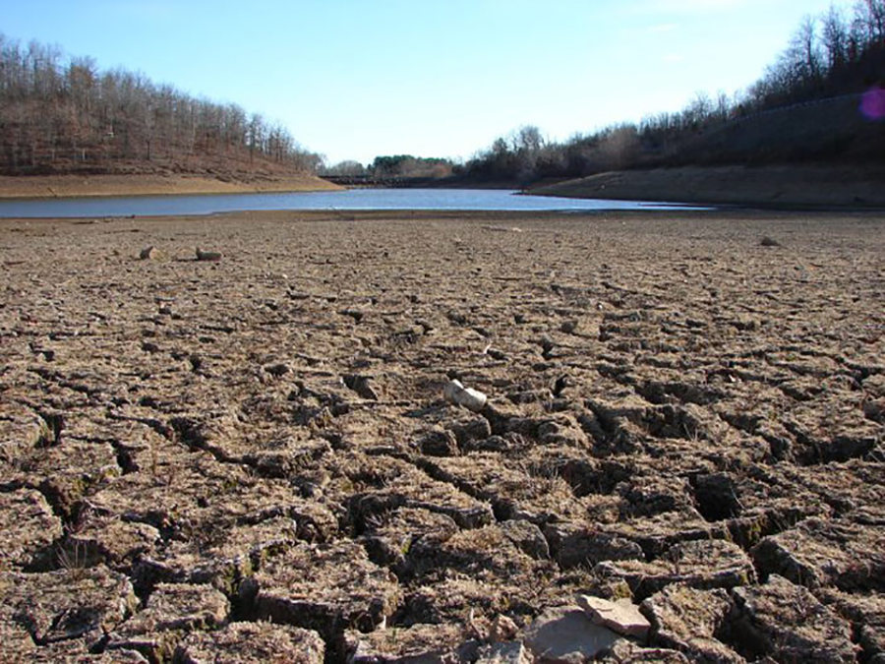
NOAA, Public Domain
More people means less fresh water
In your opinion, what could be done to solve the problem of a growing need for food, despite diminishing supply of both farming land and clean water?

Think Like an Engineer
 | As shown on the previous pages, the need to provide sufficient fresh food for people in cities is a serious problem, especially as the human population continues to grow. A very exciting idea that may help solve this problem is vertical farming—using the vertical space on tall buildings to grow food.
The vertical farm in this image is an entire building in which food is grown on the interior of every floor. The leaders of the Fresh Food Engineers company think that vertical tower farms are too expensive, since land in cities costs a lot, and building such structures may cost millions. Instead, our company is interested in farms that will grow crops on the sides of existing buildings.  Your challenge will be to design a vertical farm on the side of an apartment building. First, however, you will need to learn how to grow food with hydroponics—that is, without soil and by recycling the water over and over. You will also need to learn Computer-Aided Design, or CAD, which was used to create the image at right. |  | 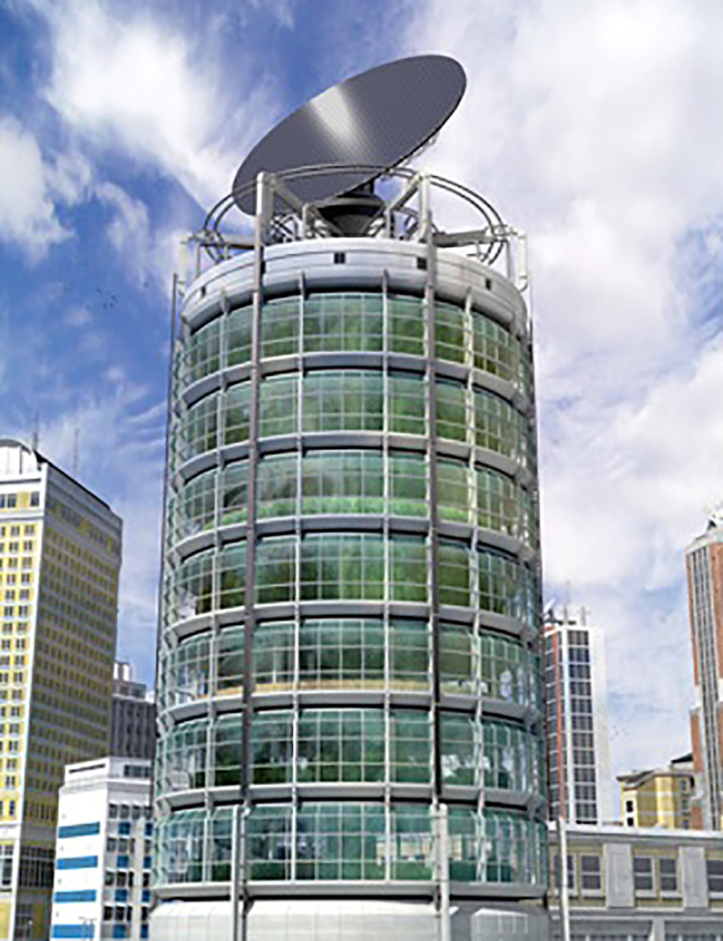  Cjacobs627 at English Wikipedia
First, here are two ideas to help you think like an engineer:
1. Vertical farming is an excellent example of sustainable development and is one way to meet the needs of today without sacrificing the ability to meet the needs of future generations. What are three other example of sustainable development?
1.

2.

3.

What Do Plants Need?
Whatever growing method is used, agricultural engineers must be able to answer the question: What do plants need to grow? Look at the diagram and list three things it shows that plants need to grow.
1___________________________________
2___________________________________
3___________________________________
It may be hard to believe, but the raw material that plants use to build their stems, flowers, roots and leaves does not come from the soil. Plants take in carbon dioxide (CO₂) from the air and water from the ground to create carbohydrates and to release oxygen back to the air. This process is unique to plants, as only they can use the sun energy to split water molecules.

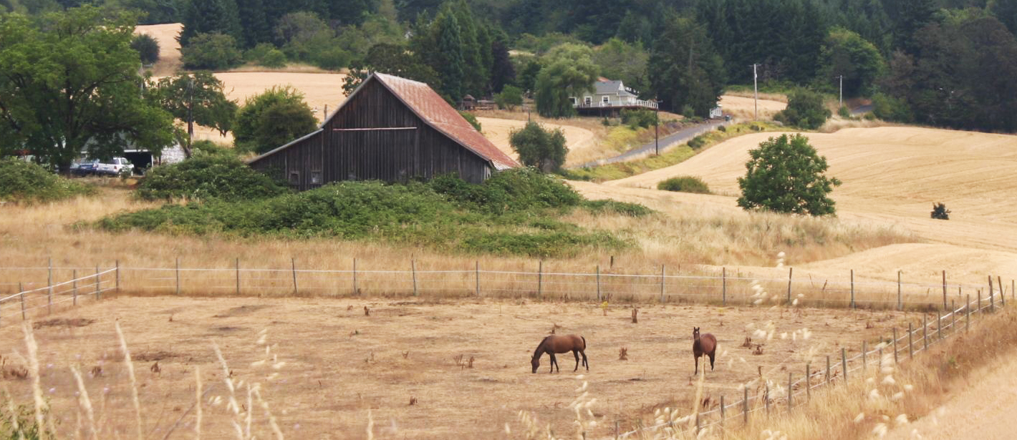
Cary Sneider
The vast majority of our fruits and vegetables come from farms like the one shown above. But soil farming is not the only way to grow food. The diagram on the left shows a plant growing without any soil—just water. What else does it need besides water to grow?

1

2_________________________________________

What Is Hydroponics?
The Greek word hydro means water; and ponos means labor or work. Hydroponics is a method of growing plants in water without soil. The water must be enriched with a few minerals and the plants need some support for their root system.
There are many different hydroponic methods. The image below shows a hydroponic farm in which the plants are watered through a plastic trough under each row of lettuce.
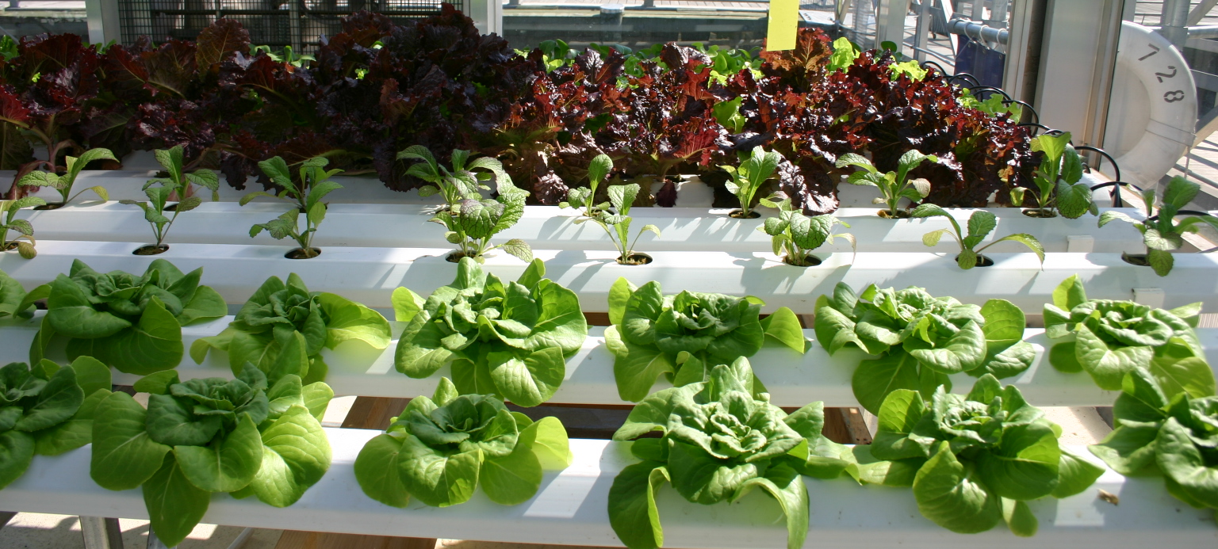

Ryan Somma, Creative Commons
Leafy Green Vegetables in a Hydroponics Farm

Hydroponics is becoming more and more common in countries like Singapore, where there is very little arable land to grow crops.
Why do you think hydroponic farming is becoming more common around the world?

Watch the following video to see how hydroponics is being used in our world today.

[VIDEO LINK INSERT http://opb.pbslearningmedia.org/resource/agd14.pd.steam.green/greenhouse-labs-in-schools/]

Advantages and Disadvantages of Hydroponics
Without additional arable land it is difficult to grow enough food for our growing population. There are many solutions to this problem, including new kinds of crops and fertilizers, and genetically modifying crops that grow faster or produce more edible food. But some agricultural engineers suggest that we find a solution that doesn’t rely on soil at all—hydroponics. In order to be a good hydroponics engineer you need to understand the pros and cons. Here is what some professionals have to say.

Pros
- No soil is needed.
- Fewer pesticides and herbicides are needed.
- Less water is required. No water is wasted because it is recycled.
- Plants grow faster and have bigger yields.
- Some hydroponically produced plants are more nutritious and taste better.
- Gardeners have more control over the nutrient amounts their plants receive.
- Less space is needed. Plants can be closer together than they could in soil. This is because the roots can be close together and event tangled up since they are constantly bathed in nutrients. In soil the plants have to be spaced farther apart so the roots have room to spread out and find nutrients in the soil.

Cons
- Some plants cannot be practically grown using hydroponics, like melons and squash because they take up too much space.
- Hydroponics requires a lot of technical knowledge.
- Hydroponic equipment can be very expensive.
- Crops must be maintained more frequently.
- If the watering system fails, plants will dry out and die rapidly.
- Given the cost of equipment, a farmer may make less money than using soil.
- Some methods require a soil replacement to hold the roots in place.

Deciding Between Soil Farming and Hydroponics
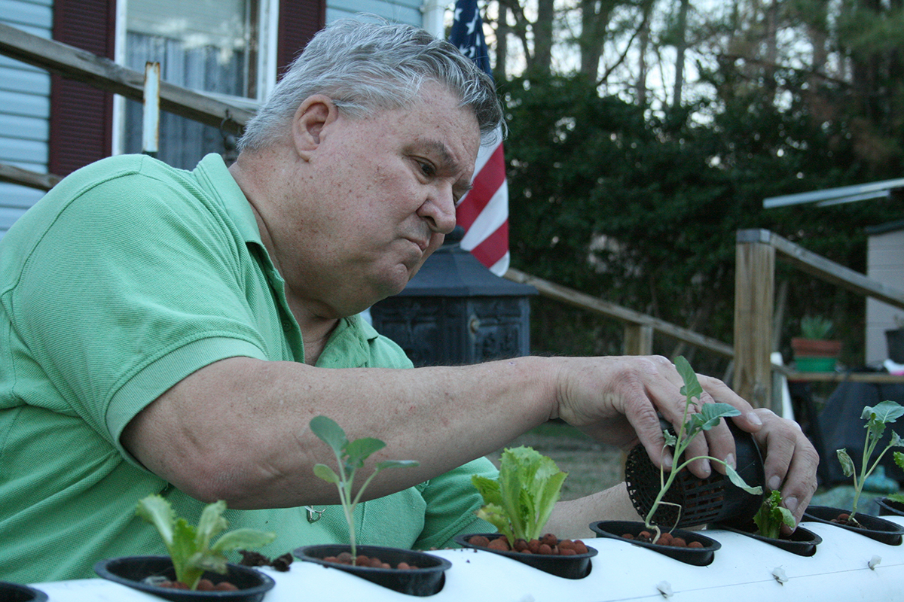  Ildar Sagdejev, Creative Commons  Hydroponics Farming | 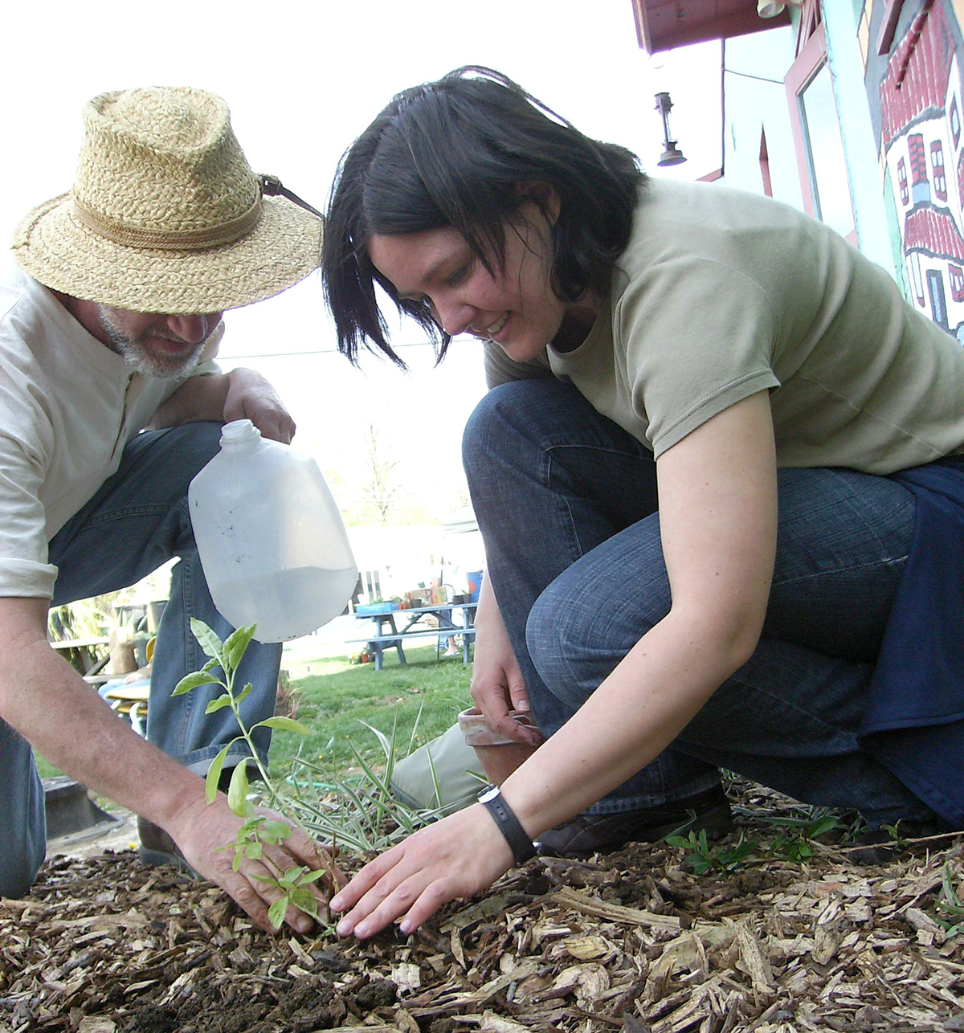  Artaxerxes, Creative Commons  Soil Farming

Although our company specializes in hydroponics, if it is better for our clients to use soil farming, we have a moral obligation to give them that advice. Here are some questions from clients. In each case, what do you recommend?
1. “I just purchased 15 acres of land in Oregon. It rains a lot there. Should I plan to use hydroponics or soil farming?” (Explain your answer.)
2. “I live in a large apartment building in New York City. I would like to grow my own food. Should I plan to use hydroponics or soil farming?” (Explain your answer.)
3. “I teach in a middle school in a small town. I would like my technology students to develop some skills in growing food. I have no idea if they will move to the city or country after graduation. Should I plan to use hydroponics or soil farming?” (Explain your answer.)

How do Hydroponic Systems Function?

We will investigate four types of hydroponic systems: Drip, Ebb and Flow, Nutrient Flow, and Aeroponic.

The Drip System

In the Drip System plants are placed into Rockwool® cubes, which hold moisture very well. If there is an interruption in pumping, the plants will survive for a few hours on their own.

1. Which part pushes the nutrient solution out of the reservoir?_______________
2. Which tube carries the nutrient solution up to the growing chamber?___________
3. Which tube returns the nutrient solution to the reservoir?___________
4. How are the plants held so they don’t fall over? _____________________________

5. Use a search engine to search for “Hydroponic Drip System” on the Internet to see what these systems look like. Try to find the various parts shown above.
The Ebb and Flow System
The Ebb and Flow system pumps nutrient solution up a tube to the growing chamber to saturate the plant’s roots and the cubes that hold them. Then the pump stops and allows the nutrient solution to flow slowly down the same tube and back into the reservoir.

1. How does the nutrient solution flow back into the reservoir? ____________________
2. What do you think the Overflow is for? _____________________________________
3. What role do you think the timer plays? ____________________________________
4. Look up “Hydroponic Ebb and Flow System” on the Internet to see what these systems look like. Try to find the various parts shown above.
5. What is the main difference between the “Drip” and the “Ebb and Flow” systems?
____________________________________________________________________
 | Points to Ponder  Rockwool® is made from Basalt rock and Chalk. These natural materials are melted at 1600° C and blown into a large spinning chamber, which pulls the hot gooey rock into fibers like "cotton candy." The fibers are compressed into a mat, which is then cut into slabs and cubes. (More information is available at http://www.hydroponics.net/learn/rockwool.asp) | 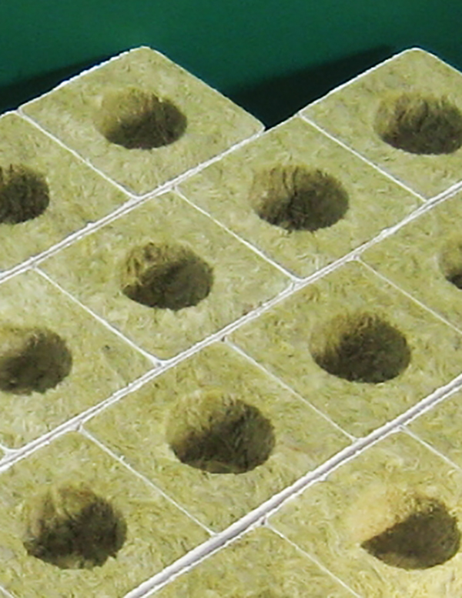  D-Kuru

The Nutrient Flow System
In the Nutrient Flow System, the roots grow on the bottom of the growing chamber while nutrient solution is pumped into one end of the chamber and flows out of the other end of the chamber. Nutrient flow can only be used after the plants have grown roots that are long enough to reach the nutrient solution.

1. How is the Nutrient Flow System similar to the Ebb and Flow System?

__________________________________________________________________

2. How is it different from the Ebb and Flow System?

3. Use a search engine to search for “Hydroponic Nutrient Flow System” on the Internet to see what these systems look like. Try to find the various parts shown above.

 | Points to Ponder  Net cups are plastic containers made especially for hydroponics. Holes in the plastic permit the roots to grow and spread out. Net cups are used in a number of hydroponic systems because they allow the roots to come into direct contact with the nutrient solution. | Net Cups  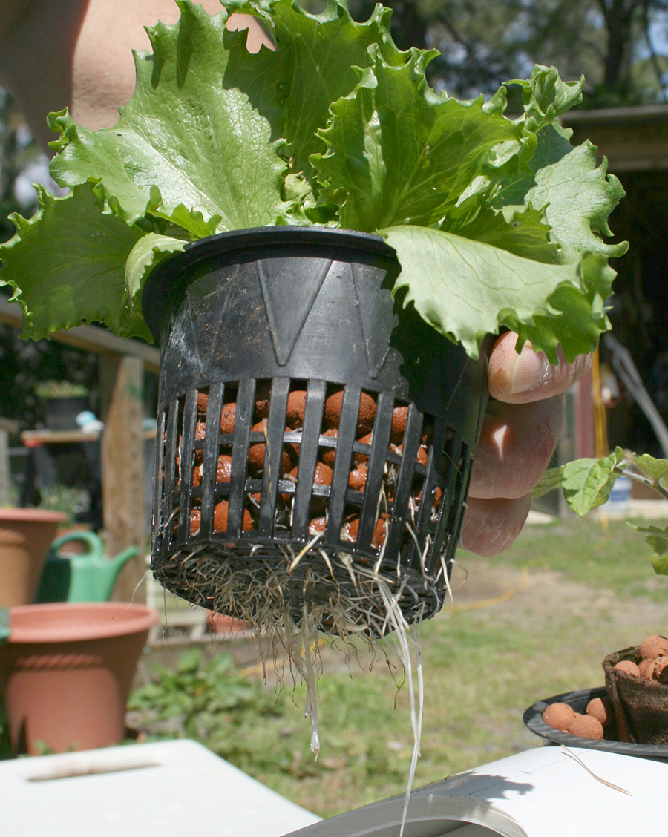  Ildar Sagdejev

The Aeroponic System
The Aeroponic System is quite different from the others, all of which bathe the roots in liquid. In this system the plants’ roots are bathed in a fine mist.

1.Why do you think it is important for the pump in this system to be stronger and provide more pressure than the previous systems?

2. The mister nozzles help to provide not just nutrient solution, but also air. Why might this improve plant growth?
_____________________________________________________________________

_____________________________________________________________________
3. Use a search engine to search for “Hydroponic Aeroponic System” on the Internet to see what these systems look like. Try to find the various parts shown above.
4. Why might an ebb and flow system need an “air stone” and an aeroponics system not need it? What function does the “air stone” serve?

Check Your Understanding

As a means of checking on your progress, do the best you can to answer the following questions.

1. What is a “food desert?”
a. A community where there is no fresh food within 100 miles.
b. A community more than 1 mile from a source of fresh food.
c. A community that does not raise its own food.
d. A l community where people cannot afford hydroponic farms.

2. Why might producing enough food be a major problem in future decades?
a. The world population is growing rapidly.
b. There will be less land suitable for farming.
c. There will be less fresh water.
d. All of the above.

3. What is sustainable development?
a. Sustaining the growth of plants over an extended period of time.
b. Providing sufficient funding for a project so that it can continue to completion.
c. Meeting the needs of today without sacrificing the ability to meet the needs of future generations.
d. Ensuring that development will continue to go on, despite setbacks.

4. Which of the following is not essential for plants to grow?
a. light
b. air
c. soil
d. water

5. Most plants in farms and gardens are grown in soil. Hydroponics is a way of growing plants without soil. Which of the following statements about hydroponics is NOT correct?
a. Hydroponics uses less fresh water than soil farming.
b. Plants grown with hydroponics require only pure water and light.
c. Weeds do not grow in indoor hydroponic systems.
d. Hydroponics requires less space to grow the same amount of food.

6. In which location would soil farming be a more economical choice than hydroponics?
a. A 15-acre farm where it rains often
b. A research center in Antarctica
c. A space station orbiting Earth
d. An apartment in the city

7. A hydroponic system that sprays plant roots from below is called:
a. Ebb and Flow
b. Nutrient Film
c. Aeroponics
d. Drip

8. A hydroponic system that periodically floods and drains plant roots is called:
a. Ebb and Flow
b. Nutrient Film
c. Aeroponics
d. Drip

9. How could hydroponics help provide fresh food for people in cities?

What’s the  Big Idea? | It is important to fully understand the following BIG IDEAS about engineering from this first KSB. Reflect on each one and explain what it means to you. There are no right or wrong answers—it’s your understanding that counts.

Supplying enough food for all people is a great engineering challenge especially as the world’s population grows.

Sustainable development is a way to meet the needs of the present without sacrificing the ability to meet the needs of future generations.

UN, 2012. World Population Prospects: The 2012 Revision. New York: The United Nations. Retrieved from: http://esa.un.org/wpp/
FAO. 2011. The state of the world's land and water resources for food and agriculture (SOLAW) - Managing systems at risk. Food and Agriculture Organization of the United Nations, Rome and Earthscan, London. Retrieved from http://www.fao.org/nr/solaw/main-messages/en/.
http://www.guide2hydroponics.com/about-hydroponics/pros-and-cons.aspx

