ENGINEERING FOR ALL

Vertical Farming:
Fresh Food for Cities

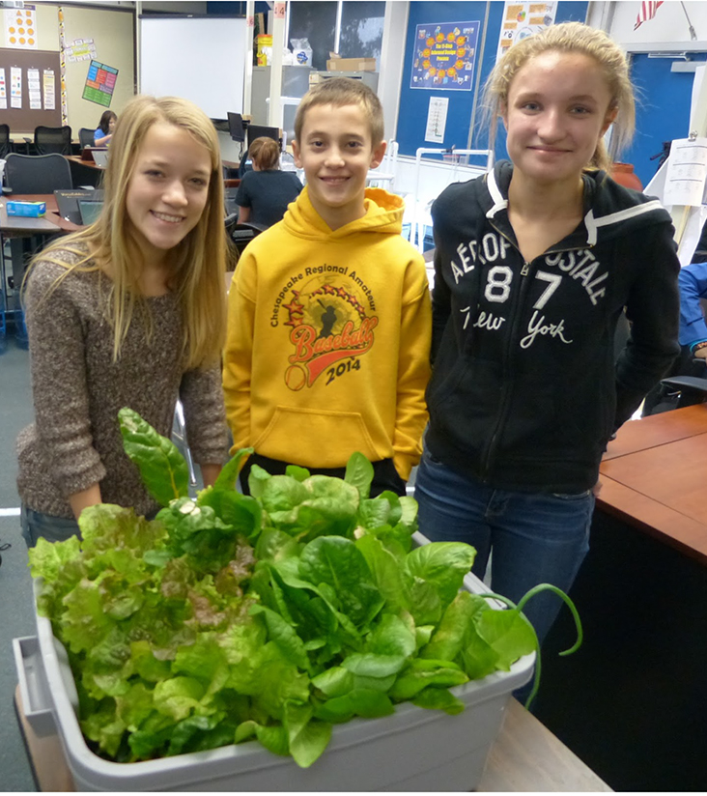
Korbin Shoemaker’s Class, Walkserville Middle School

TEACHER GUIDE

Copyright © 2015 Hofstra University

 | Vertical Farming is a unit of the Engineering for All project, developed by Hofstra University in collaboration with the International Technology and Engineering Education Association (ITEEA).  
 | This unit, and others in the Engineering for All project are made available to the public through the Engineering by Design curriculum from the ITEEA.
 | The Engineering for All project is supported by the National Science Foundation (DRL Grant #131661). Any opinions, findings, and conclusions or recommendations expressed in this material are those of the author(s) and do not necessarily reflect the views of the National Science Foundation.

TABLE OF CONTENTS

Current Units in EfA Series 4
Unit Overview 5
Engineering for All 6
Teaching the Unit
Planning 8
Summary of Big Ideas 16
Pacing Guide 17
Hydroponic Tips from Korbin Shoemaker 18
Teams 25
Materials 26
Student Companion 28
6E Instructional Model 29
Assessment and Grades 30
Consistent Features of Each KSB 30
Student Companion
First Four Days 32
KSB 1 Introduction to Hydroponics Inc. 36
KSB 2 Design and Build a Platform 42
PSB 3 Hydroponics Laboratory 47
KSB 4 Hydroponics Farming 52
KSB 6 Modeling with Computer Aided Design 56
Grand Design Challenge 59

Current Units in the Engineering for All (EfA)

Series
Engineering for All (EfA) is a series of curriculum units for technology students and teachers. At present there are two units in the EfA series:

Water: The World in Crisis
To address the grand challenge of improving water availability and safety, students will explore issues of water scarcity, including the effects of unsafe water, water contaminants, and water filtration methods. The unit begins as students are told they have been accepted to be part of a team of engineering students that will be working with the local chapter of Engineers across Borders. Students learn about the world water crisis and water scarcity and become “experts” in “traditional” design and construction of contaminate removal/filtration systems.
Upon the completion of their water exploration tasks, students are presented with the Grand Challenge; student groups will design and construct a water filtration system for a single family in a specific developing country, using only locally available materials. Groups work to design the best possible system. Students then present their system to the staff of Engineers across Borders (Principal and others) and to classmates. Classmates critique each system and select the best features of each, then redesign into one optimum filtering system. The overarching goal of this unit is for students to develop engineering design and systems analysis skills while coming to understand that engineering has great potential to be a social good.

Vertical Farming: Fresh Food for Cities
In order to address the grand challenge of producing food for a growing world population, students become “experts” in designing and constructing hydroponic systems. Once their hydroponic systems are up and running and plants are growing, the students receive a message that their firm has been asked to design a hydroponic system for the wall of an existing apartment building.
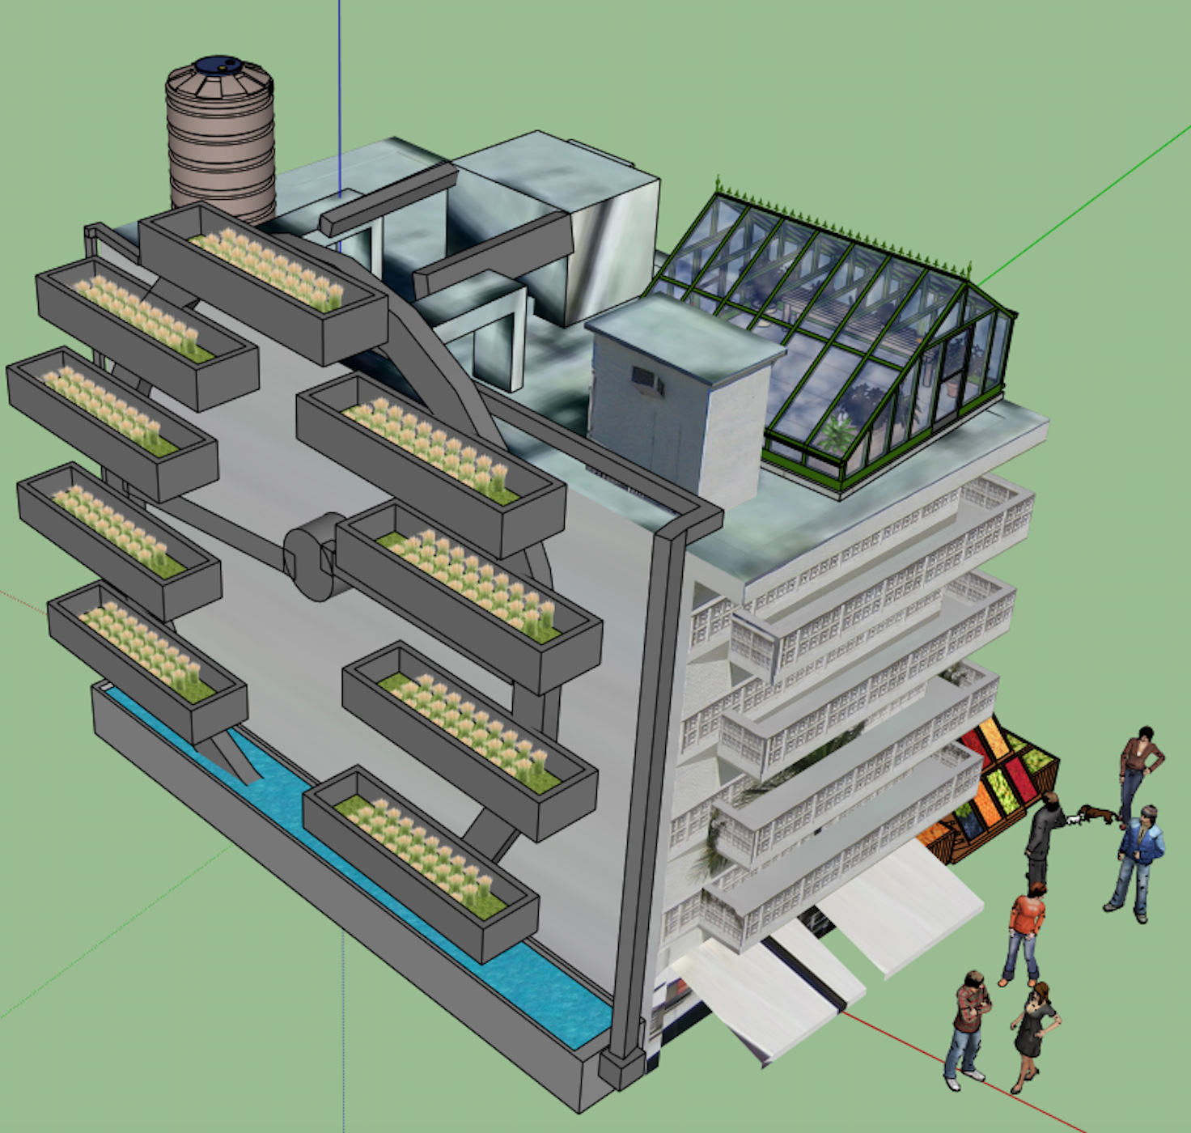
Middle School Student Project, Salem, Oregon
Small teams compete to design the best possible system. Their work culminates in design drawing and a presentation to their classmates, who will consider each design on its merits, and then work together to plan the best possible design for their client. The overarching goal of this unit is for students to develop engineering design and systems analysis skills while coming to understand that engineering has great potential to be a social good by solving such critical problems as providing food and water for people around the world.

UNIT OVERVIEW

According to the United Nations, the world population of more than 7 billion is expected to increase by nearly a billion people within the next twelve years, reaching 8 billion in 2025 and more than 9 billion in 2050. As the world population increases, so will the demand for food. Producing enough food for growing populations will be an immense challenge.
An idea that has been suggested to solve the problem of insufficient food is for city dwellers to grow some of their own food in tall buildings. Although websites display a number of exciting buildings designed to be vertical farms, the cost of land and construction in large cities make new building impractical at present. However, hydroponics and vertical farming do not necessarily require new construction. The challenge for the unit is to design a vertical farm that will grow vegetables hydroponically on one or two sides of a large apartment building.
The unit begins as students are invited to join a small engineering company that designs hydroponic vertical farms. The students are told that in order to design a vertical farm themselves they first need to learn two skills: hydroponics and computer aided design (CAD).
The students learn these skills in a series of five Knowledge and Skill Builders (KSBs).
KSB1 explains the nature of the problem, the idea of vertical farming, and provides an introduction to hydroponics.
KSB2 challenges the students to design and construct a platform to hold their hydroponic systems. The students learn to follow the Informed Design Process and to use a decision matrix to choose the best design.
KSB3 involves designing and building hydroponic systems. Teams of students are assigned to construct one of two different systems. The focus of this KSB is on the nature of systems.
KSB4 involves planting, monitoring, and harvesting plants. The focus of this lesson is that feedback is essential for maintaining systems.
KSB5 presents a series of lessons in computer aided design. Students learn to use SketchUp, a free CAD software package, guided by a series of tutorials constructed by a middle school teacher.
In the Grand Challenge students receive a letter from their first client, asking them to design a vertical farm. The students apply what they learned in the previous KSBs to meet the challenge and present their ideas to the client.
The overarching goal of this unit is for students to develop engineering design skills while coming to understand that engineering has great potential to be a social good by solving such critical problems as providing food and water for people around the world.

Engineering for All

The primary target group for the EfA units is middle school engineering and technology education (ETE) students and teachers, since the shift to STEM education substantiates the need for the nation’s 30,000 TE teachers to play an expanded role in advancing the T and E in STEM for all students. The purpose of these units is to enable students to develop predispositions to forge a sustainable future and learn that engineering is a route to engage in socially significant work. When completed, the EfA modules will become part of the International Technology and Engineering Educators Association’s flagship Engineering by Design (EbD) program.
Vertical Farming is part of the Engineering for All (EfA) project, which has been funded by the National Science Foundation (Grant # DRL 1316601) to create, test, and revise two-six week modules for middle school technology education classes on the important social contexts of food and water. The units are built on three “drivers” that underpin the Engineering for All approach. These are discussed below and include:
- Promoting engineering as a social good
- Applying themes in authentic social contexts
- Using informed design as the core pedagogy
Promoting engineering as a social good
Due to the essential roles engineering and technology play in addressing global and environmental challenges, support for ETE programs has rapidly increased. In addition to the workforce and economic imperatives, engineering can and should be appreciated as a contributor to sustainable development and transformative improvement in quality of life. The UN Millennium Development Goals and the NAE Grand Challenges for Engineering inspire development of curricula that prompt learners to seek solutions to human needs: potable water, sanitation and waste disposal, energy, sustainable transport, and production of sufficient food to meet the needs of a growing world population.
School-based engineering meets the needs of millennial students who are civic-minded, team-oriented, and want to make a difference. There is growing recognition that ETE experiences can be pedagogically valuable for all students—not only in providing an effective way to contextualize and reinforce STEM skills, but also in mobilizing engineering thinking as a way for young people to approach problems of all kinds.
Applying themes in authentic contexts
EfA has adopted the following five unifying themes (design, modeling, systems, resources, and human values) that align well with both the Standards for Technological Literacy (ITEEA, 2007) and the Next Generation Science Standards (NGSS Lead States, 2013).
Design relates to the process engineers (and others) use to develop solutions to problems. The Accreditation Board for Engineering and Technology (ABET) defines design as “the process of devising a system, component, or process to meet desired needs. It is a decision-making process (often iterative), in which the basic sciences and mathematics and engineering sciences are applied to convert resources optimally to meet a stated objective” (ABET, 2000). Multiple solutions can be suggested with different benefits and burdens. The search is for an optimal solution that meets design criteria; and tradeoffs between what is desired and what is feasible within real-world constraints of time, money, availability of resources, laws of nature, politics, etc.
Modeling involves developing representations of a solution (representational modeling) that help engineers test the effects on product performance of changing variables on a design or to depict how a design actually works. Models can be drawings; functional physical models (either made to scale or full-size); simulations (virtual models); or mathematical models. They can be used to describe a design (CAD is a form of descriptive modeling) or to predict how it might work (Simulations are a form of predictive modeling). The use of modeling, with its inherent predictive analysis, is a central theme in engineering. Modeling (and analysis) in the design process is important because design ideas cannot always be evaluated by the build-and-test approach since it is often too costly and time-consuming to do so.
Systems Thinking relates to conceptualizing an engineered system, product, or process in terms of it being comprised of a set of interrelated components or subsystems that act together to produce a desired result. All systems include inputs, controllers, processes, and outputs. System inputs are of two types: the command input (which specifies the desired result); and resource inputs such as energy, information, and materials that are combined by the system process to produce outputs. A system is designed to turn desired results into actual results. Often, actual results include both intended and unintended outputs. Systems can be open-loop systems (where the system does not alter its output based on changing conditions), or closed-loop systems that operate using feedback to respond to changing conditions.
Resources are broadly classified into several categories: people, capital, energy, information, materials, tools/equipment, and time. All technological systems use some or all these resources. Engineers select and use the most appropriate resources based on their availability, cost, and how appropriate they are for the setting in which they will be used. When engineers choose resources, tradeoffs are often made (plastic may be substituted for metal; human labor can be substituted for capital intensive machinery). Resources are chosen to accomplish desired results safely, economically, and efficiently.
Human Values must be taken into consideration when proposing solutions to design problems. When doing so, engineers try to take cultural mores and preferences into account. Tradeoffs that might be made between profitability and a design’s impact on the environment (e.g., sustainability and disposability) and on people’s health and safety must be carefully considered.
Donovan & Bransford (2005) suggest that concepts must be placed in a conceptual framework to be well understood and “take on meaning in the knowledge-rich contexts in which they are applied; ” and, to deepen conceptual understanding and facilitate learning transfer, students should encounter the same idea in a variety of contexts (de Vries, 2010; Bransford & Brown, 2005).
EfA themes will be revisited in two social contexts (food and water) that are relevant to students and relate to improving quality of life. Revisiting the themes in different contexts will facilitate learning transfer and provide a more holistic understanding of engineering.
Informed design as the core pedagogy
Informed design enables students to enhance their own related knowledge and skill base before attempting to suggest design solutions. In this way, students reach design solutions informed by prior knowledge and research, as opposed to trial-and-error problem solving where conceptual closure is often not attained. Informed design emphasizes design challenges that rely on math and science knowledge to improve design performance. The approach prompts research, inquiry, and analysis; fosters student and teacher discourse; and cultivates language proficiency.
Implementing the informed design process involves engaging students in a series of Knowledge and Skill Builders (KSBs) that they will need to solve a Grand Challenge. Solving the challenge involves eight stages: clarify problem criteria and constraints, research and investigate, generate alternative designs, choose and justify the optimal solution, develop a prototype, test and evaluate, redesign the solution, and communicate your achievements.

Teaching the Vertical Farming Unit
Planning
Plan this unit at least a month in advance so you’ll have time to order all the supplies and materials. We recommend that you start with just one class, since there is a learning curve with hydroponics. Also each system has about a 2’ x 3’ footprint, and requires several electrical outlets. The supplies, which cost about $950 can be reused by other classes at a later time, with the additional cost for consumable materials of about $150 per class. We recommend that you:
1) Read the following one-page summaries of each of the lessons. These are provided to help you plan the overall course, and also to use as a refresher before beginning each new lesson. More extensive descriptions start on page XX.
2) Read the subsequent section, “Hydroponic Tips from Korbin Shomaker.” Korbin is a middle school teacher with considerable experience in hydroponics. Reviewing his suggestions will provide a very good grounding in how to teach the practical skill of hydroponics to middle school students.
3) Test the water source closest to your classroom, following Korbin’s suggestions, to find out if you will need to obtain a water filter or if tap water will do.
4) Check out the electrical outlets in your classroom to decide where the students will set up their hydroponic systems, and how many power strips you’ll need.
First Four Days (Introduction to Engineering for All)
NASA, Public Domain | Overview (Days 1-4)  Like all projects in the Engineering by Design series, the unit is launched by an introductory lesson called The First Four Days. The students first do a short activity to “Build The Tallest Tower,” without instruction. They then learn how to design stable structures, guided by the eight steps of the Informed Design Process. They then apply the Informed Design Process to the subsequent unit, Vertical Farms: Fresh Food for Cities.  Lesson Duration: Four 45-minute periods  Big Idea: Engineering aims to benefit society and the environment and is accomplished through collaboration and problem solving.

Learning Activities
Engage: Students are given a bag of supplies and told to “build the tallest free-standing tower that you can that will support the weight of golf ball for at least two minutes.” Teams are allowed 20 minutes to plan and build. They are not given any instruction about the Informed Design Process at this point.
Explore: Students explore the materials, then build their towers. Towers that hold the weight of a golf ball for at least two minutes are measured and a “winning team” is declared.
Explain: The teacher presents the Informed Design Process, commenting on the difference between the trial-and-error approach the students just completed and engineering guided by the Informed Design Process. Student teams then undertake a series of short activities in which they construct and test squares, diamonds, and triangles made from paperclips and straws. The activity concludes as students explain what they learned about the stability of various shapes.
Engineer: Students are asked to “Think Like an Engineer” and redesign their towers using the same materials; but this time applying the knowledge they caned from the activities with shapes and the Informed Design Process.
Enrich: Students view images of bridges, towers and other full scale structures, so they can see the connection between their activity and how professional engineers build structures that help society.
Evaluate: Students reflect on the Big Idea, and how it relates to the activities that they completed. The lesson concludes with a few broad questions about the value of the Informed Design Process in daily life, and the skills that the students will need to become better at solving problems.
KSB1. Welcome to Fresh Food Engineers

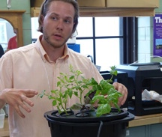  Courtesy of Cary Sneider | Overview (Days 5, 6)  Students are informed that they have been hired to work in a small engineering company that specializes in hydroponic systems design. One day they will be asked to design a large vertical farm, but first they need to learn about hydroponics and CAD. The KSB then introduces students to the need to feed a rapidly growing population, the pros and cons of hydroponics for solving the food problem, and describes four different hydroponic systems.
Lesson Duration: Two 45-minute periods
Big Idea: Sustaining the supply of food is a great engineering challenge, especially as the world’s population grows.
Learning Activities
Engage: Hand out KSB 1 (or open on computer or tablet). Discuss the idea of food deserts, pointing out that difficulty in obtaining affordable fresh fruits and vegetables leads to poor health.
Explore: Have students access the U.S. Department of Agriculture’s Food Access Research Atlas on the Internet. The assignment is for students to zoom in on the area where they live, or other areas they know personally, and use the key to see if it is a food desert. Then have students read about the global problem of feeding a growing world population with dwindling land and water supplies suitable for farming.
Explain: Introduce the idea of vertical farming. Buildings constructed for vertical farming have been designed, but it is expensive to construct new buildings in cities. However, growing food on the surface of existing buildings is a very promising idea. The students’ grand challenge will be to design such a vertical farm. First, however, they will need to learn to grow foods hydroponically and learn to use Computer Aided Design.
Engineer: Use a video projector to show and discuss the diagrams of the four hydroponic systems on pages 6, 7, 8, and 9. Have students research these and other hydroponic systems using the Internet.
Enrich: Have students search for and view videos about agricultural engineering and vertical farming. Challenge them to find examples in which food is grown on the walls of buildings.
Evaluate: Have students complete Check Your Understanding and What’s the Big Idea? to determine what they learned from the KSB.
Assessment: Examine students’ responses to the questions at the end of the unit. Discuss these ideas with the students to reinforce the most important or misunderstood concepts.
KSB2. Design and Build a platform

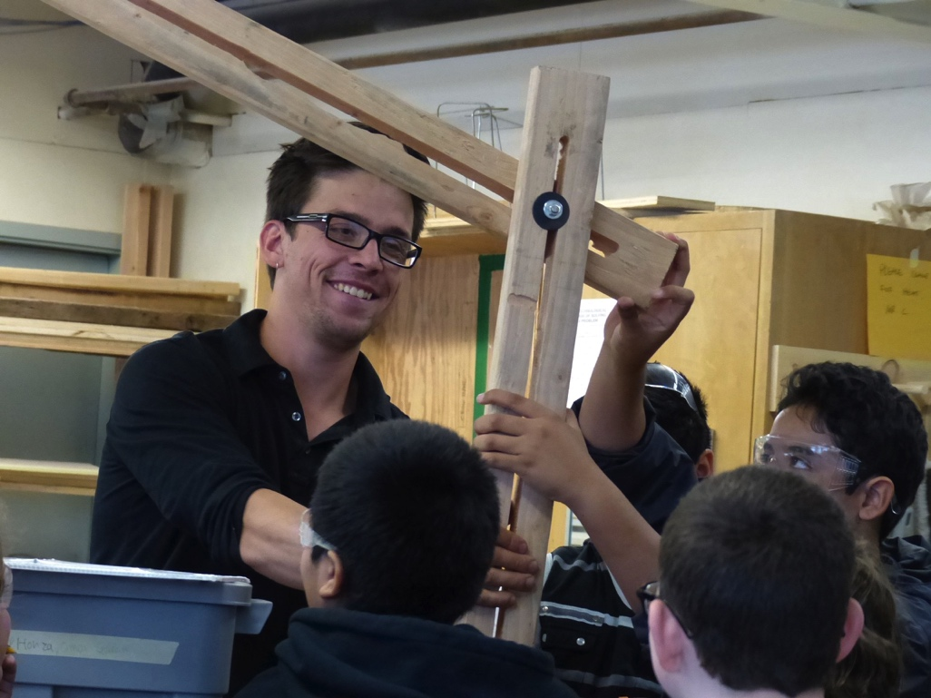Courtesy of Cary Sneider  Jake Cogger’s Class, Salem, OR | Overview (Days 7, 8, 9, 10)  This is a key lesson in which students learn to engineer a product. Students are shown the materials that they will use (either wood or PVC tubes). They are given the challenge of designing a platform that will hold the growing chamber and reservoir, allow for tubes to pass between them, and hold lights that can be adjusted. The teacher guides the students in designing their platform, creating a bill of materials, making tradeoffs, and using a design matrix. Students build their platforms.
Lesson Duration: Four 45-minute periods
Big Idea: The Informed Design process uses knowledge and skills to solve problems rather than just trial-and-error.
Learning Activities
Engage: Organize the class into six teams. Tell the students that their task is to design a platform that will hold both parts of the system, and that will hold lights suspended above the plants. Explain why the platform is needed, and the criteria and constraints of the task. Introduce the Informed Design Process (IDP).
Explore: Teams start by working together to come up with different ideas for a platform design. Students then work individually to develop one of the ideas by considering tradeoffs, then creating a drawing (Page 4) and calculating cost in their Student Companion.
Explain: Teams meet and each student explains the idea that they developed to their teammates.
Engineer: Students learn to make tradeoffs and use a design matrix (also called a Pugh Chart) to choose the best solution. With some coaching from the teacher the students create a Design Matrix to compare the ideas developed by individual students and compare each idea against the criterion and constraint of the problem. Once they have made a decision, they ask the teacher to approve the design, and obtain the supplies listed in the Bill of Materials.
Enrich: Students construct the platform that they designed, making improvements as needed when they see how well it works and run into problems.
Evaluate: Encourage the students to redesign and rebuild their platforms if they run into problems. They should also check to be sure their design meets the criteria and constraints of the problem.
Assessment: It is not sufficient for students to build stable platforms. Examine their use of the bill of materials, design matrix, and their understanding of tradeoffs by listening to conversations and examining their responses to questions at the end of the lesson.
KSB3. Hydroponics Laboratory
Aeroponics and Ebb and Flow Systems

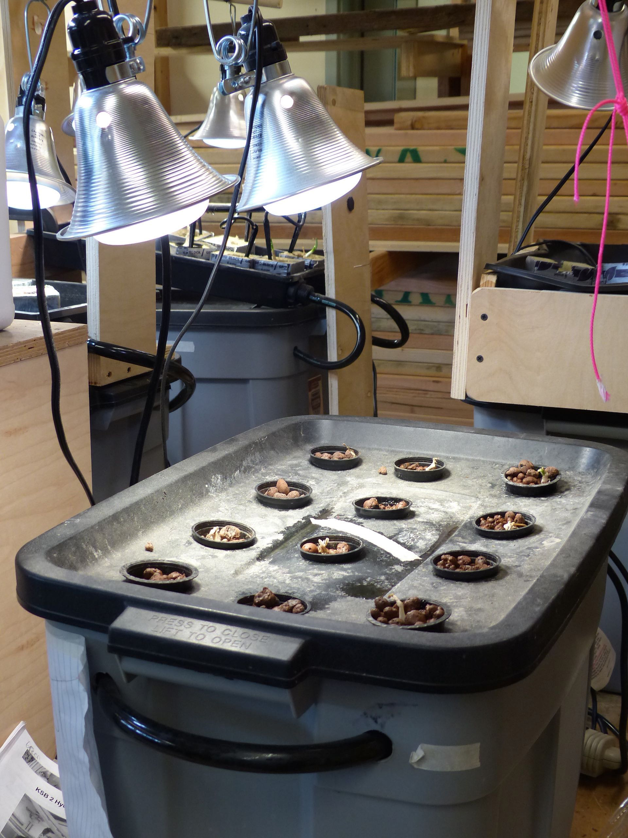  Courtesy of Jake Cogger  Aeroponics | 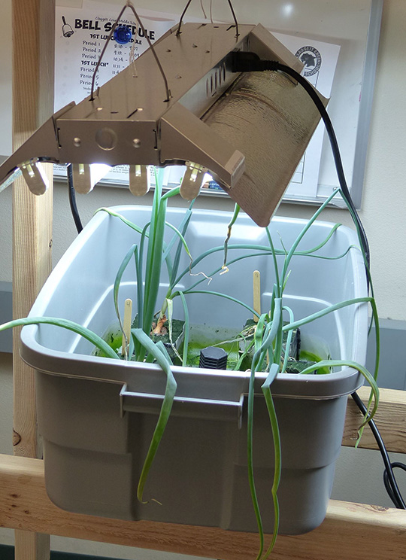  Courtesy of Steve Haner  Ebb and Flow | Overview (Days 11, 12, 13, 14, 15)  Students work in teams to design and build aeroponic systems in which the plant roots are suspended in a chamber, which is constantly misted with nutrient-rich solution, and ebb and flow system in which the plants are placed in cubes of an absorbent material. A separate version of this KSB is provided for students designing and building each of these systems.

Lesson Duration: Five 45-minute periods
Big Idea: Systems have parts that work together to achieve desired results.
Learning Activities
Engage: Divide students into six groups. Assign three groups to design and build an aeroponics system and the other three to design and build an ebb and flow system. (Smaller classes may have fewer groups and larger classes more groups.) Hand out KSB3 (print or online), to guide students in designing and building those systems. Explain that there are no detailed building plans—they are to figure out what to do with the parts and build a system like that shown in their Student Companion.
Explore: Students explore the materials and discuss how they should build the system. They do not drill holes at this point, but they begin to sketch their ideas for how the systems would go together.
Explain: As the student teams finish their plans, they show them to the teacher and explain how the system will function. When the teacher is satisfied he/she will give permission to get tools and begin building.
Engineer: Students construct their systems. As they drill, cut, and assemble the pieces, they continually refer to their plans, and revise as necessary.
Enrich: The students test their designs with water, and redesign to fix any leaks.
Evaluate: Students review each other’s systems to see how they are similar and different, and how well they appear to meet the requirements of the system they are building.
Assessment: Part of the assessment for this KSB is the quality of the systems. Check to see if they are stable, functioning systems. Also check students’ explanations of how the systems work in Check Your Understanding questions. Finally, discuss with the class their responses to questions about the big idea of systems.

KSB4 Hydroponic Farming

Courtesy of Korbin Shoemaker  Harvesting lettuce from hydroponics | Overview (Days 16 through the end of the unit)  In KSB4 students mix the nutrient solution, place seedlings in their hydroponic systems, and set timers. They then monitor their hydroponic systems two or three times a week and record data, such as plant height, color, and number of leaves, as well as quality of the water and temperature and humidity of the air. Students adjust the chemistry of the nutrient solution as needed, and replace the solution completely every two or three weeks. Since monitoring the systems does not take very much time, the rest of the class period will be spent on KBS5, in which students learn CAD and the Grand Design Challenge. Finally, they graph the data and harvest the food.
Big Idea: Feedback involves monitoring and adjusting a system to maintain a desired output.
Learning Activities
Engage: Explain to the students that from now on they will be both agricultural engineers and farmers, tending their crops and using scientific measurements to provided feedback to help them determine what the plants need to maintain healthy growth.
Explore: The students test their systems with plain water first to be sure they function. They then read the instructions on the nutrient solution package, mix the solution and start their systems. They also adjust lights and set timers, then place seedlings in cups and Rockwool cubes.
Explain: The teacher introduces the process of monitoring the systems as a feedback process, such as the kinds of measurements doctors do to maintain human health, and making sure people have good nutrition and exercise.
Engineer: Maintenance is usually the work of a technician, while design is the work of an engineer. Every now and then ask the students to think about the monitoring process. How could it be improved? Encourage students to make note of their improvements to the monitoring process.
Enrich: Students take measurements two or three times a week, learning how to maintain their systems, and how to troubleshoot problems.
Evaluate: It is important not to hang the success of the project on production of a healthy crop; although that is a good goal for the students. Success involves taking regular and accurate measurements, learning what those measurements mean, and taking action to maintain a healthy environment for the plants.
KSB5 Modeling With Computer Aided Design (CAD)

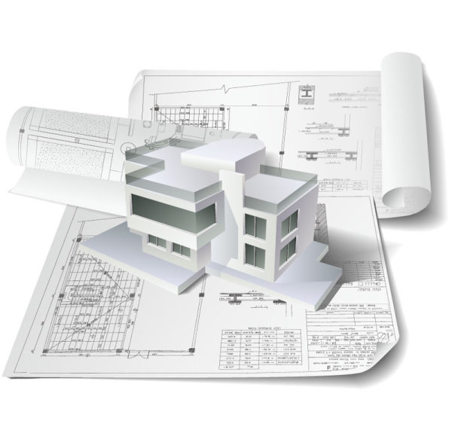  Courtesy of Fredesignfile.com. Creative Commons. | Overview (Days 18, 19, 20, 21, 22)  Students learn to use Computer Aided Design (CAD) software on a simple project, to develop their skills in preparation for the Grand Design Challenge later in the unit. A middle school teacher produced a series of five video tutorials to show students how to use Google SketchUp, a free software program that will work on a wide variety of computer platforms. However, other CAD software can be used instead. At the end of the lesson students create a 3D model of an apartment building, which they will later use to demonstrate their solution to the Grand Design Challenge.
Lesson Duration: Five 45-minute periods
Big Idea
A 3D computer model is a realistic representation of a design that can be changed and manipulated.
Learning Activities
Engagement: Discuss the different 2D drawings of apples on page 2, and how the drawings might be useful for different purposes. Use this discussion to introduce 3D modeling using CAD. Show a short video about CAD and describe its advantages over drawing.
Exploration: Students use one or two of the five tutorials to learn how to use SketchUp (or another software package.
Explain: Discuss with students that there is still an important place for hand drawing, using the table on the bottom of page 3 to help them think about when CAD is better and when hand drawing is better. The students should also appreciate that a CAD model is more than a drawing that can be changed easily. It allows the user to make and test predictions, such as where shadows will fall at different times of day.
Engineer: Students continue through the rest of the video tutorials, working in pairs to check each others’ understanding, using the checklists in the Student Companion.
Enrich: Students design and build a model of a large apartment building.
Evaluation: Students critique their own and the teachers’ building models using a score sheet.

The Grand Challenge (Days 23 through the end of the unit)
The Design Journal guides students through the informed design process, shown in this image, to meet the Grand Challenge posed by their client—The Community Council.
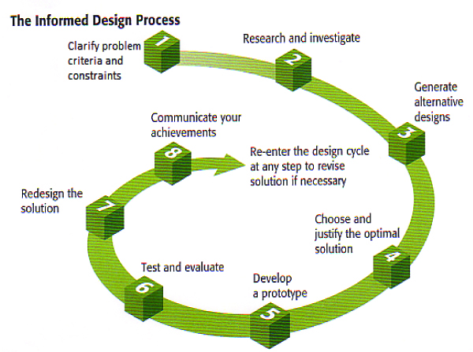
Stage 1: Clarify Problem Criteria and Constraints (Day 22). The students receive a letter from The Community Council asking for their help. The Grand Challenge is to create a vertical farm design using a 3D modeling program, and demonstrate an operating hydroponic system. Students learn about the informed design process and define the problem in terms of criteria and constraints.
Stage 2: Research and investigate (Day 23). Student teams review what they learned in the KSBs. Then they survey friends in class to see what kinds of fruits and vegetables they like best.
Stage 3: Generate Alternative Designs (Estimate Days 24, 25, 26, 27). Students work in pairs or as individuals to create CAD models of different designs for vertical farm, using the building model they constructed in KSB5 as the foundation.
Stage 4: Choose and Justify the Optimal Solution (Day 28) Teams use a Decision Matrix to evaluate different design ideas against criteria and constraints, and decide on the best idea.
Stage 5: Develop a Prototype (Day 29, 30). Student teams make slight revisions in the 3D model if needed and draft a presentation (e.g. poster or PowerPoint) to show their design to another team.
Stage 6: Peer Review (Estimate Days 31) Pairs of teams to present their ideas and give and receive suggestions for improvement.
Stage 7: Redesign the Solution (Day 32) Teams revise their vertical farm designs based on feedback from the other teams and prepare a presentation for the entire class (their client).
Stage 8: Communicate Your Achievements (Day 33, 34,35) Teams present their final design. Presentations illustrate the trajectory of development, including designs that were not selected and why, feedback on the final design, and modifications. Presentations need to show how the design meets the criteria and constraints of the problem. Students evaluate each other’s designs in terms of who well they meet the client’s needs.
Summary of the Big Ideas in the Unit
KSB 1 Sustaining the supply of food is a great engineering challenge, especially as the world’s population grows.
KSB 2 The Informed Design process uses knowledge and skills to solve problems rather than just trial-and-error.
KSB 3 Systems have parts that work together to achieve desired results.
KSB 4 Feedback involves monitoring and adjusting a system to maintain a desired output.
KSB 5 Models are a powerful means for analyzing and predicting the behavior of systems.
Grand Challenge
Vertical farming is a bold and innovative design concept to provide healthful food in urban environments. Like all new technologies a vertical farm must:
- Meet the needs of people and the environment.
- Make best use of resources, including money, tools and materials, energy, information, and people.

Pacing Guide
The amount of time spent on each lesson and overall length of the unit will vary depending on your student and schedule. The following pacing guide may be helpful for some teachers.
Suggested Pacing Guide (Based on five 45-minute periods per week)
Knowledge & Skill Builders | Week1 | Week 2 | Week 3 | Week 4 | Week 5 | Week 6 | Week 7
First Four Days | XXXX
KSB 1 Welcome to Hydroponics | X | X
KSB 2 Design a Platform |  | XXXX
KSB 3 Design Hydro Systems |  |  | XXXXX
KSB 4 Hydroponic Farming |  |  |  | XXXXX | XXXXX | XXXXX | XXXXX
KSB 5 Create 3D Models |  |  |  | XXX | XX
Grand Design Challenge
Stage 1 Clarify the Problem |  |  |  |  | X
Stage 2 Research and Investigate |  |  |  |  | X
Stage 3 Alternative Designs |  |  |  |  | X | XX
Stage 4 Choose the Best Design |  |  |  |  |  | X
Stage 5 Develop a Prototype |  |  |  |  |  | XX
Stage 6 Test and Evaluate |  |  |  |  |  |  | X
Stage 7 Redesign the Solution |  |  |  |  |  |  | X
Stage 8 Communicate |  |  |  |  |  |  | XXX

Hydroponic Tips from Korbin Shoemaker
Walkersville Middle School, Walkersville, MD
Test the Water Before You Start
One of the most useful tools you can have for a successful hydroponics classroom is a TDS meter that costs about $15 dollars. TDS stands for Total Dissolved Solids, so it measures the concentration of solids in the water, including the concentration of nutrients that your students will be adding to the water intentionally.
In KSB4 students learn to test and adjust the pH level of their nutrient solutions. You can also teach your students how to use the TDS meter. I explain what it measures and help them decide what to do as a result of a measurement. As you’ll see below it can get a little complicated.
Even before you begin the hydroponics unit, start by measuring the tap water that you will be using to fill the hydroponic systems. Pure distilled water is 0 parts per million (ppm). In my tests, bottled water is under 50 ppm. The EPA recommends that drinking water should contain no more than 500 ppm, as well as specific guidelines about which contaminants are okay in different concentrations and which are not.
Plants need different TDS ppm ranges depending on their size and if they are fruit or not. If you’re not sure what ppm level your plants need, it is best to start with a lower concentration and increase the concentration if the plants are growing more slowly than you expect. I use the linked chart from Home Hydro Systems
Before going on I should point out that TDS can be measured in different units, just as temperature can be measured in °C or °F. Industry uses electrical conductivity factor (CF) instead of ppm. I prefer ppm because it has more physical meaning for the students. So I use a TDS meter that measures in ppm.
Now back to checking your tap water. If you are growing lettuce (or most plants) and the TDS is higher than 350 ppms, you will likely need to do what I’ve had to do in my classroom—get a filter. I use a reverse osmosis filter, which is available at most hardware and hydroponic stores.
To get familiar with how the pH and TDS interact start with one gallon of fresh water and add one teaspoon (tsp) of liquid nutrient. Use the meter to see how that changes the TDS. Then add 2mL of pH Up solution, and use the meter again. You’ll see that every time you add solutions to the water, the TDS level will increase. Here are some typical results from my classroom. You can see from this example why I filter the water. If I did not the ppm levels would be too high for the health of our plants.

Filtered Water | pH | ppm | Unfiltered | pH | ppm
1 gallon of filtered tap water | 5.4 | 20 | 1 gallon unfiltered tap water | 7.0 | 380
Add 1 tsp liquid nutrient | 3.8 | 410 | Add 1 tsp liquid nutrient | 6.4 | 770
Add 2 mL of pH Up solution | 6.0 | 440 | Add 2 mL of pH Up solution | 6.0 | 780

Throughout the growing process students use the TDS meter to monitor the condition of their reservoirs, especially after adding nutrients to make sure we are in the proper range for the plants we are growing. If too high, we add more water to lower the PPMs or concentration of nutrients. If too low, we add more nutrients and increase the concentration.
Even if students do not add pH Up or Down solution to keep the pH in the proper range, ppm will increase as water evaporates, or as plants take up more water, and the solution becomes more concentrated. The TDS level will decrease as plants take up more of the nutrients from the water. So if the water level has dropped due to evaporation, use your meter to measure ppm. If ppm is low, the plants have been absorbing a lot of the nutrients, so mix additional nutrient solution to restore the water level. If ppm is high, then add fresh tap water (filtered if necessary). | 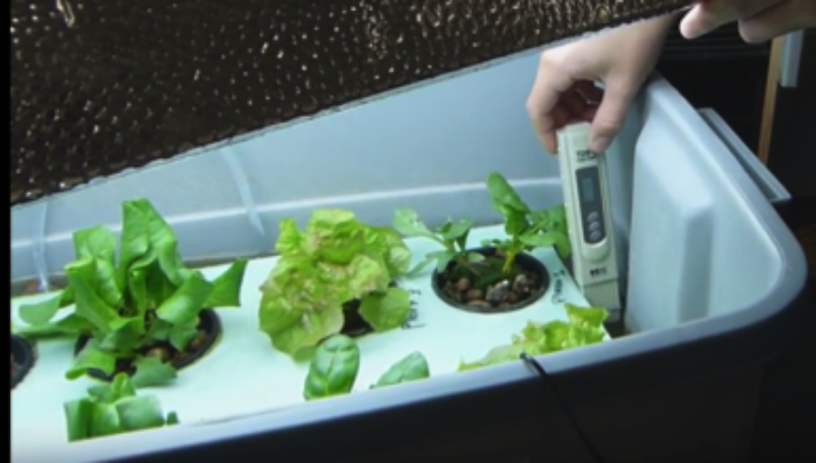  Courtesy of Korbin Shoemaker  Using the TDS meter to measure ppm
I also use the meter for troubleshooting. When plants are not looking healthy or die, I check the ppm of the troubled system as well as the other systems to see if the problem is due to the solution or something else.
In summary, the TDS meter is a very powerful tool, both for growing healthy plants and for showing students the value of collecting relevant data. In KSB4 students will find a place to record ppm on their data chart, next to pH.

Electrical Outlets
A number of electrical connections will be needed for each hydroponic system: pump, lights, two timers (one for lights and one for the pump), and in the case of the ebb and flow system, an additional pump to aerate the nutrient solution. Before ordering supplies it is a good idea to take inventory of the electrical outlets around the room, and to determine if they are all on one circuit, so you do not overload the electrical system.
If you can spread out the hydroponic systems around your room, than normal surge protectors should be sufficient. However, if all systems are close together, there may not be enough outlets, and timers can cover up multiple outlets. One solution is to use 4-ft. power strips.
A Kill-A-Watt meter can be used to monitor electricity usage to make many other curricular connections.
Electrical Safety notes  Hydroponics depends on water, and water is a safety hazard around electrical power. Therefore:  - Hang a “U” or “J” hook on each power cord, so that water cannot run along the cord to the outlet.  - When changing water, unplug the power strip, not just the pumps.  - Use GFI outlets when possible. | 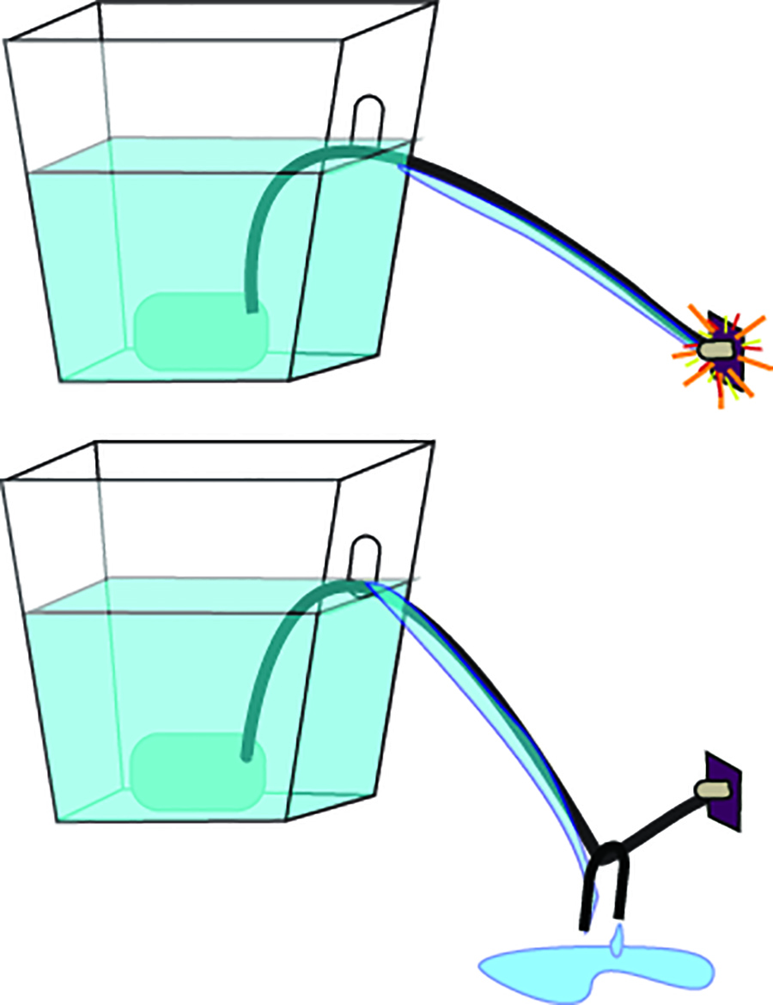  Hang a weight on the power cord
Lights
It is important to use special lights for growing plants, since the types of bulbs intended for general lighting purposes do not provide most of their light in the spectrum that plants need for photosynthesis. There are two categories of lights that will work well.  Fluorescent Bulbs (top). Fluorescent tubes or bulbs for growing plants have been available for many years. The designation “T5” are best for hydroponics. In addition to the more common tubes, T5 bulbs are made for standard bulb sockets. Although the bulbs are more difficult to hang two or more can be attached to an insulation board, so the reflect more light and can be raised and lowered together. In general more 5T bulbs mean faster growth.  LEDs. Arrays of LED lights for growing plants have come on the market in recent years. These include red and blue LEDs that correspond to two peaks in the spectrum that most plants need for photosynthesis. LEDs tend to produce more light for the same amount of electrical energy than fluorescent bulbs, so they are a good choice. | 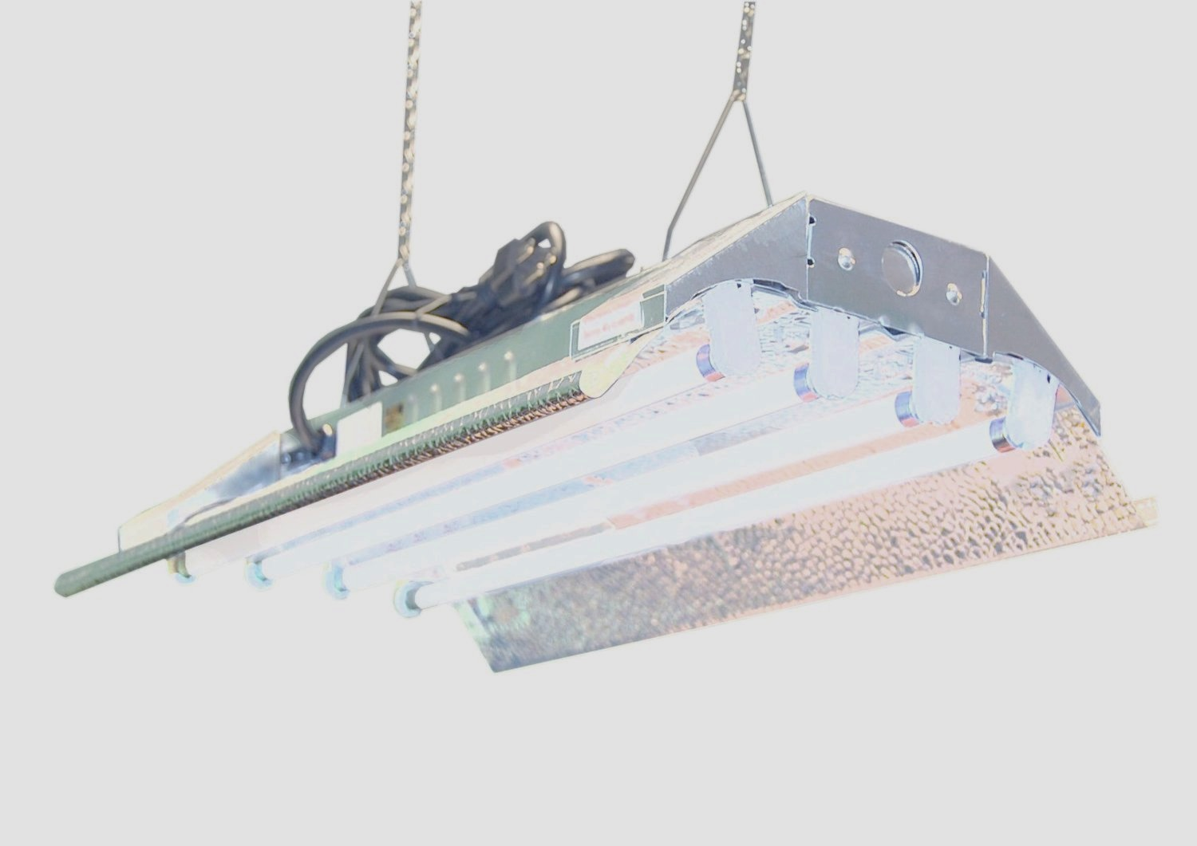  Fluorescent Tubes
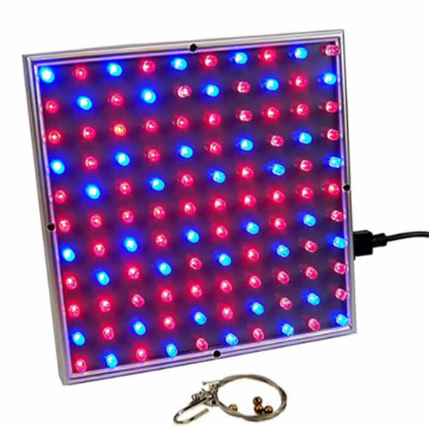
LED Array

Preventing Leaks
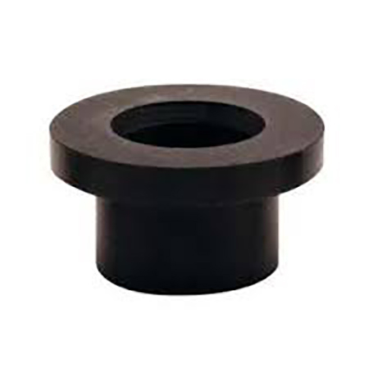Rubber grommet | Depending on how your students design their hydroponic systems, both the ebb and flow and the aeroponics system may require that tubes pierce the growing chamber below the water line. The best way to prevent leaks is to use the rubber grommets in the recommended parts list. A rubber grommet with a 5/8” inner hole will fit the ½” black hose. They will require drilling a ¾” hole be drilled in the bottom of the growing chamber. I find a step drill bit to be useful for to make the holes in the bottom of the growing chamber. | 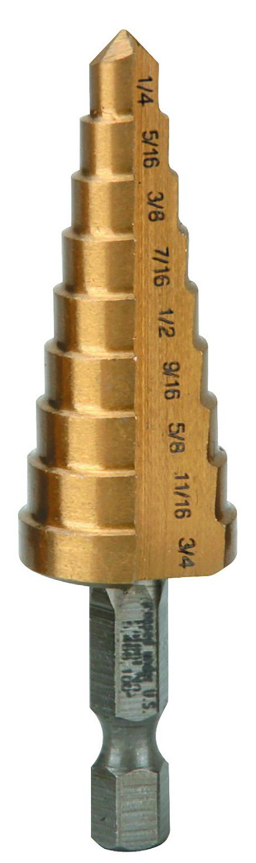  Step drill bits

Selecting Plants to Grow  Many different plants can be grown hydroponically. We have had especially good luck with lettuce, since it germinates easily and the students do not need to wait for the plant to produce fruits, since the leaves are edible. Some of the teachers have had good luck with mint, basil, and vegetables grown from bulbs, such as onions and garlic. Onion bulbs are sold in “sets,” which are packages of 20-40 small bulbs for planting.  Students do not have to plant all the same kind of plant in their growing chamber. They can try two or three different kinds of plants to see how they grow differently, provided they have approximately the same pH and ppm requirements. | 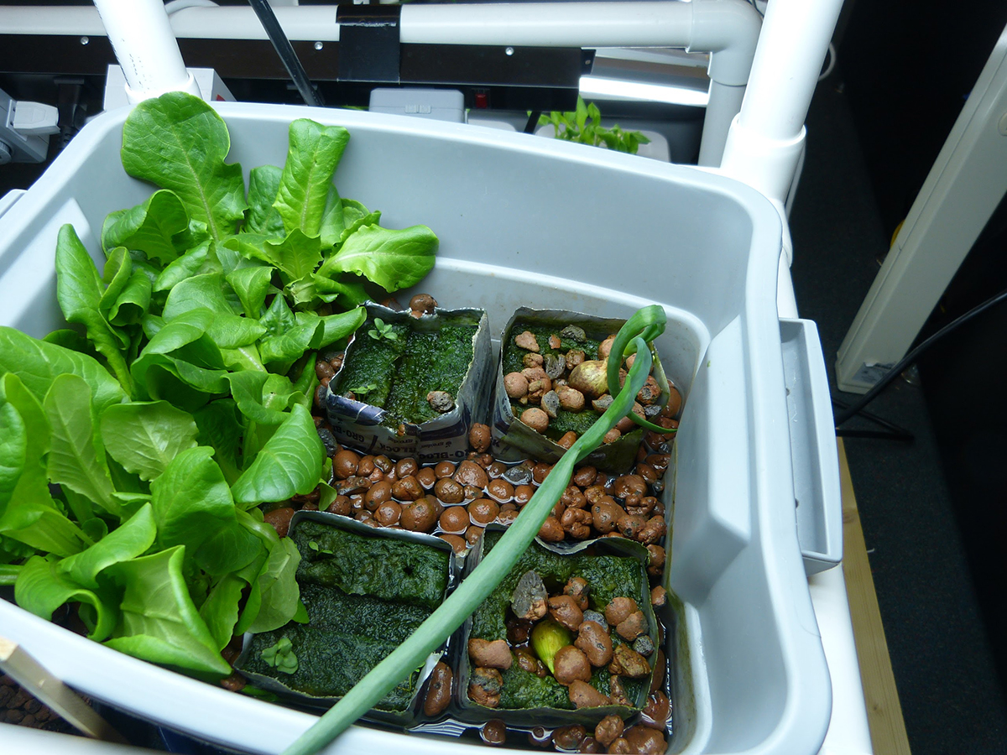  Courtesy of Korbin Shoemaker  Growing lettuce and onions

Germinating Seeds
Germination is the step when a seed begins to sprout. Some plants are very quick germinators, other take longer and have unique growing requirements such as temperature; so it’s a good idea to check the seed packet or the Internet for specific requirements. (On the next page after next are temperature requirements for a long list of plants that can be grown hydroponically.)
In order for students to start growing plants as soon as they build their hydroponic systems in KSB3, I like to start the germination process during the first week of class, about three weeks before students will be ready to start KSB4 Hydroponics Farming.
In order to avoid disturbing the very young root hairs as little as possible, I germinate seeds in Rockwool cubes or net cups and transfer them the cubs or cups to the hydroponic systems when ready. Here’s the process I use.
1. Soak Rockwool in pH adjusted (5.5-6.5) water and remove.
2. Use a toothpick to poke two or three holes in the Rockwool.
3. Put 2-3 sees in each hole (to increase likelihood of 1 strong germinated seed).
4. Gently close the hole with toothpick so the seeds do not get direct light.
5. Put Rockwool in a sealed clear plastic container or special germination dome.
6. Place the germinating directly under a grow light and monitor daily. Open the container every few days to allow fresh air in.
7. Caution: Do not allow the Rockwool cubes to dry out. In dry climates some teachers prefer to take the germinating seeds home over the weekend. Use a mister if needed.
8. You can transfer the Rockwool cubes into the hydroponic systems when three or more leaves have developed, and/or when roots are emerging from the bottom or sides.
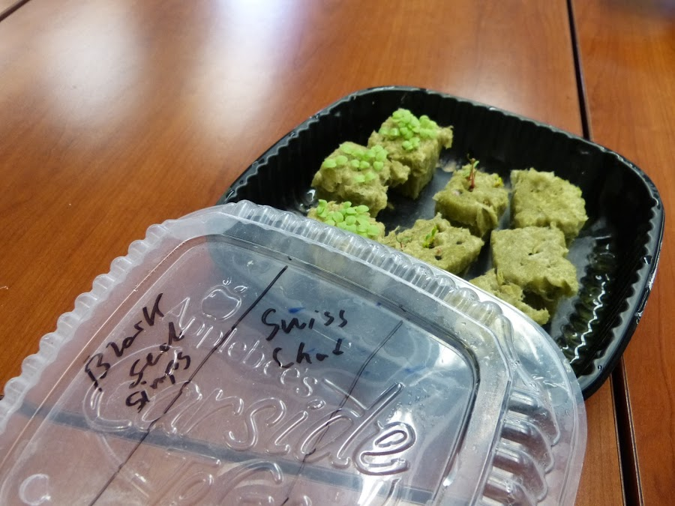  Seeds placed in Rockwool cubes | 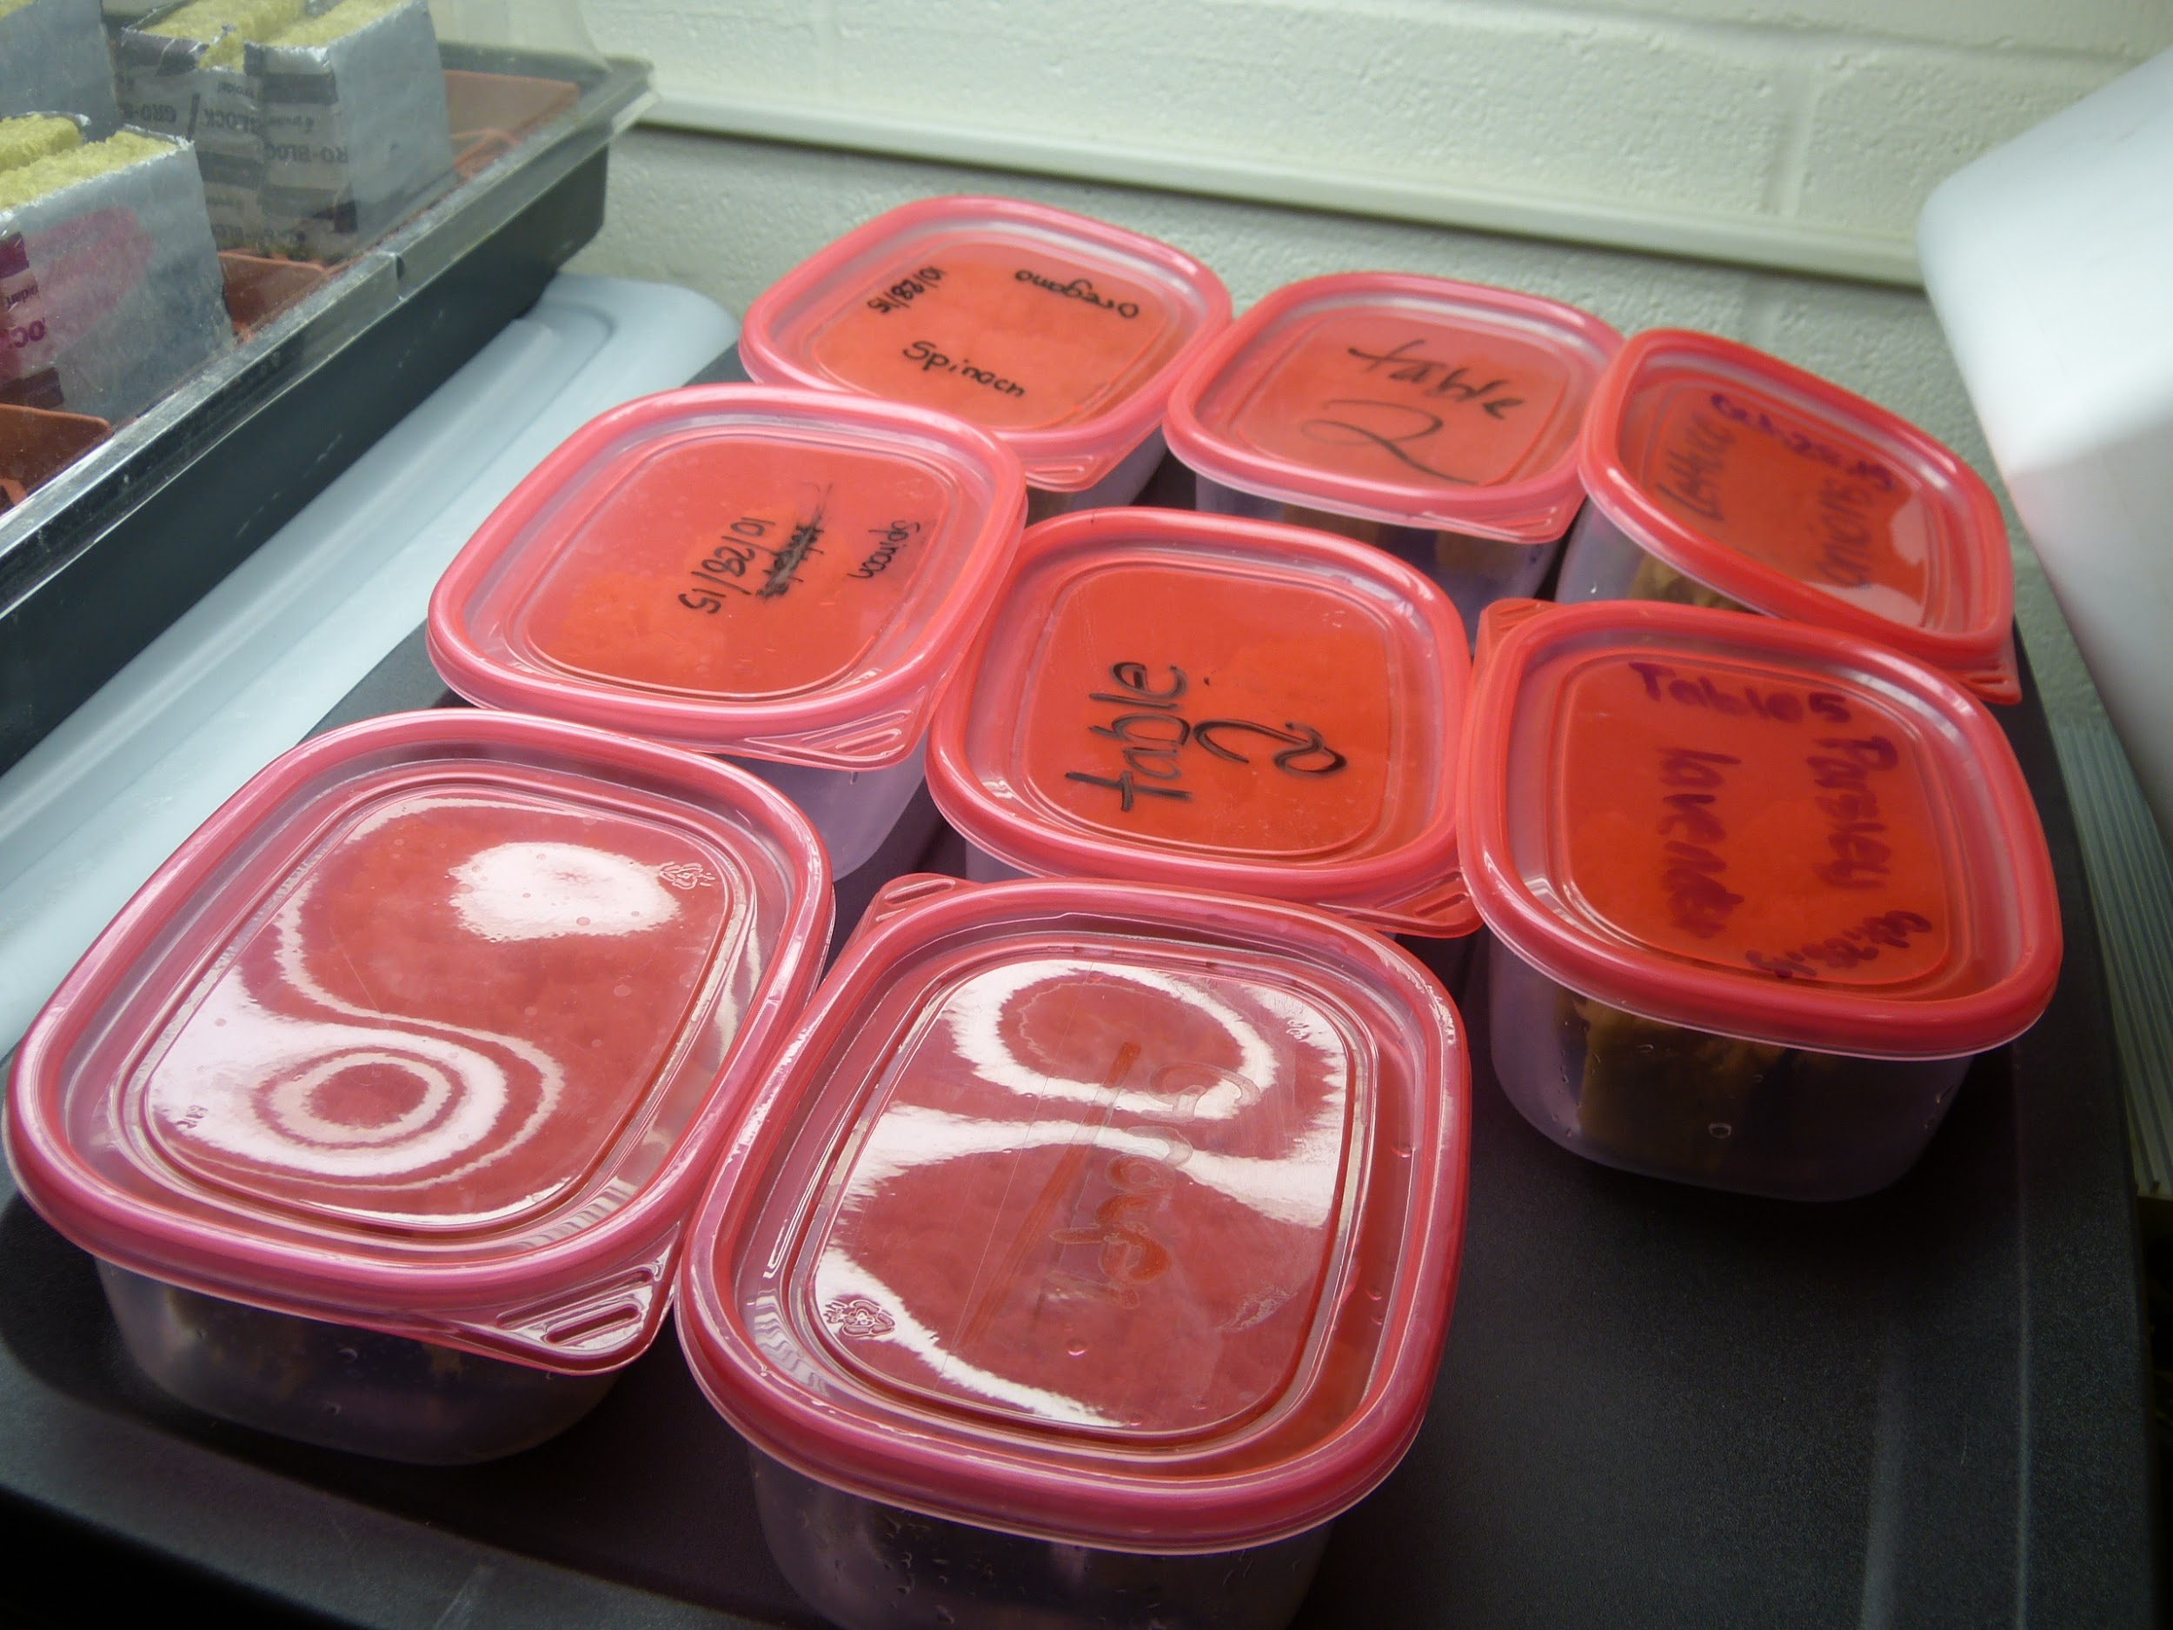  Containers are covered
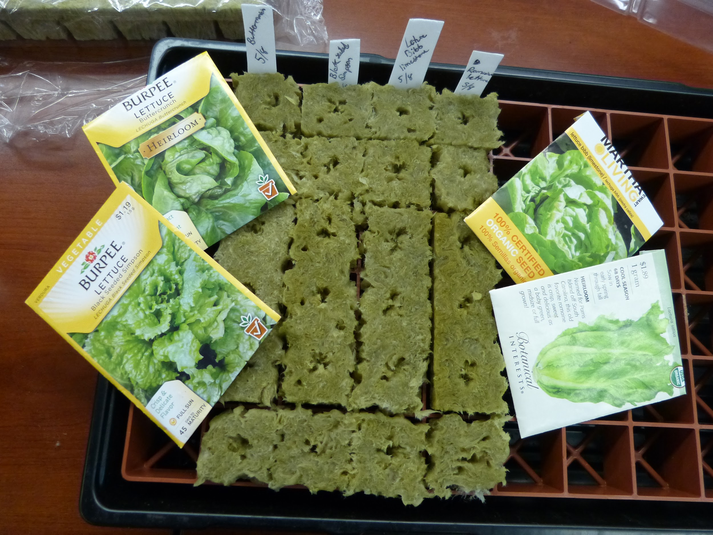  Seeds in rock wool in germination dome | 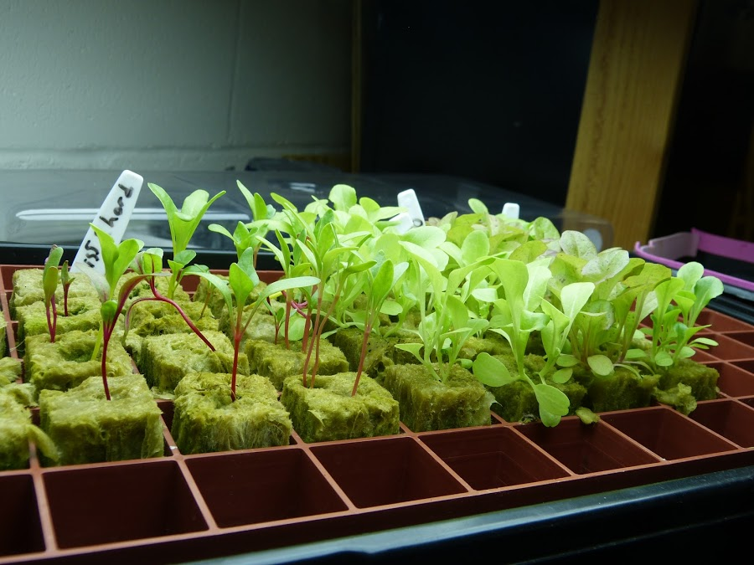  Seedlings in germination dome
Four images above courtesy of Korbin Shoemaker

Temperature Conditions for Vegetable Seed Germination in °F
Crop | Minimum | Optimum | Maximum
Asparagus | 50 | 75 | 95
Bean | 60 | 80 | 95
Beet | 40 | 85 | 95
Swiss Chard | 40 | 85 | 95
Lettuce | 35 | 75 | 95
Onion | 35 | 75 | 95
Pea | 40 | 75 | 85
Pepper | 60 | 85 | 95
Radish | 40 | 85 | 95
Spinach | 35 | 70 | 85
Tomato | 50 | 85 | 95
Data compiled by J.F. Harrington, Department of Vegetable Crops, University of California at Davis

Changing the Nutrient Solution
Plants produce waste products, which can build up in the nutrient solution. Therefore, nutrient solutions should be changed about every two weeks. Having every group replace their nutrient solutions on the same day can be pretty chaotic if space is tight. It takes about 30-45 minutes to empty the water and mix a new solution. Therefore I have found it helpful to have just two or three groups do this in a class period, so that all of the systems have fresh solutions over a period of two or three days.
On those days have several empty 5 gallon water buckets ready to empty the used solutions and several other 5 gallon water buckets filled with fresh water so time does not have to be wasted filling them up. (10 gallons of water is heavy and easy to spill, so it’s best to move water 5 gallons at a time.) The students should mix the nutrients in the buckets before pouring them into the reservoirs.
Tips for Mixing Nutrients
It’s challenging to pour a large container of nutrient concentrate into small measuring cups or spoons. One method is to pour the solution into beakers or measuring cups with spouts, and give those to the students to measure when mixing their solutions.  An even easier method is to provide the students with cups or beakers of nutrient concentrate and plastic syringes (no needle), which are graduated to measure quantities precisely.  Be sure to have your students read the instructions on the container. Most nutrients require different concentrations for different stages of growth, starting with lower concentrations for seedlings, and higher concentrations for more mature plants. | 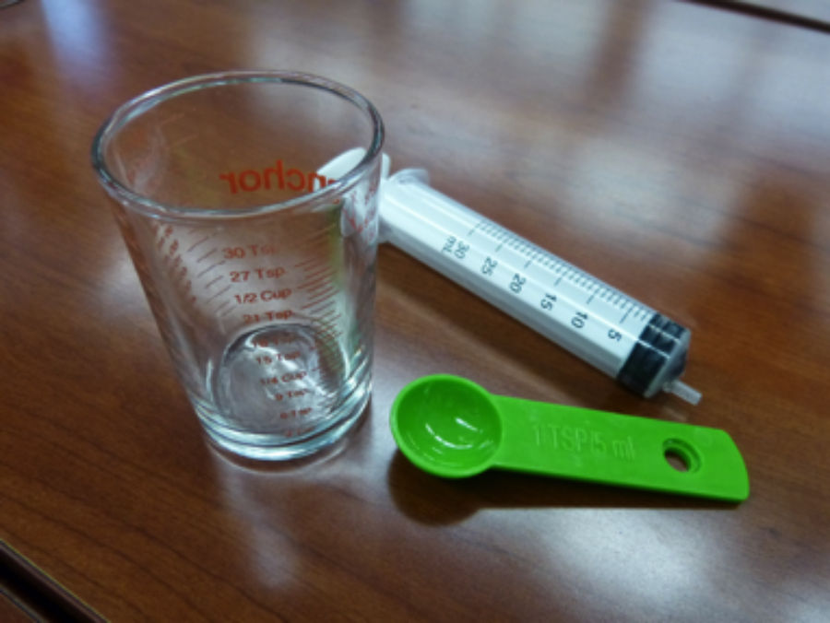 Courtesy of Korbin Shoemaker
Measuring Plant Growth
Since different plants grow in different ways, there is no single method that works. For some plants students can count leaves. Others will increase in height. Onion and garlic plants put out long leaves that can be measured. The length, width, and number of lettuce leaves can be measured. Leave these decisions to your students. It’s okay if the plants need to grow for a few days or even a week before the students settle on a method. It will be easier for them to analyze the data if they choose a single measurement. Also measuring in millimeters is easier than measuring in inches as students do not need to deal with fractions. | 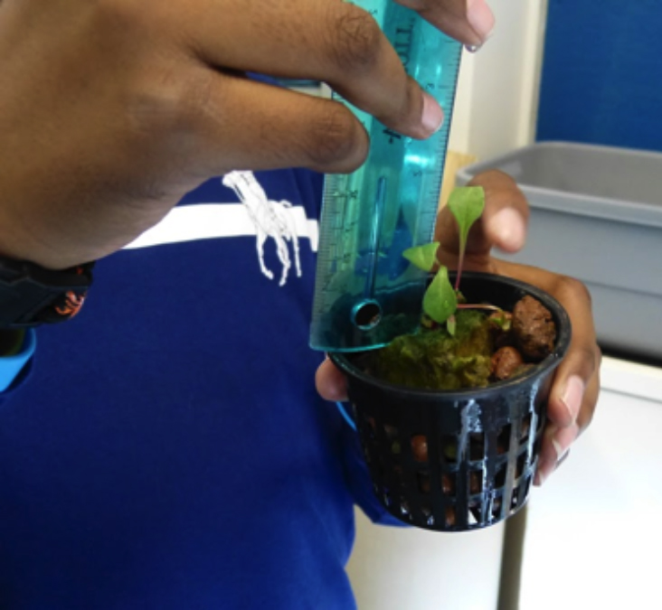  Courtesy of Korbin Shoemaker
Troubleshooting
Not all plants will thrive, even if the nutrient solution is perfect. This in itself is a good lesson. However the lesson will be even better if you can help the students figure out what is wrong. The use of pH and TDS for troubleshooting is mentioned above. Here are some other things to check:
Temperature of the water: Especially on very hot or very cold days temperature could cause problems. In that case see if there might be a different location in the room that might provide a better environment.
Temperature of the air: For most plants air temperature should be between 65°F - 85°F. In schools we often don’t know what the temperatures are like at night or on weekends, so that requires some investigation when starting out. If too high or too low try adjusting the thermometer in the room or change the height of the light. A fan can also be helpful in reducing air temperature.
Humidity: Plants can dry out if the humidity is too low. Ideal greenhouse conditions are between 50% and 80% humidity. Although there may not be much you can do to change this level, it may at least be helpful to know the cause of a problem.
Water depth: Mark a wooden dowel with centimeter increments. Dip it into the reservoir a couple of times per week to measure depth. The pump should be covered with at least one inch of water. Also, knowledge of water depth will help you explain changes in pH or ppm, and provide further information about the condition of your plants.
— Korbin Shoemaker

Choosing plants. As Korbin Shoemaker explained in the previous section, there are three ways of starting plants: from seed, from bulbs, and from cloning (also called “cuttings.”) Some of our pilot teachers have had good luck with germinating seeds for lettuce, kale, mint, basil, and other leafy greens. Other teachers who had difficulty germinating plants from seeds had success planting onion bulbs. Hydroponic experts recommend cloning. So as far as we have been able to determine, all of these methods work. You may want to go to your local nursery to see what kinds of seeds and bulbs are available. One teacher went to the grocery store to purchase a whole basil plant to make clones. It’s a good idea to use a small number of different varieties and see what works best for your local growing conditions.
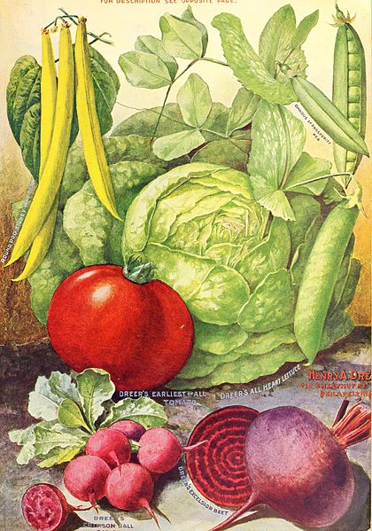  Vegetable Seeds | 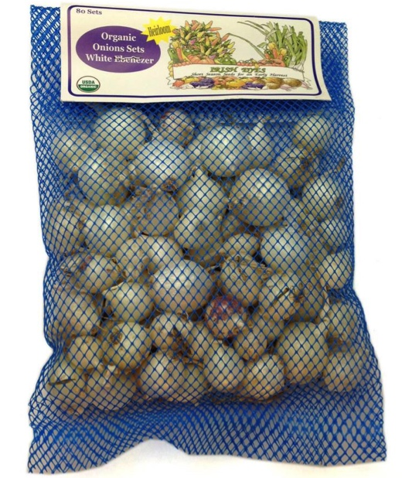  Onion Bulbs | 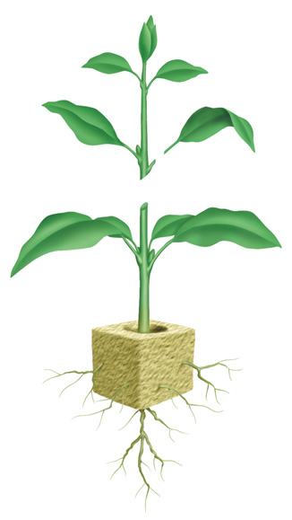  Clone

Teams
Each team will develop one hydroponic system, either aeroponics or ebb and flow. Pilot teachers had three of each type of system in their classrooms, for a total of six teams, so that students could see two types of systems in operation, but ordering equipment was not too complicated.
To order supplies you will need to know how many teams of students you will have. Deciding on the number of students per team involves a tradeoff between keeping the number of students small, so that they will be more engaged, and keeping the number of teams small to contain equipment costs, classroom space, and presentation time near the need of the unit. As a general guide, it is best for teams to include no more than 4 or 5 students.
Materials

Platforms  You will also need to decide between wood or PVC tubes for building platforms. PVC pieces fit in many different ways, and can be re-used many times. Wooden 2’ x 4’s offer the opportunity for students to learn woodworking skills. Purchasing PVC locally costs about the same as purchasing it online and paying for shipping. | 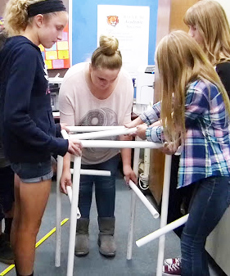  Courtesy of Korbin Shoemaker  PVC Platform | 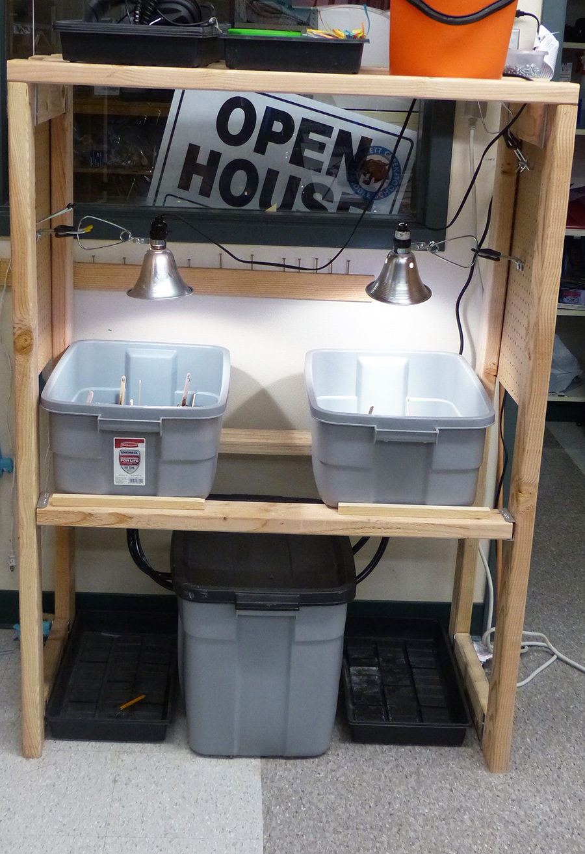  Courtesy of Steve Haner  Wood Platform

Per Team | Qty. | Source | Part Number | Item Description (PVC Option) | Item Cost | Total
0.5 | 2.0 | Lowes | #: 23993 | Charlotte Pipe 1" 200PSI SDR 21 PVC pipe - 10ft | 2.81 | 5.62
4 | 16.0 | PVC* | 1" 3-WAY FURN SIDE ELBOW | 1" 3-WAY FURNITURE FITTING - SIDE ELBOW | 0.94 | 15.04
6 | 24.0 | PVC* | 406-010 | 1" Sch 40 PVC 90 Elbow | 0.34 | 8.16
4 | 16.0 | PVC* | 1" 4-WAY FURN SIDE OUTLET TEE | 1" 4-WAY FURNITURE FITTING - SIDE OUTLET TEE | 1.14 | 18.24
4 | 16.0 | PVC* | 401-010 | 1" Sch 40 PVC Tee | 0.45 | 7.20
6 | 24.0 | PVC* | 429-010 | 1" Sch 40 PVC Coupling | 0.27 | 6.48
 |  |  |  |  |  | 60.74
* Refers to PVC Online. PVC straight tubes can be cut before class into a variety of 6”, 12”, 18”, 24” and 36” lengths.

Per Team | Qty. | Source | Part Number | Item Description (Wood Option) | Item Cost | Total
2 | 8.0 | Home Depot | #6006 | Whitewood Stud 2"x4"x96" | 2.62 | 20.96
1 | 1.0 | Home Depot | Item: 17365 | Grip Rite 1lb #8 x 2.5" Deck Screws | 0.94 | 0.94
 |  |  |  |  |  | 21.90

Hydroponic Supplies
Some supplies can be purchased at Do It Yourself (DYI) stores, like Home Depot or Lowes. Hydroponic supplies can be purchased at specialized stores in most large cities or over the Internet. Other supplies can be purchased locally at hardware stores. Following is a list of materials that you will need for one aeroponics system and one ebb and flow system. You will need to multiply by the number of teams in your class(es). Following is a shopping for hydroponics supplies.
Hydroponics Equipment for Six Teams (3 Aeroponics, 3 Ebb and Flow)
Per Team | Qty. | Source | Part Number | Item Description | Item Cost | Total
1 | 4.0 | DIY Store | SKU # 383321 | Roughneck 18 Gallon Tote | 6.97 | 27.88
1 | 4.0 | DIY Store | SKU #489754 | Roughneck 10 Gallon Tote | 7.97 | 31.88
1 | 4.0 | Amazon | AAPA3.2L | Air Pump 3.2L | 10.46 | 41.84
1 | 4.0 | Amazon | B00S2DPYQM | Erligpowht 45W Indoor Grow Light | 27.99 | 159.96
1 | 4.0 | Amazon | B00FA7A8QY | Hydrofarm 15 minute Grounded Timer (for Pump) | 14.99 | 59.96
0.5 | 2.0 | Amazon | B00O3H03LW | Instapack Grounded 24 Hour Timer (2 pack) (for Light) | 14.99 | 29.98
1 | 4.0 | Amazon | B00B2CZTJW | Jebao PP388 High Volume Submersible Pump AERO | 18.99 | 75.96
0.5 | 2.0 | Amazon | B00520AR9C | Lexan sheet 18"x24" | 18.67 | 37.34
1 | 4.0 | Amazon | B00L77655Y | CNZ Blue Stone Bar (2 pack) | 5.29 | 21.16
1 | 4.0 | Amazon | B0002563MW | Penn-Plax Air Line Tubing | 4.65 | 18.60
1 | 4.0 | Amazon | B00IGFDTSQ | Gro Top Hat rubber grommets 10pk | 6.95 | 27.80
 | 1.0 | Organica | 708660 | 1/2" ID Black Tubing (NOTE NOT OD) - 25FT Length | 10.95 | 10.95
0.5 | 2.0 | Organica | AAST50 | 1/2" Stopper - 10 pack | 6.95 | 13.90
2 | 8.0 | Organica | BCFTBKKT | 1/2" Bulkhead Barbed Fitting | 9.95 | 79.60
2 | 8.0 | Organica | AAEL50 | 1/2" Barbed Elbow | 0.95 | 7.60
2 | 8.0 | Organica | AAT50 | 1/2" Barbed Tee | 0.95 | 7.60
1 | 4.0 | Organica | PBV210 | 1/2" Barbed Shut-off valve | 4.95 | 19.80
5 | 20.0 | Organica | EZCSPJ | ez Clone 360 Misting Nozzles MUST BE RED TYPE | 0.75 | 15.00
0.5 | 2.0 | Organica | GH1515 | pH Test Kit 1oz | 7.95 | 15.90
5 | 20.0 | Organica | GH6601 | 2" Net Cups | 0.30 | 6.00
1 | 1.0 | Organica | GMC10L | PlantIt Clay Hydroton 10L 8-16mm | 11.95 | 11.95
3 | 3.0 | Organica | RWDM4G | Rockwool 3"x3"x2.5" 8-pack | 6.50 | 19.50

Hydroponics Equipment to be Shared by All Teams
 | 1.0 | Amazon | B004NJTYQA | CTT 13 Pc Hole Saw Set | 13.84 | 13.84
 | 1.0 | Amazon | B001OEPYWK | Meiko Step Drill Set (3/16"-3//4") | 11.30 | 11.30
 | 1.0 | Amazon | B000VTQM70 | HM Digital TDS-3 Handheld TDS Meter | 15.96 | 15.96
 | 1.0 | Organica | DYNRO100 | Dyna-Gro 1gallon | 55.95 | 55.95
 | 1.0 | Organica | 708660 | 1/2" ID Black Tubing (NOTE NOT OD) - 25FT length | 10.95 | 10.95
 | 1.0 | Organica | GH1532 | pH Down Acid Liquid Quart | 11.95 | 11.95
 | 1.0 | Organica | GH1522 | pH Up Base Liquid Quart | 11.95 | 11.95
 |  |  |  | Grand TOTAL |  | 861.11

Most of the above materials can be used more than once. Following is a list of consumable supplies that can be used for a new class. Prices and sources will change over time. See KSB3 and KSB4 for images of these materials. These are pictured in KSB3A, KSB3B, and KSB4.

Replenishment Materials Needed to Repeat the Class
Per Team | Qty. | Source | Part Number | Item Description | Item Cost | Total
1 | 6 | DIY Store | SKU #489754 | Roughneck 10 Gallon Tote | 7.97 | 31.88
0.5 | 2.0 | Organica | GH1515 | pH Test Kit 1oz | 7.95 | 15.90
5 | 20.0 | Organica | GH6601 | 2" Net Cups | 0.30 | 6.00
1 | 1.0 | Organica | GMC10L | PlantIt Clay Hydroton 10L 8-16mm | 11.95 | 11.95
3 | 3.0 | Organica | RWDM4G | Rockwool 3"x3"x2.5" 8-pack | 6.50 | 19.50
1/Class | 1.0 | Organica | 708660 | 1/2" ID Black Tubing (NOTE NOT OD) - 25FT LENGTH | 10.95 | 10.95
 |  |  |  | Total |  | 146.51

Useful Tools
Hole Saw Set  Step Drill Set  Cordless Drills | Tubing Cutter Shears  Scissors Drill Index  Small Files and Rasps | Extension Cords  Power Strips  Measuring Tape | Marking Pens

Student Companion  Materials to guide student work are in the form of separate word files for each KSB. They can be provided to students in print or online. The materials should be handed out one KSB at a time. There are places in the Student Companion for students to write or draw. If students have access to computers they can be provided as editable computer files; or the materials can be printed and handed out in class. As shown at the right, one of the micro-test teachers sent the files to the district’s print shop that made 8 ½ ” x 11” booklets of each KSB. | 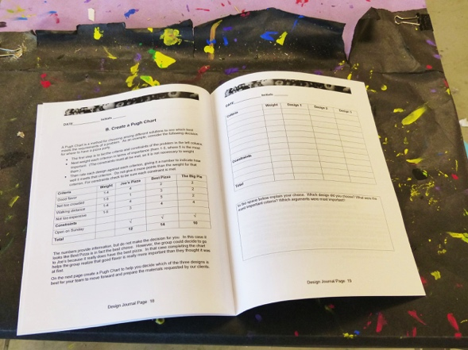  Steve Haner  Printed Version of Design Notebook

The 6E Instructional Model

The 6E instructional model, summarized below, permeates the Engineering for All units. Although each day’s instruction does not necessarily include all six stages of the model, each lesson generally includes these instructional procedures in roughly the same order. The following summary is drawn from an article that appeared in the March 2014 issue of The Technology and Engineering Teacher. The complete article can be found in the Appendix to this Teacher Guide.

Engage The purpose of the ENGAGE phase is to pique student interest and get them personally involved in the lesson, while pre-assessing prior understanding. During this experience, teachers present the instructional task to their students. They also make connections between past learning experiences (prior knowledge), setting the organizational groundwork for upcoming activities. The purpose is to stimulate students’ curiosity and encourage them to ask questions. | 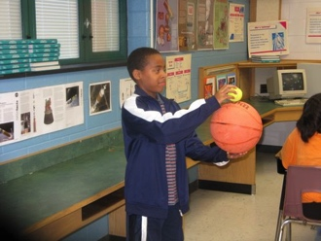
Explore is the period where students get directly involved with phenomena and materials. As they work together in teams, students build common experiences that prompt sharing and communicating. The teacher acts as a facilitator, provides materials and guides the students in problem solving, making hypotheses, testing their predictions, and drawing conclusions. | 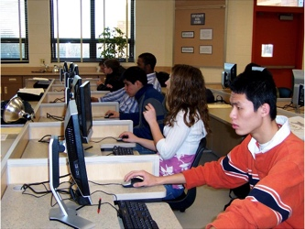
Explain is the phase during which teachers encourage learners to begin to communicate what they have learned. Language provides motivation for sequencing events into a logical format. Communication occurs between peers, with the facilitator, and through reflection and Socratic Questioning. The teacher may also explain concepts and phenomena, helping to correct misconceptions observed during the earlier phases. | 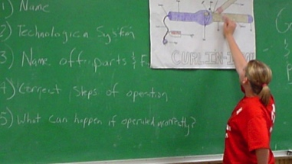
Engineer is the phase of learning where teachers help students integrate scientific inquiry and engineering design to make more informed decisions. Teachers will focus on the EfA themes of design, systems, modeling, resources, and human values as the basis for development, construction, refinement, assessment, and redesign. | 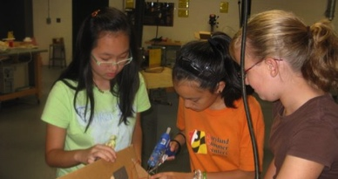
Enrich is the phase during which learners can transfer understanding and purpose to new situations and applications. They understand and are able to utilize concepts relating to Design, Modeling, Resources, and Systems and apply them to Human Values in ways that enrich their understanding and their ability to transfer learning to new situations and problems. | 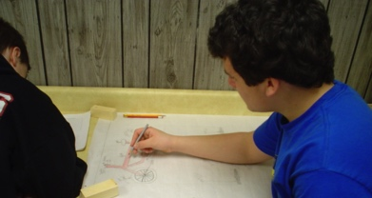
Evaluate The final "E," is an ongoing diagnostic process that allows the teacher to determine if the learner has attained understanding of concepts and knowledge. Evaluation and assessment is not linear and should occur during all phases of instruction.  Above images courtesy of ITEEA | 
Assessment and Grades
The purpose of the KSBs is for the students to acquire knowledge and skills that they will later need to meet the Grand Design Challenge. Each KSB has also been designed to teach an important idea about engineering design, called the Big Idea. Each KSB ends with a section called “Check Your Understanding” and “What’s the Big Idea.” Students’ responses to these sections provide information on their understanding of the ideas from the KSB. However, the most important method for assessment will be to observe the students during class and listen to their conversations to see the extent to which they understand the concepts, develop the skills, and maintain interest in the project. The Grand Design Challenge asks each student to submit their Design Journal at the conclusion of the project for scoring with a rubric. You can use the students’ responses to the questions at the end of each KSB and the scores on the rubric at the conclusion of the GDC as a source of data for grades if that is consistent with your school’s policies. We have chosen not to provide additional tests so as to maintain focus on what the students do during each KSB and the Grand Challenge.
Consistent Features of Each KSB

Big Idea. One big idea about engineering is emphasized in each KSB and the Grand Challenge. It is these ideas that we would like our students to remember and apply in the future.
Learning Goals. These are written for students in the KSBs, beginning with the phrase “I can…” Connections between the learning goals and standards are provided in the KSB section of this Teacher Guide.
Think Like an Engineer. This feature invites students to view the subject matter in a way similar to how an engineer might think about this question or issue.
Points to Ponder. This feature stimulates student thinking. For example, many people have difficulty understanding how hydroponics functions, since they are used to seeing plants growing in soil. But few people think about what soil provides, or the importance of carbon dioxide in the air as a source of carbon for plants to grow. This feature is intended to raise such questions.
Check Your Understanding. This feature enables students to reflect on what they’ve learned and can serve as embedded formative assessment opportunities.
What’s the Big Idea? Asks students to reflect on the big idea presented on the first page.
Safety is of paramount importance to every classroom. While this guide contains some general safety guidelines, it does not address specific tools, equipment, or working spaces. Teachers must provide comprehensive safety guidelines to students based upon individual classrooms. General safety guidelines should include:
- Students use tools and equipment safely, maintaining a safety level for themselves and others in the laboratory-classroom.
- Students demonstrate respect and courtesy for the ideas expressed by others in the class.
- Students show respect for and appreciation of the efforts of others.
These safety notes apply to every KSB and phase of informed design, whether or not tools are involved.
First Four Days (Introduction to Engineering for All)
NASA, Public Domain | Overview (Days 1-4)  Like all projects in the Engineering by Design series, the unit is launched by an introductory lesson called The First Four Days. The students first do a short activity to “Build The Tallest Tower,” without instruction. They then learn how to design stable structures, guided by the eight steps of the Informed Design Process. They then apply the Informed Design Process to the subsequent unit, Vertical Farms: Fresh Food for Cities.  Big Idea: Engineering aims to benefit society and the environment and is accomplished through collaboration and problem solving.

Lesson Duration: Four 45-minute periods (Days 1, 2, 3, and 4)

Standards and Learning Goals
Standards | Learning Goals
NGSS MS-ETS1-2. Evaluate competing design solutions using a systematic process to determine how well they meet the criteria and constraints of the problem.  NGSS Crosscutting Concepts: Structure and Function; Influence of Science, Technology and Engineering on Society and the Natural World.  STL 9 Students will develop an understanding of engineering design.  STL 11. Students will develop the abilities to apply the design process.  EfA Theme: Design | 1. I can give an example of how engineering benefits society and the environment.  2. I can explain how using a systematic process to solve a problem is more likely to result in a good solution than using a trial and error approach.  3. I can work well with others to solve a problem.

Vocabulary
Engineering: Creating or improving technologies to solve problems and meet peoples needs or wants.
Criterial: Qualities of a successful solution.
Constraints: Limits.
Human values: Convictions and beliefs that guide daily life.

Tools/Materials/Equipment
For constructing towers
Tools and materials will vary widely depending on what you have available. Most common tools and materials used for this activity are used paper and tape, and scissors. Teams will also need one golf ball or equivalent. These may be put into paper bags and given to teams.
For experimenting with shapes
5-6 plastic straws
10-12 paper clips
Safety
Safety issues may involve use of sharp tools. Remind students that this is a laboratory, and playing with tools is not allowed.

Learning Activities
Engage: Students are given a bag of supplies and told to “build the tallest free-standing tower that you can that will support the weight of golf ball for at least two minutes.” Teams are allowed 20 minutes to plan and build. They are not given any instruction about the Informed Design Process at this point.
Explore: Students explore the materials, and then build their towers. Towers that hold the weight of a golf ball for at least two minutes are measured and a “winning team” is declared.
Explain: The teacher presents the Informed Design Process, commenting on the difference between the trial-and-error approach the students just completed and engineering guided by the Informed Design Process. Student teams then undertake a series of short activities in which they construct and test squares, diamonds, and triangles made from paperclips and straws. The activity concludes as students explain what they learned about the stability of various shapes.
Engineer: Students are asked to “Think Like an Engineer” and redesign their towers using the same materials; but this time applying the knowledge they caned from the activities with shapes and the Informed Design Process.
Enrich: Students view images of bridges, towers and other full scale structures, so they can see the connection between their activity and how professional engineers build structures that help society.
Evaluate: Students are asked to reflect on the Big Idea, and how it relates to the activities that they just completed. The lesson concludes with a few broad questions about the value of the Informed Design Process in daily life, and the skills that the students will need to become better at solving problems.

Products
The products that students produce in this KSB is the two towers—one made with a trial-and-error approach and one made with the Informed Design Process. Differences between the two may or may not be evident. What is important is that students recognize that the second approach is much more systematic and thoughtful, and in most cases is likely to lead to a more productive outcome.

Assessment
The most important outcome of this KSB is for students to learn about the purpose and process of engineering. Their responses to questions 1 and 2 on page 8, should indicate that they understand that the aim of engineering is to benefit society and the environment and is accomplished through collaboration and problem solving. They may also learn that engineering is systematic problem-solving. Their response to question 3 might list skills such as understanding people’s needs, being creative, and working well with others.

Answer Key
Page 4
1. The square collapses to the side (shear).
2. The diamond also collapses to the side
3. The triangle keeps its shape.
4. The triangle is the strongest and most stable shape.
5. Large structures should be strengthened with triangles.
Page 5
Step 1. Define the Problem.
Statement of the Problem: Build the tallest tower possible without tying it down with tape or anything, and using just the materials we were given.
Criteria for Success: The tower holds a golf ball at least two minutes. It is as tall as possible.
Constraints: We can use just the materials you have given us. It has to be done by (the time the teacher specified.)
Step 4. Choose and Justify the Optimal Solution.
Students should have a good reason for their decision.
Page 6
Step 6. Test and Evaluate Your Design.
Students should be able to explain how the new tower differed from the prior tower.
Step 7. Redesign the Solution.
Students should be able to discuss at least one improvement they could make.
Step 8. Communicate Your Achievements.
Students list what they have accomplished, what they learned, and what other teams told them about their design.
Page 7
1. Strong and stable structures help people meet their needs and stay safe. Good engineering should also use minimal resources so as not to harm the environment.
2. Answers will vary.
3. The tower consists of parts that are all connected to each other. If one part is removed or breaks the entire tower will collapse.
4. It is much less expensive and safer to test a model than to test a full scale structure.
KSB1. Welcome to Fresh Food Engineers

Cary Sneider | Overview (Days 5, 6)  Students are informed that they have been hired to work in a small engineering company that specializes in hydroponic systems design. One day they will be asked to design a large vertical farm, but first they need to learn about hydroponics and CAD. The KSB then introduces students to the need to feed a rapidly growing population, the pros and cons of hydroponics for solving the food problem, and describes four different hydroponic systems.

Big Idea: Sustaining the supply of food is a great engineering challenge, especially as the world’s population grows.

Lesson Duration: Four 45-minute periods

Standards and Learning Goals
Standards | Learning Goals
MS-ESS3-4. Construct an argument supported by evidence for how increases in human population and per-capita consumption of natural resources impact Earth’s systems  NGSS Crosscutting Concept: Science, technology, and engineering influence society and the natural world.  STL 15. Students will develop an understanding of and be able to select and use agricultural and related biotechnologies.  EfA Theme: Human Values | I can:  1. Explain how “food deserts” impact people who live in low-income neighborhoods.  2. Explain that increased population and reduction in fresh water and land suitable for farming put the world’s food supply at risk.  3. Define hydroponics and explain how some representative hydroponic systems function.  4. Make a case for how hydroponics can help provide fresh food for people in cities.

Vocabulary
Hydroponics: A method of growing plants in a water (hydro) solution, without soil.
Agricultural Engineer: A person who develops new and improved technologies for growing an processing food.
Food Desert: A low-income community located more than a mile from a source of fresh fruits and vegetables.
Vertical Farming: Using tall buildings to grow food.
Sustainable Development: A way to meet the needs of the present without sacrificing the needs of future generations.
Aeroponics: A hydroponic system in which the plant roots are suspended in a chamber, which is constantly misted with nutrient-rich solution
Ebb and Flow: A hydroponic system in which the plants are placed in cubs of an absorbent material (Rockwool) and a nutrient-rich solution is pumped into the chamber and then drained periodically

Tools/Materials/Equipment
- Projector
- Computer
- You Tube Video
- Student Companion, KSB1 for every student (online or printed)

Safety
No relevant safety issues in this KSB.

Learning Activities
Engage: Hand out KSB 1 (or open on computer or tablet). Ask the students to imagine they have just been hired as an engineer, working for a company called Fresh Food Engineers, Inc. Explain that the purpose of the company is to help people who live in cities in the U.S. and around the world have access to fresh, nutritious, and affordable foods. Discuss the idea of food deserts, pointing out that in many low-income neighborhoods in the U.S. people have difficulty obtaining affordable fresh fruits and vegetables, which leads to poor health.
Explore: Have students access the U.S. Department of Agriculture’s Food Access Research Atlas on the Internet. The assignment is for students to zoom in on the area where they live, or other areas they know personally, and use the key to see if it is a food desert (Page 2).
Discuss with students the global problem of feeding a growing world population with dwindling land and water supplies suitable for farming (Page 3).
Explain: Introduce the idea of vertical farming by having students read about it in KSB1 (Page 4), and/or by having them research the concept on the Internet and report their findings. Buildings constructed for vertical farming have been designed, but it is expensive to construct new buildings in cities. However, growing food on the surface of existing buildings is a very promising idea.
Explain that the students’ grand challenge will be to design such a vertical farm. First, however, they will need to learn to grow foods hydroponically and learn to use Computer Aided Design.
Have the students read “What Do Plants Need?” (Page 5) and discuss the rather surprising idea that plants do not get most of their mass from the soil or nutrient solution—but rather from the air! Plants take in carbon dioxide and, with the help of energy from sunlight, break it down into carbon and oxygen. They release the oxygen to the air and use the carbon to build stems, leaves, roots, and other plant parts. This means that plants do not need soil to grow. They just need air, sunlight, and water with some dissolved minerals.
Have students read and discuss the concept of hydroponics, and the pros and cons of hydroponics (Pages 6 and 7). Then show the 5-minute video Hydroponic Lettuce, and invite students to discuss their impressions. Explain that as engineers for this company they will be asked for their advice about where hydroponics should be used and where it should not be used. Have them work in pairs to answer the questions on Page 8.
Engineer: Use a video projector to show and discuss the diagrams of the four hydroponic systems (Pages 9-12). Have students research these and other hydroponic systems online.
Enrich: Have students search for and view videos about agricultural engineering and vertical farming. Challenge them to find examples in which food is grown on the walls of buildings.
Evaluate: Have the students work individually to complete Check Your Understanding and What’s the Big Idea? Then have the students work in pairs to discuss their answers. Facilitate a class discussion, asking students to share what they learned from the KSB, and what questions they may have. Pick up the students’ papers to conduct your own assessment.

Products
Completed Student Companion for KSB1

Assessment
Examine students’ responses to Check Your Understanding (Page 13, 14), focusing primarily on whether they were able to:
1. Explain how “food deserts” impact people who live in low-income neighborhoods. (Q1)
2. Explain that increased population and reduction in fresh water and land suitable for farming put the world’s food supply at risk. (Q2)
3. Define hydroponics and explain how some hydroponic systems function. (Q5, 6, 7, 8)
4. Make a case for how hydroponics can help provide fresh food for people in cities? (Q9)
Read the students’ responses to questions in What’s the Big Idea? (Page 15). Make a list of any misconceptions or concerns expressed by the students in Check Your Understanding and What’s the Big Idea? Plan further discussions or activities to address these. Even if the great majority of students grasp the most important ideas it is a good idea to briefly review for students who may be less confident and to show all of the students that you’ve read their responses and care what they write.
You may also wish to use the Student Companion to obtain further information on students’ understanding and participation. Following is a list of the responses to expect on each page of the Student Companion that asks for students to write.

Answer Key
Following are answers to all of the questions asked in this KSB.
Page 2 Answers will vary depending on what students find.
Page 3 Answers will vary, but should reflect recognition that both fresh water and land are essential for growing food, and that the demand for food will increase in future decades.
Page 4
1. Students may think of ideas such as conserving on consumption of electricity, water, and other resources, or using more sustainable methods of generating electrical energy, such as solar and wind power.
2. Answers will vary depending on students’ experiences. Some students may point out that not all engineering is necessarily beneficial (e.g. weapons of mass destruction, pollution from industry, etc.)
Page 5
Top: Students list water, air (or CO₂) and sunlight
Bottom: air (or CO₂) and sunlight
Page 6 Answers will vary.
Page 8
1. Soil farming is less expensive where there is available land and adequate rain.
2. Hydroponics is a better choice in cities where land and water are both very expensive.
3. Answers will vary; but some students may suggest both methods.
Page 9
1. Pump
2. Inflow
3. Outflow
4. Rockwool® cubes
Page 10
1. Through the inflow/outflow tube
2. To prevent the nutrient solution from covering the plants
3. To switch the pump on and off
Page 11
1. In both systems the roots are periodically flooded with nutrient solution.
2. Ebb and flow floods and then drains, while the nutrient flow system channels the solution from one end of the growing chamber to the other.
Page 12
1. The pump must be strong enough to produce a spray.
2. Plants need the carbon dioxide in air to grow.
Page 13 and 14 Check Your Understanding
1. b
2. d
3. c
4. c
5. b
6. a
7. c
8. a
9. Hydroponics takes less space and less water than soil farming, so it is suitable for growing food in cities. Vertical farming would make it possible to grow food on vertical walls, taking up even less space.
Page 15 What’s the Big Idea?
There are no right or wrong answers for these questions. However, students’ answers should provide some insight into how they think about the most important idea in this KSB.

KSB2. Design and Build a platform

Cary Sneider  Jake Cogger’s Class, Salem, OR | Overview (Days 7, 8, 9, 10)  This is a key lesson in which students learn to engineer a product. Students are shown the materials that they will use (either wood or PVC tubes). They are given the challenge of designing a platform that will hold the growing chamber and reservoir, allow for tubes to pass between them, and hold lights that can be adjusted. The teacher guides the students in designing their platform, creating a bill of materials, making tradeoffs, and using a design matrix. Students build their platforms.

Big Idea: The Informed Design process uses knowledge and skills to solve problems rather than just trial-and-error.

Lesson Duration: Four 45-minute periods

Standards and Learning Goals
Standards | Learning Goals
NGSS MS-ETS1-2. Evaluate competing design solutions using a systematic process to determine how well they meet the criteria and constraints of the problem.  STL 9 Students will develop an understanding of engineering design.  STL 11. Students will develop the abilities to apply the design process.  EfA Theme: Design | I can:  1. Us the Informed Design Process to solve a problem.  2. Explain why the Informed Design Process is a better approach than trial-and-error.  3. Make tradeoffs to improve a design.  4. Use a design matrix to choose the best solution to a problem.  5. Use tools competently and safely.

Vocabulary
Criteria: The desirable features of a successful solution to a problem
Constraint: Limits to a solution, usually refers to available materials, budget, and/or time
Tradeoff: A design process in which one feature is sacrificed favor of another feature
Design Matrix: A table in which each solution is scored against criteria and constraints
Bill of Materials: List of all materials and costs for fabricating an object
Tools/Materials/Equipment
As described on page 26, there are two options for building hydroponic platforms: using PVC tubes or wood. Ether option is fine for learning the important ideas in this KSB about how to use the Informed Design Process, including use of a Design Matrix and Bill of Materials. PVC tubes can be reused many times, while wood is less expensive and provides experience in woodworking. Here is list of materials needed for each team, for each of those options.
Per Team | Qty. | Source | Part Number | Item Description (PVC Option) | Item Cost | Total
0.5 | 2.0 | Lowes | #: 23993 | Charlotte Pipe 1" 200PSI SDR 21 PVC pipe - 10ft | 2.81 | 5.62
4 | 16.0 | PVC* | 1" 3-WAY FURN SIDE ELBOW | 1" 3-WAY FURNITURE FITTING - SIDE ELBOW | 0.94 | 15.04
6 | 24.0 | PVC* | 406-010 | 1" Sch 40 PVC 90 Elbow | 0.34 | 8.16
4 | 16.0 | PVC* | 1" 4-WAY FURN SIDE OUTLET TEE | 1" 4-WAY FURNITURE FITTING - SIDE OUTLET TEE | 1.14 | 18.24
4 | 16.0 | PVC* | 401-010 | 1" Sch 40 PVC Tee | 0.45 | 7.20
6 | 24.0 | PVC* | 429-010 | 1" Sch 40 PVC Coupling | 0.27 | 6.48
 |  |  |  |  |  | 60.74
* Refers to PVC Online. PVC straight tubes can be cut before class into a variety of 6”, 12”, 18”, 24” and 36” lengths.

Per Team | Qty. | Source | Part Number | Item Description (Wood Option) | Item Cost | Total
2 | 8.0 | Home Depot | #6006 | Whitewood Stud 2"x4"x96" | 2.62 | 20.96
1 | 1.0 | Home Depot | Item: 17365 | Grip Rite 1lb #8 x 2.5" Deck Screws | 0.94 | 0.94
 |  |  |  |  |  | 21.90

In addition to the above materials, each team will need:
1 10- gallon tote
1 18-gallon tote
1 copy of the Student Companion (print or online) for KSB2

Safety
If you have not already done so, give your students a lesson on using tools safely, and provide a list of safety rules.

Learning Activities
Engage: Organize the class into six teams. Provide each team with a 10-gallon and 18 -gallon tote. Explain that the smaller tote will be the growing chamber for the plants and the 18-gallon tote will be the reservoir for the nutrient solution that will be pumped into the growing chamber. Tell the students that their task is to design a platform that will hold both parts of the system, and that will hold lights suspended above the plants. Explain why the platform is needed, and the criteria and constraints of the task (Page 2). Introduce the Informed Design Process (IDP) (Page 3).
Explore: Invite the students to examine the materials they can use to build the platform, and provide a list of the cost of the materials. Teams work together to come up with different ideas for a platform design. Students then work individually to develop one of the ideas by considering tradeoffs, then creating a drawing (Page 4) and calculating cost in their Student Companion (Page 5).
Explain: Teams meet and each student explains the idea that they developed to their teammates.
Engineer: Students learn to make tradeoffs (Page 5) and use a design matrix (also called a Pugh Chart) to choose the best solution. With some coaching from the teacher the students create a Design Matrix to compare the ideas developed by individual students and compare each idea against the criterion and constraint of the problem. (Page 6) Once they have made a decision, they ask the teacher to approve the design, and obtain the supplies listed in the Bill of Materials.
Enrich: Students construct the platform that they designed, making improvements as needed when they see how well it works and run into problems. (Page 7)
Evaluate: Encourage the students to redesign and rebuild their platforms if they run into problems, and to be sure their design meets the criteria and constraints of the problem. (Page 7)

Products
Each team should construct a sturdy platform that meets all of the criteria and constraints that you specified. Each individual should complete their Student Companion for KSB2.

Assessment
It is not sufficient for students to build stable platforms. Examine their use of the bill of materials, design matrix, and their understanding of tradeoffs by listening to conversations and examining their responses to questions at the end of the lesson.
Examine students’ responses to Check Your Understanding (Page 8-9), focusing primarily on whether they were able to:
Question 1-4: Use a design matrix to make a logical choice.
Questions 5-6: Recognize the value of the Informed Design Process.
(See the Answer Key below for specific answers to the questions.)
Read the students’ responses to questions in What’s the Big Idea? (Page 15). Note what the students like and dislike about using the IDB, and encourage them to discuss their thoughts the next day in class.
You may also wish to use the Student Companion to obtain further information on students’ understanding and participation. Following is a list of the responses to expect on each page of the Student Companion that asks for students to write.

Answer Key
Page 2: The questions at the bottom of page 2 are intended to provide feedback to you about whether or not the students heard your message about what materials they can use and when the assignment needs to be completed.
Page 3: Students should provide measurements of how large the platform needs to be, including the clearance between the two totes.
Page 4: Each student should develop one idea, with a sketch and list of the advantages and disadvantages of the is design.
Page 5: Top: Look for one or two tradeoff ideas. Bottom: Check the Bill of Materials with the sketch on the previous page, to see if students properly calculated the amount of materials they needed and correctly calculated the cost.
Page 6: Coach students in using the design matrix. Tell them not to award more than five points for each design on each criterion and constraint. At the bottom of the page check to see if the students have explained their decision and the tradeoffs they made.
Pages 8-9. Check students’ answers to these questions. Here are the correct answers:
1. c
2. b
3. Because there are rarely perfect solutions, so it is usually necessary to give up some of one desirable quality in order to get more of another quality.
4. Answers will vary.
5. Students should disagree with the statement, which suggests the IDP is a trial-and-error method. Instead it is a systematic way of finding the best solution to a problem.
6. Answers will vary.
7. Answers will vary
KSB3. Hydroponics Laboratory
Aeroponics and Ebb and Flow Systems

Jake Cogger  Aeroponics | Steve Haner  Ebb and Flow | Overview (Days 11, 12, 13, 14, 15)  Students work in teams to design and build aeroponic systems in which the plant roots are suspended in a chamber, which is constantly misted with nutrient-rich solution, and ebb and flow system in which the plants are placed in cubes of an absorbent material. A separate version of this KSB is provided for students designing and building each of these systems.

Big Idea: Systems have parts that work together to achieve desired results.
Lesson Duration: Five 45-minute periods
Standards and Learning Goals
Standards | Learning Goals
NGSS: MS-ETS1-4. Develop a model to generate data for iterative testing and modification of a proposed object, tool, or process such that an optimal design can be achieved.  NGSS Crosscutting Concept: Systems and System Models  STL 2. Students will develop an understanding of the core concepts of technology. (Systems have parts or components that work together to accomplish a goal.)  STL 15. Students will develop an understanding of and be able to select and use agricultural and related biotechnologies.  EfA Themes: Design | I can:  1. Explain the difference between a system and a collection of parts.  2. Explain how the system that I designed (aeroponics or ebb and flow) functions.  3. Describe the inputs, outputs, and goals of the system I designed.  4. Use tools competently and safely.

Vocabulary
Growing Chamber: Container in which plants grow in a hydroponic system.
Reservoir: Container for holding nutrient solution in a hydroponic system.
Barbed fittings: Hard plastic tube connectors for flexible plastic tubing
Misting Nozzles: Small plastic parts that create a misting spray when placed over the end of a tube with water under pressure.
pH: A measure of the acid or base property of a solution.
System: a group of related parts that move or work together to accomplish a desired result.

Tools/Materials/Equipment
- Student Companion, KSB3 for every student (online or printed)
- A shopping list of materials needed for this KSB is shown in the Preparation section of this Teacher Guide, on pages 26-28. Materials lists with images of each part appear in the Student Companion materials for KSB3.

Safety
- Students will be using a number of tools during KSB3. Be sure they are familiar with the rules and guidelines for using tools before starting this lesson. All students should wear goggles when starting to build.

Learning Activities
Engage: Divide students into six groups, assigning three of the groups to design and build an aeroponics system and the other three to design and build an ebb and flow system. (Smaller classes could have fewer groups and larger classes more groups.) Hand out KSB3 (print or online), to guide students in designing and building those systems. Tell students that there are no detailed building plans—they are to figure out what to do with the parts so as to build a system like that shown in the diagram in their Student Companion.
Explore: Students explore the materials and discuss how they should go about building the system. They do not drill any holes at this point, but they do begin to sketch their ideas for how the systems would go together.
Explain: As the student teams finish their plans, they show them to the teacher and explain how the system will function. When the teacher is satisfied he/she will give permission to get tools and begin building.
Engineer: Students construct their systems. As they drill, cut, and assemble the pieces, they continually refer to their plans, and revise as necessary.
Enrich: The students test their designs with water, and redesign to fix any leaks.
Evaluate: Students review each other’s systems to see how they are similar and different, and how well they appear to meet the requirements of the system they are building.

Assessment
Part of the assessment for this KSB is the quality of the systems. Check to see if they are stable, functioning systems. Also check students’ explanations of how the systems work in Check Your Understanding questions. Finally, discuss with the class their responses to questions about the big idea of systems.

Assessment
There are two sources of data for assessing student work in KSB3: the system that they plan, build, test, and improve; and the drawing on page 10.
The completed system. The hydroponic system should function as described in the diagram and the Student Companion. It should be free of leaks, and cycle the nutrient solution using the timer. It should also hold the lights firmly, and allow the lights to be gradually raised as the plants grow. Assign students whose systems worked to coach teams whose systems are not yet functioning.
Drawing on page 10. The drawing should be an accurate sketch of the hydroponic system, showing all of its parts, and using arrows to show how the fluid will flow.

Products
Students will complete functioning hydroponic systems that are free of leaks. They will also have completed The KSB3 Student Companion.

Answer Key for Aeroponics System
Page 3: The image to the left is not a system, while the image to the right is a system.
The image to the left is not a system because the part are not connected. The parts in the image to the right are connected and they work together to accomplish a desired result.
The goal of the aeroponics system is to grow vegetables.
Subsystems of the aeroponics system include the lights, the growing chamber, the reservoir, the pump and the timer. There are others as well.
Page 6: The sketch should show the cups widely spaced so there is room for all of the roots to be sprayed.
Page 7: Sketches of mister array should indicate that the mist will reach all of the roots. The drawing need not be to scale.
Page 8: Gray boxes represent the totes. Students’ drawings should indicate a front view of the misting nozzles (on the left) and an end view (on the right.) The scheme should look reasonable before permitting the students to start cutting tubes and assembling the system.
Page 10: Check Your Understanding: The diagram should show all of the parts of the aeroponic system and how they function together. The explanation should indicated that the pump forces the nutrient solution into the tubes and out through the misters, which then spray all of the roots. The falls to the bottom of the growing chamber and then drains back into the reservoir, where it is recycled.
Page 11: Points to Ponder: Calculations need not be exact, but similar to the following:
- The inside of the tote lid is about 14” x 20” so the area of the lid is A_{Lid} = L x W = 280 in²
- The radius of one 2” cup is 1”. So the area of one 2” circle is A_{circle} = 3.14 x 1² = 3.14 in²
- The area of eight 2” circles is 8 x 3.14 in² = 25.12 in²
- The area removed by drilling is approximately 25 in²/ 280 in² = 9% so the growing chamber should stay dark enough for good growth.
Page 12: What’s the Big Idea?
Name at least 8 parts of the aeroponics system: reservoire, growing chamber, pump, turbing, misters, Lights, Light timer, pump timer, nutrient solution, net cups
If one of the parts breaks down it is likely that the entire system will fail and the crops will not grow.
Responses to the next two questions will vary, but should show that the student has a good grasp of the concept of a system.

Answer Key for Ebb and Flow System
Page 3: The image to the left is not a system, while the image to the right is a system.
The image to the left is not a system because the part are not connected. The parts in the image to the right are connected and they work together to accomplish a desired result.
The goal of the aeroponics system is to grow vegetables.
Subsystems of the aeroponics system include the lights, the growing chamber, the reservoir, the pump and the timer. There are others as well.
Page 6: The challenge of designing and building a good ebb and flow system is to design the growing chamber so it drains completely. The two sketches on this page should show reasonable ideas for how this could be done.
Page 7: Sketches of the system from the front and side should show all of the tubes and their dimensions. The scheme should look reasonable before permitting the students to start cutting tubes and assembling the system.
Page 9: Check Your Understanding: The diagram should show all of the parts of the ebb and flow system and how they function together. The explanation should indicate that the pump forces the nutrient solution into growing chamber, which then floods the roots. The nutrient solution then drains back into the reservoir, where it is recycled.
Page 11: Points to Ponder: Calculations need not be exact, but similar to the following:
- Height of the Bulkhead Screen Fitting is 2”
- The growing chamber is approximately 14” x 20”.
- The volume of water at full flood = 14” x 20” x 2” = 560 in³
- The volume in gallons is 560 in³ x 1 gallon / 231 in³ = 2.4 gallons
- If the nutrient solution is pumped into the growing chamber at the rate of 4 gallons per minute, it will take 4 gallons/minute /2.4 gallons, or about 1.4 minutes to reach full flood.
Page 12: What’s the Big Idea?
- Name at least 8 parts of the ebb and flow system: reservoire, growing chamber, nutrient pump, aquarium pump, turbing, air stone, Lights, Light timer, pump timer, nutrient solution, net cups
- If one of the parts breaks down it is likely that the entire system will fail and the crops will not grow.
- Responses to the next two questions will vary, but should show that the student has a good grasp of the concept of a system.
KSB4 Hydroponic Farming

Korbin Shoemaker  Harvesting lettuce from hydroponics | Overview (Days 16 through the end of the unit)  In KSB4 students mix the nutrient solution, place seedlings in their hydroponic systems, and set timers. They then monitor their hydroponic systems two or three times a week and record data, such as plant height, color, and number of leaves, as well as quality of the water and temperature and humidity of the air. Students adjust the chemistry of the nutrient solution as needed, and replace the solution completely every two or three weeks. Since monitoring the systems does not take very much time, the rest of the class period will be spent on KBS5, in which students learn CAD and the Grand Design Challenge. Finally, they graph the data and harvest the food.
Lesson Duration:
Big Idea: Feedback involves monitoring and adjusting a system to maintain a desired output.
Standards | Learning Goals
NGSS-MS-ETS1-4. Develop a model to generate data for iterative testing and modification of a proposed object, tool, or process such that an optimal design can be achieved.  STL 10. Students will develop an understanding of the role of troubleshooting, research and development, invention and innovation, and experimentation in problem solving.  STL 12. Students will develop the abilities to use and maintain technological products and systems.  EfA Themes: Design, Modelng | I can:  1. Explain how to monitor and maintain a functioning hydroponic system.  2. Make critical measurements of nutrient solution quality.  3. Adjust the chemical balance of the nutrient solution so as to maintain maximum growing conditions.

Vocabulary
Experimental variable: The variable being tested in a controlled experiment to determine its effect on the outcome. It is also called the independent variable or manipulated variable.
Control variable: Factors that may make a difference in an experiment, but which are not intentionally being studied. These variables are to be kept the same.
Outcome variable: The variable which is being measured to determine which trial is most successful. Also called the dependent variable, respondent variable, or measured variable.
Tools/Materials/Equipment
- Projector
- Computer
- You Tube Video
- Student Companion, KSB4 for every student (online or printed)
- It is likely that no additional materials will be needed, other than those used to set up the hydroponic systems in the first place.

Safety
Although only safe chemicals are involved students should wear goggles and gloves when conducting chemical tests.

Learning Activities
Engage: Explain to the students that from now on they will be both agricultural engineers and farmers, tending their crops and using scientific measurements to provide feedback to help them determine what the plants need to maintain healthy growth.
Explore: The students test their systems with plain water first to be sure they function. They then read the instructions on the nutrient solution package, mix the solution and start their systems. They also adjust lights and set timers, then place seedlings in cups and Rockwool® cubes.
Explain: The teacher introduces the process of monitoring the systems as a feedback process, such as the kinds of measurements doctors do to maintain human health, and making sure people have good nutrition and exercise.
Engineer: Maintenance is usually the work of a technician, while design is the work of an engineer. Every now and then ask the students to think about the monitoring process. How could it be improved?
Enrich: Students take measurements two or three times a week, learning how to maintain their systems, and how to troubleshoot problems. Chemical tests include pH and TDS (total dissolved solids, measured in parts per mission, or ppm).
Evaluate: Each time students make measurements they should evaluate the effectiveness of their hydroponic systems. They should conclude this activity near the end of the unit by graphing their data to present to the client as part of the Grand Challenge.

Instructional Hint
Graphing and interpreting the results of the students’ experiments will provide an excellent opportunity to provide experiences aligned with the following middle school Common Core State Standard in Mathematics:
CCSS-M 1. Construct and interpret scatter plots for bivariate measurement data to investigate patterns of association between two quantities. Describe patterns such as clustering, outliers, positive or negative association, linear association, and nonlinear association.
Lead the students in a discussion about question 4 in Check Your Understanding. Notice that the growth pattern starts off gradually, increases, then begins to level off in a classic “S-curve” common for many types of growth. The data points that do not fall on the curve are probably due to measurement errors, since it is not likely that the planet will shrink. At this point the teams can draw a curve through the data points showing how they think the plant actually grew, ignoring errors in measurement, as shown below.
Have the students draw smooth curves through their data points and have pairs of teams work together to comment on each other’s data. You may need to point out that an experiment is not a contest to see who can grow the best plant. Instead, both teams “win” by learning how to design the best hydroponic system. Students can compare their scatter plots side-by-side, or plot the data from both teams on one graph using differently colored points.
Assessment
It is important not to hang the success of the project on production of a healthy crop; although that is a good goal for the students. Success involves taking regular and accurate measurements, learning what those measurements mean, and taking action to maintain a healthy environment for the plants.
Don't wait too long to use the Teamwork Survey on page 8. It is best to have students reflect on their teamwork and improve their interpersonal skills before problems develop.

Answer Key
Page 5: Each day students take data from their hydroponic systems they complete one row of the table. They should fill in the date, the pH (acid/base ) level, the measurement of Total Dissolved Solids using a TDS pen, and the depth of their nutrient solution to check on evaporation. The remaining columns are for recording plant growth. The students will need to determine how to measure plant growth before filling in these columns. Students should use a different sheet of paper if that would be easier.
Page 6: Answers will vary since students have different data. The response to question 4 should demonstration understanding of the concept of feedback.
Page 7: 1. The response to this question should illustrate the concept of control of variables. 2. This calls for personal opinions; so answers will vary.
Page 8. This teamwork assessment can provide a valuable focus for discussion, allowing students to share their feelings about the teamwork efforts so far, and to ensure that students understand how important teamwork is, both in engineering and in many different aspects of daily life.
Pages 9-10: Check Your Understanding
1. b
2. c
3. c
4. c
5. c
Page 11: Students responses should indicate understanding of the concept of feedback.
KSB5 Modeling With Computer Aided Design (CAD)

Fredesignfile.com. Creative Commons. | Overview (Days 18, 19, 20, 21, 22)  Students learn to use Computer Aided Design (CAD) software on a simple project, to develop their skills in preparation for the Grand Design Challenge later in the unit. A middle school teacher produced a series of five video tutorials to show students how to use Google SketchUp, a free software program that will work on a wide variety of computer platforms. However, other CAD software can be used instead. At the end of the lesson students create a 3D model of an apartment building, which they will later use to demonstrate their solution to the Grand Design Challenge.
Big Idea: Models are a powerful means for analyzing and predicting the behavior of systems.

Lesson Duration: 4-5 days

Standards and Learning Goals
Performance Expectations | Learning Goals
NGSS: MS-ETS1-4. Develop a model to generate data for iterative testing and modification of a proposed object, tool, or process such that an optimal design can be achieved.  STL17 K. The use of symbols, measurements, and drawings promotes a clear communication by providing a common language to express ideas.  EfA Themes: Modeling | I can:  1. Use CAD to design an apartment building with at least one wall that has no windows.  2. Create models of hydroponic equipment, or download relevant models from the SketchUp Warehouse using sufficient skill in CAD

Vocabulary
Computer Aided Design (CAD): Computer software for creating digital models.

Tools/Materials/Equipment
- Projector
- Computer with Google SketchUp (or other CAD software) loaded
- You Tube Video
- Student Companion, KSB5 for every student (printed or online)

Learning Activities
Engagement: Discuss the different 2D drawings of apples on page 2, and how the drawings might be useful for different purposes. Use this discussion to introduce 3D modeling using CAD. Show a short video about CAD and describe its advantages over drawing.
Exploration: Students use one or two of the five tutorials to learn how to use SketchUp (or another software package.
Explain: Discuss with students that there is still an important place for hand drawing, using the table on the bottom of page 3 to help them think about when CAD is better and when hand drawing is better. The students should also appreciate that a CAD model is more than a drawing that can be changed easily. It allows the user to make and test predictions, such as where shadows will fall at different times of day.
Engineer: Students continue through the rest of the video tutorials, working in pairs to check each others’ understanding, using the checklists in the Student Companion.
Enrich: Students design and build a model of a large apartment building.
Evaluation: Students critique their own and the teachers’ building models using a score sheet.

Assessment
The 3D model of an apartment building that the students construct should provide adequate evidence of their competence in using SketchUp. The score sheet on page 5 provides a good opportunity for students to evaluate their own skill, and to receive feedback from a classmate.
If students need additional assistance consider pairing students with greater skill with those who have less skill, until all students are able to use the essential software tools.

Answer Key
Page 2: There are no right or wrong answers. The questions are intended to provoke discussion leading to the realization that different types of drawings have different purposes.
Page 4: Answers will vary. Look for understanding of the process of making tradeoffs (more of one feature means less of another.)
Many careers require experience in using CAD, such as architect, drafters, car designers, fashion designers, electrical contractors, cabinet makers and other carpenters, and all types of engineers (mechanical, structural, manufacturing, electrical, transportation), etc.
Page 6: Points to Ponder: Cad or Hand Drawing?
The responses are a matter of judgment. However, the following responses seem reasonable:
1 CAD is much easier to use when drawing precise dimensions.
2. Definitely hand drawing.
3. CAD if manufacturing drawings are needed.
4. Drafters, architects and engineers are the first careers that pop up. Students who look a little further will find careers such as fashion designers, jewelers, illustrators and artists.
Page 7: What’s the Big Idea?
There are multiple answers to these questions. The purpose of these questions is to urge students to share their ideas about CAD. Invite students to talk about their answers with another student, rather than view these questions as a test.

Grand Design Challenge

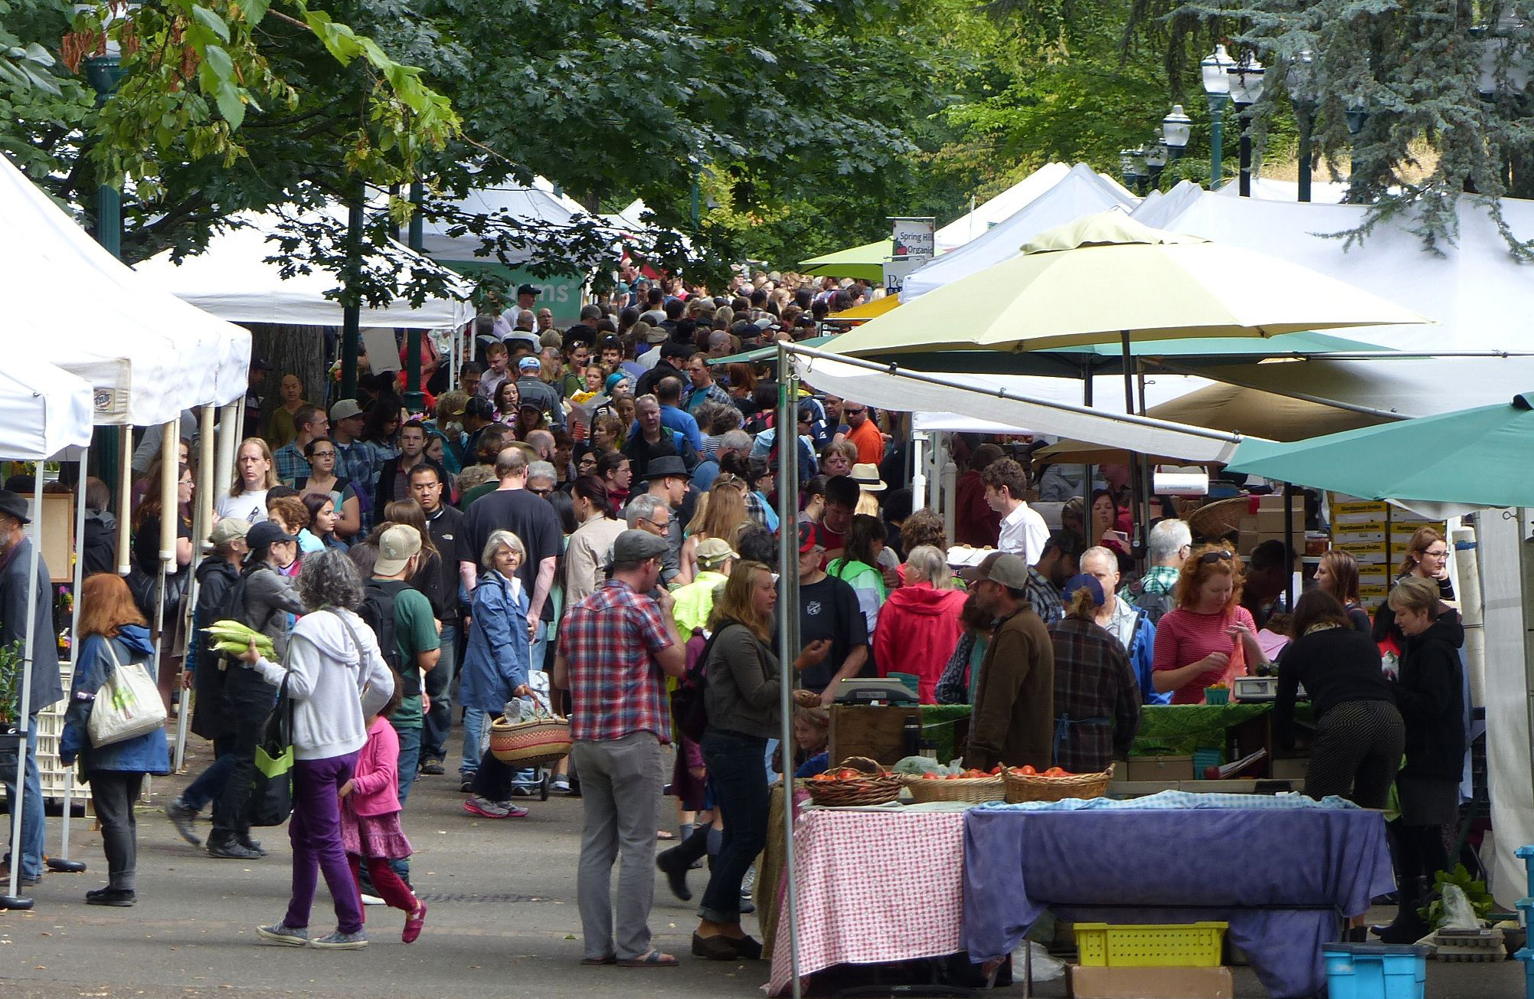 | Overview (Days 23 to 35)  The students receive a letter from The Community Council asking for their help. The Grand Challenge is to create a vertical farm design using a 3D modeling program, and demonstrate an operating hydroponic system to show that they know how to grow food with hydroponics. Students use the Informed Design Process to meet the challenge.

Big Idea: Vertical farming is a bold and innovative design concept to provide healthful food in urban environments. Like all new technologies a vertical farm must:
- Meet the needs of people and the environment.
- Make best use of resources, including money, tools and materials, energy, information, time, and people.

Lesson Duration: Approximately thirteen 45-minute periods

Standards and Learning Goals
Standards | Learning Goals
NGSS-MS-ETS1-1. Define the criteria and constraints of a design problem with sufficient precision to ensure a successful solution, taking into account relevant scientific principles and potential impacts on people and the natural environment that may limit possible solutions.  NGSS-MS-ETS1-2. Evaluate competing design solutions using a systematic process to determine how well they meet the criteria and constraints of the problem.  STL 9. Students will develop an understanding of engineering design.  STL 11. Students will develop the abilities to apply the design process.  STL 15. Students will develop an understanding of and be able to select and use agricultural and related biotechnologies.  EfA Themes: Design, Modeling, Systems Thinking Resources, Human Values | I can:  1. Apply what I learned through the KSBs to design a vertical hydroponic farm on an external apartment wall.  2. Use the Informed Design Process.  3. Work effectively with teammates.  4. Communicate a final design idea with a CAD drawing, hydroponics display, and report.

Tools/Materals/Equipment
- Projector
- Computer with Google SketchUp (or other CAD software) loaded
- Student Companion, Grand Challenge, for every student (printed or online)

Learning Activities
Engage
Discuss the letter from The Community Council (Page 2) with the students. Help them rephrase the grand challenge in their own words. Then remind the students of the Informed Design Process (IDP) (Page3), explaining that the Student Companion will guide the students through each stage of the design process. Point out the rubric on page 15, at the end of the Student Companion, which you will use to evaluate their work.
Stage 1: Clarify Problem Specifications and Constraints. Students work individually to write their understanding of the design challenge, criteria and constraints (Page 4). They then meet as a team to see where they agree and disagree, going back to the letter if necessary to resolve disagreements. Students are free to change their written ideas and add an additional sheet if they wish.
Lead a class discussion to be sure that everyone is on the same page regarding what is required: 1) a design for a vertical farm on a building of their choice (one of the buildings designed during KSB5 will do); and 2) A completed hydroponics system and report of the data showing successful plant growth.
Explore
Stage 2: Research and investigate. Student teams review what they learned in the KSBs (Pages 5 and 6). Then they survey five of their friends (who could be in the same class) to see what kinds of fruits and vegetables they like best (Page 7) and tally the results. Research conducted to better understand the need is an important part of the IDP. The students will use this information when they plan their vertical farm.
Stage 3: Generate Alternative Designs. Students work as individuals with paper and pencil to come up with different ideas for a vertical farm (Page 8). Then the students develop a CAD model of their best idea. If there are enough computers each student should create their own model; but if computers are in short supply they can work in teams of two.
Explain
Stage 4: Choose and Justify the Optimal Solution Teams use a Decision Matrix (Page 9) to evaluate different design ideas proposed by the team members. The teams construct a decision matrix, in which criteria and constraints are listed in the first column, and different models produced by the team members are listed at the head of subsequent columns. The teams work together to rate each idea against each criteria and constraint, awarding it a score from 0 (does not meet a criterion) to 5 (meets criterion very well.) If an idea does not meet a constraint, it is not considered further.
Engineer
Stage 5: Develop a Prototype (Day 27). Student teams develop a detailed plan for the vertical farm, considering tradeoffs. They create drawings and a 3D model, and prepare their hydroponic system for demonstration.
Stage 6: Peer Review (Estimate Days 28) Students teams present their ideas to their classmates who act in the role of consulting engineers to provide critical feedback.
Enrich
Stage 7: Redesign the Solution (Day 29) Teams revise their vertical farm designs based on feedback from the other teams.
Evaluate
Stage 8: Communicate Your Achievements (Day 30) Teams make presentations to their clients from the apartment complex (classmates acting as the client), about their final design. Presentations illustrate the entire trajectory of development, including designs that were not selected and why, feedback on the final design, and modifications. Presentations to show how the design finally achieved meets the criteria and constraints of the problem. The class evaluates each project regarding how well it meets the needs of the client.

Products
There are three products from this set of activities: 1) the students’ completed Grand Challenge Student Companion; 2) the vertical farm design developed by each group; and 3) The student’s completed hydroponics system and data display.

Assessment
Use the rubric on pages 4 and 5 of the Student Companion to assess the students’ vertical farm design. Use the “Final Project Assessment” on page 24 to rate the students on how well they and their team did on each stage. The students should rate themselves first, then the teacher should rate the students.
Use students’ responses to questions throughout the Grand Challenge as further information on the work of individual students.

Answer Key
Page 6: Show a design for a vertical farm, and demonstrate a hydroponic system that is growing vegetables.
Criteria are that the vertical farm design should
- Take advantage of as much sunlight as possible.
- Provide maximum space to grow fruits and vegetables year round.
- Include a plan for planting and harvesting.
- Make our building more attractive.
The constraint is that it be ready to show in one week. (The teacher can adjust this time based on actual constraints of the school schedule.)
Pages 7 and 8: Students summarize what they learned in their own words what they learned in each KSB, and how it will help them meet the current challenge.
Page 9: Students should have family and/or friends check the items that they commonly eat. Use tally marks to identify the numbers in the right column.
Pages 11-12: The students should show sketches of two possible ideas for a vertical farm, with labels. At least some of the ideas from page 10 should be shown in the drawings.
Page 13: All of the student on the team should record the results of the design matrix. Criteria and constraints should be filled in, and each idea should receive points for each criterion and constraint.
Page 14: All students in the team should have a similar drawing on this page for the vertical farm. Features should be labeled.
Pages 15-15: All students on the team should have similar information in the table, giving details of their team’s plan. Tradeoffs considered by the team should be included at the bottom of page 16.
Page 19: Students should use the table on page 19 to critique the other teams, and to note comments on their own team’s ideas. All boxes should be filled in with a “yes” if the design answered the question, and a “no” if it did not.
Page 20: This page should have notes about what the other teams said about their design. Ideas should be listed under what the other teams liked, what suggestions they offered for improvement, and additional ideas that the students’ own team came up with. The page should conclude with notes about what changes would be made and which would not.
Page 22: Responses on this page will vary. It asks students about their personal reflections on the entire design experience.

UN, 2012. World Population Prospects: The 2012 Revision. New York: The United Nations. Retrieved from: http://esa.un.org/wpp/

